2018-2019（上）高三第四次月考英语试卷
组题人：漆敏 审题人：刘文婷

第一部分 听力（共两节, 满分30分）
第一节 (5小题；每小题1. 5分, 共7. 5分) 听下面5段对话。每段对话后有一个小题, 从题中所给的A、B、C三个选项中选出最佳选项。听完每段对话后, 你都有10秒钟的时间来回答有关小题和阅读下一小题。每段对话仅读一遍。
1. What will the woman do this evening?
A. Have dinner with Mike. B. Go out with her parents.
C. Stay at home with her brother.
2. How will the man help the woman?
A. By writing invitations. B. By preparing dinner. C. By going shopping.
3. What day is it today?
A. Friday. B. Saturday. C. Sunday.
4. What is next to the oldest building in town?
A. City Hall. B. The police station. C. The post office.
5. Why is the man talking to the woman?
A. To take out insurance. B. To describe his illness.
C. To make an appointment.
第二节 (共15小题；每小题1. 5分, 满分22. 5分) 听下面5段对话或独白。每段对话或独白后有几个小题, 从题中所给的A、B、C三个选项中选出最佳选项。听每段对话或独白前, 你将有时间阅读各个小题, 每小题5秒钟；听完后, 各小题将给出5秒钟的作答时间。每段对话或独白读两遍。
听第6段材料。回答第6、7题。
6. Where does the conversation take place?
A. In a hotel. B. In the man’s office. C. In a post office.
7. What will the man do next?
A. Post some papers. B. Find a fax machine. C. Go downstairs.
听第7段材料, 回答第8至10题。
8. How will the woman go to California from Los Angeles?
A. By bus. B. By plane. C. By train.
9. Why will the woman go to California?
A. To study in a university. B. To see her sister. C. To visit the man.
10. What time is it now?
A. About 6:00. B. About 7:00. C. About 8:00.
听第8段材料。回答第11至13题。
11. Where did the man most probably lose his phone?
A. On the underground. B. In a restaurant. C. In a bank.
12. What will the man do before five o’clock?
A. Meet the woman. B. Buy a new phone. C. Make a call to the woman.
13. How does the man feel in the end?
A. Surprised. B. Doubtful. C. Grateful.
听第9段材料。回答第14至17题。
14. What does the man think of Lucy’s taking flying lessons?
A. Impractical. B. Surprising. C. Interesting.
15. What is Lucy?
A. A pilot. B. A nurse. C. A doctor.
16. What does the man advise the woman to do?
A. Teach in a college. B. Start her own restaurant.
C. Organize an Italian cooking class.
17. What is the relationship between the speakers?
A. Husband and wife. B. Brother and sister. C. Teacher and student.
听第10段材料。回答第18至20题。
18. Who is the speaker?
A. An English teacher. B. A university student.
C. A news reporter.
19. What does the speaker suggest?
A. Practicing listening more after class.
B. Trying to understand every word when listening.
C. Listening to pop songs without reading the words.
20. What is the speaker mainly talking about?
A. How to understand teachers better.
B. How to find interesting materials.
C. How to improve English listening.
第二部分 阅读理解（共两节, 满分40分）
第一节 （共15小题, 每小题2分, 共30分）
A
The online business model is changing on a satisfaction-first basis. It doesn’t matter if someone recommended you an app, nothing beats getting to try out the app first before deciding on whether or not to apply the service.
●Rhapsody
Listen to Rhapsody’s large music library and get the option to download and listen to songs or even full-length albums even when you’re offline. At the moment, this service is available in 32 countries only. Remember that you’1l need to cancel within the free trial period to avoid being charged for your first month.
[Trial period－14 days | After trial－$9. 99 / month | Try now]
●Bigstock
Need to save photos for your presentations and artworks? Go to Bigstock to check out its collection from top artists and photographers around the world. Choose from over 30 million photos, and illustrations(插图), with 75, 000 images coming in every new week. All you need to start your free trial is your email address.
[Trial period－7 days | After trial－$79／month | Try now]
●Canvas
If you are drowning in paperwork, perhaps it is time to use Canvas and transfer all your paperwork online. Digitalize your work orders, forms etc so that they can be completed right on any mobile device. This makes it easy to create, edit, gain valuable data and send it to people who need it in seconds.
[Trial period－30 days | After trial－$13／month | Try now]
●Backupify
If you’ve ever lost your phone, you know how important it is to backup(备份)all your important documents, notes, contacts and other personal details. Get cloud-to-cloud protection of up to 3 PB of data with Backupify. You can backup your data for Google apps, Office 365, various social media sites and even Salesforce.
[Trial period－15 days | After trial－$3／month | Try now]
To learn more about the apps above, Click Here.
21. Who is more likely to use the app Canvas?
A. A secretary. B. A photographer. C. An artist. D. A musician.
22. To save photos, can be of some help.
A. Bigstock and Canvas B. Backupify and Bigstock
C. Rhapsody and Backupify D. Rhapsody and Canvas
23. What is the advantage of the four apps?
A. Users will access them via email accounts.
B. They offer free entertainment services.
C. They can help brush up users’ work skills.
D. Users can try them without paying money.
24. Where can you find more information about such apps?
A. In a magazine. B. In a TV show. C. On a website. D. On a newspaper.
B
When was the last time you told someone they inspire you to go to work each morning?
Teachers at Oak Park High School in Kansas City, Missouri, did just that this September, when they pulled individual students out of class to tell them just how much they appreciated them.
The students’ reactions, which were captured(捕捉)on video and shared on YouTube, ranged from shy thanks to hugs and tears.
“I have been challenged to find a student who makes me want to come to school every day, ”says one teacher in the video,“and that’s you. ”
Jamie McSparin, a teacher in charge of the school’s academy program for at-risk sophomores(二年级学生)and juniors, posed the challenge, writes ABC News.
“Initially when we pulled the kids out, they all thought they were in trouble, ”McSparin told ABC News. “Any teacher-student interaction always seems to be negative(消极的), and that was something that bothered me, too. No matter if they’re good kids or troublemakers, they always thought they were in trouble, ”she says.
McSparin says she got the idea for the project after attending a professional development workshop this summer called the power of positivity.
“I like the idea of letting students know they are appreciated, because we do appreciate them. I just don’t think we say it enough, ”she told the local news outlet WDAF-TV.
It’s safe to say the challenge was effective.
“I feel special,”said one of the boys in the video. “You should, ”said his teacher. “You are special. ”
25. What does the underlined word“posed”in Paragraph 5 mean?
A. Presented. B. Rejected. C. Ignored. D. Evaluated.
26. How did the students probably feel when pulled out of the classroom at first?
A. Nervous. B. Thrilled. C. Curious. D. Encouraged.
27. What inspired McSparin to challenge the project?
A. The trouble caused by students.
B. The need of shooting the video.
C. A seminar named the power of positivity.
D. A program related to students’ interactions.
28. What message does this text mainly convey?
A. Challenge is unavoidable in life. B. Everyone needs to be appreciated.
C. Positivity outweighs negativity. D. News media contribute to students’ progress.
C
As cultural symbols go, the American car is quite young. The Model T Ford was built at the Piquette Plant in Michigan a century ago, with the first rolling off the assembly line(装配线)on September 27,1908. Only eleven cars were produced the next month. But eventually Henry Ford would build fifteen million of them.
Modern America was born on the road, behind a wheel. The car shaped some of the most lasting aspects of American culture：the roadside diner, the billboard, the motel, even the hamburger. For most of the last century, the car represented what it meant to be American—going forward at high speed to find new worlds. The road novel, the road movie, these are the most typical American ideas, born of abundant petrol, cheap cars and a never-ending interstate highway system, the largest public works project in history.
In l928 Herbert Hoover imagined an America with “a chicken in every pot and a car in every garage. ”Since then, this society has moved onward, never looking back, as the car transformed America from a farm-based society into an industrial power.
The cars that drove the American Dream have helped to create a global ecological disaster. In America the demand for oil has grown by 22 percent since 1990.
The problems of excessive(过度的)energy consumption, climate change and population growth have been described in a book by the American writer Thomas L. Friedman. He fears the worst, but hopes for the best.
Friedman points out that the green economy(经济)is a chance to keep American strength. “The ability to design, build and export green technologies for producing clean water, clean air and healthy and abundant food is going to be the currency of power in the new century.”
29. Why is hamburger mentioned in paragraph 2？
A. To explain Americans’ love for travelling by car.
B. To show the influence of cars on American culture.
C. To stress the popularity of fast food with Americans.
D. To praise the effectiveness of America’s road system.
30. What has the use of cars in America led to?
A. Decline of economy. B. Environmental problems.
C. A shortage of oil supply. D. A farm-based society.
31. What is Friedman’s attitude towards America’s future?
A. Ambiguous. B. Doubtful. C. Hopeful. D. Tolerant.
D
Long before iPhones, the cigarette was the companion of choice for restlessness. And long before Facebook and WeChat, it was tobacco that promised to better your social life. Now, quitting smartphones has become the new quitting smoking.
Of course, technology does not yellow your teeth, cause disease or lead to cancer. But some individuals are so concerned that device addiction is damaging their mental health. In order to reduce their dependence, even in Silicon Valley, people are turning off the messages that constantly buzz for their attention, banning smartphones from the bedroom and, curiously, changing the colors on their screens to a less tempting scale of gray.
The big tech companies will have to work out how to respond to this new generation of quitters. Facebook is the first to go public with its attempt, hoping its recent move can make the social network more homely.
Last year the tech industry got a bad name—Big Tech—with unfortunate echoes of other industries that have faced fierce opposition, including Big Tobacco. Like them, the tech industry has to reduce concern from a new generation of activist shareholders(股东)that are questioning its role in the world. These campaigns are never as fierce as those faced by Big Tobacco. In the 1990s, socially responsible investors refused to put money in tobacco stocks.
It is far difficult for investors to challenge Big Tech and hard to separate the good these companies do in the world—connecting old friends and giving space for people to share their ideas—from the bad. In the meantime, stopping using technology remains problematic. In The World Without Mind：The Existential Threat of Big Tech, Franklin Foer argues that tech should be seen in a similar way to junk food：a convenience that some reject for more continuing nutrition.
So we need to do more to turn the tide. In the same way that public service announcements made smoking around your children taboo, we can warn parents against losing themselves in their smartphones while taking care of kids. We can also create no-smartphone zones at dinner. Eventually smartphones could be banned from all public places and we could give our attention to the people around us instead.
32. How did people keep close relationships with others in the past?
A. By smoking. B. By drinking. C. By phoning. D. By dining out.
33. Why is the tech industry called Big Tech?
A. It plays a bad role in the world. B. It is as big as Big Tobacco.
C. It has an unfortunate name. D. It is a giant in Silicon Valley.
34. What can we infer from Franklin Foer’s argument about the tech?
A. It promotes social development. B. It is still favored by some people.
C. It is worse than Big Tobacco. D. It offers continuing nutrition.
35. Which can be the best title for the passage?
A. Creating a no smartphone life
B. Smartphones enrich our social life
C. Smoking does greater harm than smartphones do
D. Quitting smartphones is the new quitting smoking
第二节 七选五（共5小题；每小题2分, 共10分）
Little Habits Make a Big Difference
Everything around us is changing at amazing speed, it seems－but some things will always remain the same. 36 Some of our daily habits have the power to always give us happiness and lead toward success. Here are some little habits that can make a big difference：
1. 37 Many studies have linked early rising with success. An early morning wake-up carries benefits including better planning and anticipation(预料)of problems, and more time to the things that make you happy.
2. Happiness comes to those who are curious. 38 As long as you live, there will always be something to learn, and as long as you follow your heart and your passions, you won’t miss out on learning.
3. Believe in yourself and all that you are. 39 Confidence is the key to success－the thing that lets you look at the past without regret, stay grounded in the present, and prepare for the future without fear.
4. A day well spent gets you a good night sleep. Enough sleep makes you feel healthier and happier, and it’s more than lifting you up or removing exhaustion(疲惫). Adequate sleep is a key part of your health and inner happiness. 40
It doesn’t take a huge effort to make a significant change in your life－using one or two tiny habits may be all you need. Get started today and you’ll soon be experiencing the rewards.
A. That’s why habits are so powerful.
B. The ground work of all happiness is good health.
C. Early to rise makes you healthy, wealthy, and wise.
D. The habit of respect means treating everyone with kindness.
E. Nothing will ever make you happier than having faith in yourself.
F. When you rest better, you can live better and achieve more happiness.
G. There is no stage in life when we can’t be learning something valuable.
第三部分 语言运用（共两节, 满分45分）
第一节 完形填空（共20小题；每小题1.5分, 满分30分）
It happened to Susan Black in a cold winter. Everything seemed in a 41 those days. Both her parents suffering from depression, sending for a 42 became a common practice. As a woman in her 40s, it was a 43 job to be a teacher of 30 first-graders, who were always 44 , and she’d tried all sorts of methods, but 45 to get them quiet in class…
Misfortunes were 46 one after another. After a long and tiring day at work, Susan dragged herself along, 47 towards the parking lot. She came to the car, only to find she had locked her keys and cell phone inside. 48 kicking the tyre of the car, she sensed tears 49 her cheeks.
“What’s wrong?”a voice was heard. Susan looked up, and saw a young man with a 50 at his side. Susan stopped weeping and explained her situation, adding that 51 she called her husband, he wouldn’t bring her the spare car key, since he was working at the 52 end of the town and it was still not time to 53 the day’s work. “Call your 54 and tell him I’m coming to get the key, ”the young man handed Susan his phone. “But that’s a nine miles’ round trip…”said Susan. “There’s no time for 55 . I’ll be back as soon as possible. ”
Two hours later, the motor rider returned with a big smile and 56 face, key in hand. Susan 57 some money, but he refused. “Let’s just say I needed the 58 , ”with those words, like a 59 in the movie, he rode off into the sunset.
For Susan, the“cowboy”not only fetched the key, but 60 her day, or rather, warmed the long and cold winter days.
41. A. battle B. row C. mess D. hurry
42. A. worker B. psychologist C. policeman D. lawyer
43. A. tough B. rare C. boring D. rewarding
44. A. kind B. quick C. happy D. noisy
45. A. at heart B. in vain C. on purpose D. with ease
46. A. coming true B. piling up C. going well D. running out
47. A. looking B. marching C. yelling D. heading
48. A. Mildly B. Randomly C. Suddenly D. Wildly
49. A. streaming down B. flowing past C. showing up D. casting away
50. A. bicycle B. car C. motorbike D. taxi
51. A. even if B. unless C. just as D. whenever
52. A. wide B. deep C. far D. long
53. A. end B. forget C. give up D. put off
54. A. friend B. family C. daughter D. husband
55. A. waiting B. hesitation C. traveling D. delivery
56. A. charming B. sweating C. worrying D. encouraging
57. A. received B. shared C. offered D. loaded
58. A. exercise B. help C. reward D. lesson
59. A. young man B. stranger C. motor rider D. cowboy
60. A. kept B. burnt C. fixed D. built
第二节 （共10小题；每小题1.5分, 满分15分）
It was a dark and rainy morning in Tibet, but I could not sleep. The clock just 61 (strike) 4 as I got up and prepared to go to the Sho Dun Festival, one of the region’s largest yearly 62 (celebrate). A friend had advised me to make an early start 63 I wanted to experience the“sunning of the Buddha”ceremony, which marks 64 start of the festival held in Lhasa.
I considered myself lucky that my vacation happened to meet the opening of the festival, so 65 (miss)the opening of the 500-square-meter thangka (唐卡), a religious silk painting that is unique to Tibet, was unthinkable.
I first took a cab and then walked for 40 minutes to the foot of the hill, 66 the image of the Buddha would be displayed. Some Tibetan women joined me along the way to the spot, carrying 67 (child)on their backs. There was also a group of other foreigners, cycling with flashlights 68 (attach)to their heads.
69 (final), I arrived at the foot of the hill, and paid 60 yuan (about $ 8. 70)to have a quite good experience of getting close 70 true Tibetan culture.

第四部分 写作（共两节, 满分35分）
第一节 短文改错（每小题 1分, 满分10分）
It seems that if the result is bad, which people work for will be meaningless. Personally speak, the process of fighting for the goal is less important than the result. When we fight for our goals, we will be devoted what we are doing and try to improve us. If we fail in the end, when we look back on the beginning, we will find that we are no longer the childish one. We have grown up. What’s the more, in the process of fighting, we got close to success. As the saying goes, failure are the mother of success. So don’t treat the result so serious；just enjoy the process.
第二节 书面表达（满分25分）
假如你是李华, 你将要参加本周六主题为“An Unforgettable Experience in High School”的英语演讲比赛。你写了一篇演讲稿, 请外教Jason给予指导。请根据以下要点, 给他写一封邮件。
1. 说明情况；2. 指导内容(词汇、语法、句式结构等)；3. 回复时间；4. 表达感激。
注意：1. 词数100左右：2. 信的格式已给出, 不计入总词数；
3. 适当增加细节, 以使行文连贯。
Dear Jason,

Yours sincerely,
Li Hua

2018-2019（上）高三第四次月考英语试卷答案
1—20 CCABC ABCBA BACBB CABAC

21—24 ABDC 25—28 AACB 29—31 BBC 32—35 AABD
36—40 ACGEF

41—60 CBADB BDDAC ACADB BCADC

61. struck 62. celebrations 63. if 4. the 5. missing 6. where 7. children
8. attached 9. Finally 10. to

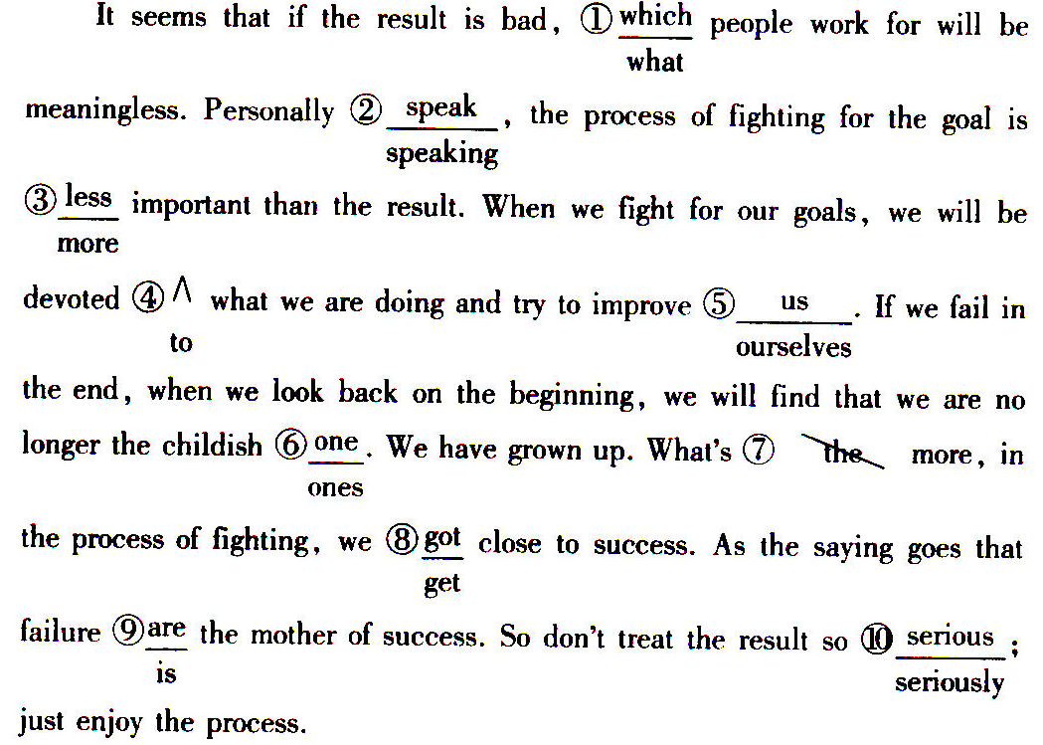

One possible version：
Dear Jason,
I’m Li Hua. I’m writing to ask you to do me a favor. It’s about an English speech contest with the title An Unforgettable Experience in High School, which I’m going to take part in this Saturday. I’ve finished my draft, but it is still far from satisfactory.
I’m not sure of the usage of some words. There may also be some mistakes in grammar and sentence structures. Would you be kind enough to spare some time to check my article? If it’s convenient for you, please send it back by Thursday afternoon.
I’d appreciate it if you could give me your guidance. Looking forward to your reply.
Yours sincerely,
Li Hua

