延庆区2018—2019学年度模拟考试试卷
高三英语
本试卷共13页，共120分。考试时长100分钟。考生务必将答案答在答题卡上，在试卷上作答无效。考试结束后，将答题卡交回。
第一部分：知识运用（共两节，45分）
第一节语法填空（共10小题；每小题1.5分，共15分）
阅读下列短文，根据短文内容填空。在未给提示词的空白处仅填写 1个适当的单词，在给出提示词的空白处用括号内所给词的正确形式填空。
A
At my first class in the Forks High School, Mr. Banner,my English teacher sent me to an empty desk at the back without 1 (introduce) me to the class. It was harder for my new classmates 2 (stare) at me in the back, but somehow, they managed. I kept my eyes down on the reading list the teacher had given me. It was 3 (fair) basic: Bronte,Shakespeare,Chaucer, Faulkner. I’d already read everything. That was comforting… and boring.
B
Your teeth may be part of your smile, 4 they have amore important job—theyare the first step in theprocess of digestion. You have three 5 (kind) of teeth. In the very front of yourmouth are eight flat, thin teeth called incisors. They are used for cutting and biting food. Next to these arepointed teeth called canines, 6 also help you tearfood. The remaining teeth are molars. These teeth haveflat tops for crushing and grinding the food.
C
The Beijing Vanke-Shijinglong Ski Resortis located 7 Yanqing District,a nationaldemonstration area for ecologicalconstruction.With Longqing Gorge to itseast and Guanting Reservoir to its west,ithas fresh air and an 8 (impress) environment. 9 (build) in 1999, it was the first large ski resort tobe built near Beijing.In 2016,a massiverenovation project 10 (start) byVanke, the Beijing Badaling Tourism General Company, and the original Beijing Shijinglong Ski Resort.
第二节完形填空（共20小题；每小题1.5分，共30分）
阅读下面短文，掌握其大意，从每题所给的A、B、C、D四个选项中，选出最佳选项，并在答题卡上将该项涂黑。
Worth the pain in the end
I used to hate running. It seemed too hard and pushing outside my comfort zone was not something I was raised to do.
In fact, I wouldn’t have become a 11 if it weren’t for my husband Charles. He had been a serious competitive runner for many years. After our marriage, he wouldn’t stop talking about how much he missed it.
“So start running again, why don’t you?” I was getting 12 of hearing about it.
So he picked it up again, and after about a year, I started to join him at the track (跑道). Just a few weeks later, Charles signed us both up for a five-kilometer race. I 13 about doing it. It was too soon.
But on 14 day, there I was.
The gun went 15 .Thousands of runners pushed forward.
The first kilometer was 16 .
“I don’t think I’m going to make it.” I was already breathing heavily and painfully aware of the group of runners 17 past me.
“No, you’re doing 18 ”, said Charles. He was trying to encourage me, to get me focused on something other than my 19 .
“I can’t,” I said, 20 audibly (听得见地).
He tried a different way to 21 me. “Just make it to that house and let’s see how you feel.”
After another minute I saw the three-kilometer 22 . All I could think of was that I was dying and that my husband was torturing (折磨) me.
Miserable doesn’t even begin to describe 23 I felt. And there was so much 24 .
“You’ll be fine. You’ve got less than a kilometer to go.”
I rounded a corner and saw both sides of the street thick with people watching the race, all cheering the runners on. I 25 my legs to keep going.
Then I looked up and saw the clock. The seconds ticking away (一分一秒地过去) gave me an incentive (助力). I knew that if I finished this race, I would have achieved something. So, I straightened up, and kicked it.
I had my arms held higher when I passed 26 the finish line. A volunteer put a 27 around my neck.
“You did great! I’m so 28 of you!” Charles was thrilled that I’d 29 it.
“That was AMAZING! I want to do another race. This running stuff is amazing!” I proudly hugged my medal as we started to walk to the post-race festivities.
My lungs and my comfort zone both 30 .
11. A. runner B. traveler C. racer D. cheerleader
12. A. afraid B. tired C. aware D. confident
13. A. thought B. dreamed C. hesitated D. cared
14. A. race B. sport C. show D. task
15. A. on B. off C. up D. down
16. A. long B. short C. easy D. tough
17. A. brushing B. walking C. pounding D. sliding
18. A. wrong B. right C. great D. bad
19. A. disability B. dishonor C. disgrace D. discomfort
20. A. barely B. nearly C. merely D. roughly
21. A. advise B. persuade C. order D. force
22. A. signal B. symbol C. point D. mark
23. A. how B. what C. when D. why
24. A. sweat B. anger C. pain D. pleasure
25. A. willed B. dragged C. pulled D. supported
26. A. by B. over C.at D. through
27. A. ring B. necklace C. medal D. scarf
28. A. ashamed B. guilty C. sure D. proud
29. A. done B. made C. taken D. caught
30. A. developed B. expanded C. changed D. progressed

第二部分：阅读理解（共两节，40分）
第一节（共15小题；每小题2分，共30分）
阅读下列短文，从每题所给的A、B、C、D四个选项中,选出最佳选项，并在答题卡上将该项涂黑。
A
Our Museums, Galleries, and Zoo
19 world-class museums, galleries, and a zoo
The Smithsonian offers eleven museums and galleries on the National Mall and six other museums and the National Zoo in the greater National Capital Area. In New York City, we invite you to tour two museums in historic settings.
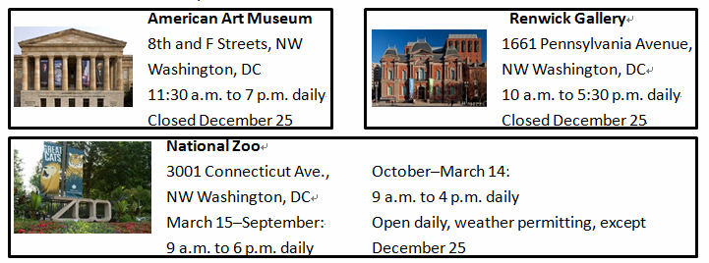
Not near a Smithsonian museum? Look for exhibitions and museums in your community. Here we have listed some places to visit:

Tips & Guidelines:
- Stop at any Smithsonian museum information desk where friendly and knowledgeable staff and volunteers can assist you in planning your visit.
- Service animals are welcome at the museums and the National Zoo. Pets are not permitted.
- Lunches should be properly closed or stored in lockers during your visit.
31. The Smithsonian offers all these EXCEPT_________.
A. galleries B. concerts C. museums D. zoos
32. If you are interested in animals, you can_________.
A. go to 1661 Pennsylvania Avenue, NW Washington, DC
B. go to 8th and F Streets, NW Washington, DC
C. visit the museum 11 a.m. on Christmas
D. visit the zoo at weekends on June 25
33.Toarrange your visit better, you can__________.
A. have lunch during your visit
B. take your pets along with you
C. ask the staff and volunteers for help
D. fill in an application form before your visit
B
Half a Day
I walked alongside my father, holding his right hand. All my clothes were new: the black shoes, the green school uniform, and the red cap. They did not make me happy, however, as this was the day I was to be thrown into school for the first time.
"Why school?" I asked my father. "What have I done?”
"I'm not punishing you," he said, laughing. "School's not a punishment. It's a place that makes useful men out of boys. Don’t you want to be useful like your brothers?"
I was not convinced. I did not believe there was really any good to be had in tearing me away from my home and throwing me into the huge, high-walled building.
When we arrived at the gate we could see the courtyard, vast and full of boys and girls. "Go in by you,” said my father, "and join them. Put a smile on your face and be a good example to others. "
I hesitated and squeezed his hand firmly, but he gently pushed me from him. “Be a man”, he said. "Today you truly begin life. You will find me waiting for you when it's time to leave. "
I took a few steps. Then the faces of the boys and girls came into view. I did not know a single one of them, and none of them knew me. I felt I was a stranger who had lost his way. But then some boys began to glance at me in curiosity, and one of them came over and asked, "Who brought you?"
"My father,” I whispered.
"My father's dead,” he said simply.
I did not know what to say. The gate was now closed. Some of the children burst into tears. The bell rang. A lady came along and said, "This is your new home. There are mothers and fathers here, too. Everything that is enjoyable and beneficial is here. So dry your tears and face life joyfully. "
Well, it seemed that my misgivings had had no basis. From the first moments I made many friends. I had never imagined school would have this rich variety of experiences.
34. On the way to school, the boy felt__________.
A. happy B. embarrassed C. upset D. excited
35. About schooling, Father suggested __________.
A. wearing a smile B. tearing himself away from games
C. waiting for parents D. throwing himself to studying
36. ________ helped him most on the first day at school?
A. Teachers and classmates B. Courtyards and buildings
C. Father and brother D. New uniforms and shoes
37. What would probably happen next?
A. The school life would turn out to be a failure.
B. Boys in the school would watch him curiously.
C. He would open up a new journey of colorful life.
D. His parents would accompany him at the school
C
Learning, Fast and Deep


Over the past five years researchers in artificial intelligence have become the rock stars of the technology world. A branch of AI known as deep learning, which uses neural(神经的) networks to scan through large volumes of data looking for patterns, has proven so useful that skilled practitioners can command high six-figure salaries to build software for Amazon, Apple, Facebook and Google.
The standard route into these jobs has been a PhD in computer science from one of America’s top universities. Earning one takes years and requires a personality suited to academia, which is rare among more normal folk.
That is changing.
Last month fast.ai, a non-profit education organizationbased in San Francisco, kicked off the third year of its course in deep learning. Since its foundation it has attracted more than 100,000 students around the globe from India to Nigeria. The course and others like it, come with a simple idea: there is no need to spend years obtaining a PhD in order to practise deep learning. Creating software that learns can be taught as a craft, not as a high intellectual pursuit to be undertaken only in an ivory tower. Fast.ai’s course can be completed in just seven weeks.
To make it accessible to anyone who wants to learn how to build AI software is the aim of Jeremy Howard, who founded fast.ai with Rachel Thomas, a mathematician. He says school mathematics is sufficient. “No. Greek. Letters,” Mr. Howard intones, pounding the table with his fist for punctuation.
Some experts worry that this will serve only to create a flood of unreliable AI systems which will be useless at best and dangerous at worst. In the earliest days of the Internet, only a select few nerds, namely computerholicswith specific skills, could build applications. Not many people used them. Then the invention of the World Wide Web led to an explosion of web pages, both good and bad. But it was only by opening up to all that the Internet gave birth to online shopping, instant global communications and search. If Mr. Howard and others have their way, making the development of AI software easier will bring forth a new crop of fruit of a different kind.
38. What can we learn about deep learning?
A. It replaces artificial intelligence.
B. It attracts rock stars to practice.
C. It scans patterns for large companies.
D. It helps technicians to create software.
39. Fast.ai is an organization that __________________.
A. ensures one to obtain a PhD B. teaches craft in ivory tower
C. offers a course in deep learning D. requires weeks to apply
40. The underlined words “No. Greek. Letters”in Paragraph 5 means doing fast.ai course is
_______.
A. easy B. difficult C. interesting D. boring
41. It can be inferred from the last paragraph that _______.
A. it is quite reliable for anyone to grasp artificial intelligence
B. the Internet has brought forth a flood of useless AI systems
C. opening up to all leads to instant global search and online shopping
D. simplifying software development may result in unexpected outcomes
D
WISH YOU WERE MORE CREATIVE?
I want to ask you a favor. I have a pair of pants. Tell me: How many different ways can I put a pair of pants to use?Now imagine you're an architect. Same question. Now imagine you're Bill Gates. A scuba diver.A medieval knight. You still have the pants. What alternative uses come to mind?
What you just practiced--the conscious act of "wearing" another self--is an exercise that, according to psychiatrist SriniPillay, MD, is essential to being creative.
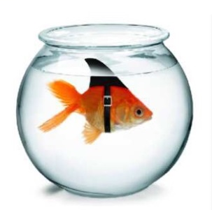
One great irony (讽刺) about our collective addiction to creativity is that we tend to frame it in uncreative ways. That is to say, most of us marry creativity to our concept of self: Either we’re “creative” or we aren't, without much of a middle ground. "I'm just not a creative person!” a discouraged student might say in art class, while another might blame her talent at painting for her difficulties in math, making a comment "I'm very right-brained."
Dr.Pillay, an assistant professor at Harvard University, has spent years overturning these ideas. He believes that the key to unlocking your creative potential is to challenge the stereotyped (陈词滥调的) advice that urges you to “believe in yourself.” In fact, you should do the opposite: Believe you are someone else.
He points to a study showing the impact of stereotype on one's behavior. The authors, psychologists Denis Dumas and Kevin Dunbar, divided their college student subjects into two groups, instructing one group to think of themselves as "eccentric poets" and the other to imagine they were "rigid librarians". The researchers then presented them all with ordinary objects, including a fork, a carrot, and a pair of pants, and asked them to come up with as many different uses as possible for each one. The former group came up with the widest range of ideas, whereas the latter had the fewest.
These results suggest that creativity is not an individual characteristic but a “product of context and perspective”. Everyone can be creative, as long as he or she feels like a creative person.
Dr. Pillay's work takes this a step further: He argues that simply identifying yourself as creative is less powerful than taking the brave, creative step of imagining you are somebody else. This exercise, which he calls psychological Halloweenism, refers to the conscious action of “wearing” another self. An actor may employ this technique to get into character, but anyone can use it. According to Dr. Pillay, it works because it is an act of conscious unfocus, a collection of brain regions that spring into action when you're not focused on a specific task or thought. Most people spend nearly half of their days in a state of "unfocus." This doesn't make us lazy; it makes us human.
Imagining yourself in a new situation, or an entirely new identity, never felt so productive. You’re making yourself more creative, and you're giving yourself permission to do something you'd otherwise feel guilty about.
42. What’s the function of the questions in paragraph 1?
A. To lead in the topic. B. To make a comparison.
C. To state an opinion. D. To ask a favor.
43. The study led by Denis Dumas and Kevin Dunbar proves_____
A. creativity is an individual characteristic
B. librarians are more creative than poets
C. ordinary objects can improve creativity
D. your creativity is determined by yourself
44. According to Dr. Pillay, Halloweenism works because ______.
A. it is an act of unconscious focus
B. certain brain areas begin to act together
C. people are in a state of laziness
D. all actors employ this technique
45. If you want to be more creative, you are supposed to _______.
A. focus on a specific task B. believe in your own talent
C. pretend to be someone else D. turn to be right-brained

第二节（共5小题；每小题2分，共10分）
根据短文内容，从短文后的七个选项中选出能填入空白处的最佳选项。选项中有两项为多余选项。
The Surprisingly Easy Trick That Can Help You Use Your Phone a Little Bit Less

The first thing I do in the mornings is look at my phone. That’s mainly because my phone is my alarm clock, but once my eyes are open and that screen is lit up in my hands, it’s an awfully short trip to checking emails and perusing headlines.46 My emails that early in the morning are mainly junk, and the headlines won’t change much before I’ve brushed my teeth and poured a cup of coffee, right?
My wife says I’m addicted to my phone. 47 I’m not terribly active on social media, but I do enjoy me some idle scrolling（enjoy playing the mobile phone）. And, wow, do these tech companies know how to keep those thumbs constantly swiping up.
48 While I think we’re pretty good about limiting her screen time, it would seem that technology has had its hooks in me from the start. So, I decided to try loosening my phone’s grasp on my attention by switching the screen to black and white.
Changing the display to black and white is very easy. In your iPhone’s settings, choose General, then Accessibility. Next choose Display Accommodations, then Color Filters. Tap the toggle on and a list of filters appears. 49
But no one wants to go through all this every time they want to turn color back on to check out an Instagram story. Clearly, you don’t always want your screen to be black and white. After all, there will unavoidably be photos to view and videos to share.50 In the Accessibility menu, tap Accessibility Shortcut and choose Color Filters. Now, pressing the home button three times will switch your display to color, and then back with another three.
A. There’s no reason for me to be doing this.
B. We’ve got a three-year-old child.
C. Choose Grayscale and you’re all set.
D. It can help you use your phone a little bit less
E. I disagree, but I can definitely stand to spend less time looking at it.
F. Here comes a surprisingly easy trick.
G. That is what makes setting a shortcut necessary.

第三部分:书面表达(共两节，35分)
第一节（15分）
假设你是红星中学高三学生李华，你的英国朋友Jim在给你的邮件中询问北京近几年的变化。请你根据以下要点进行回复。内容包括：
1．变化是什么
2．对你的影响；
3．期待朋友来北京
注意：
1．词数不少于50；
2．开头和结尾已给出，不计入总词数。
Dear Jim,
_______________________________________________________________________
________________________________________________________________________
________________________________________________________________________
________________________________________________________________________
________________________________________________________________________
________________________________________________________________________
Yours
Li Hua

- （20分）
假设你是红星中学高三学生李华，请根据以下四幅图的先后顺序，写一篇英文周记，记录上周你和同学参与国家博物馆“庆祝改革开放四十周年大型展览（Celebrating 40th Anniversary of Reform and Opening-up”志愿者活动的全过程。
注意：词数不少于60 提示词：国家博物馆the National Museum of China
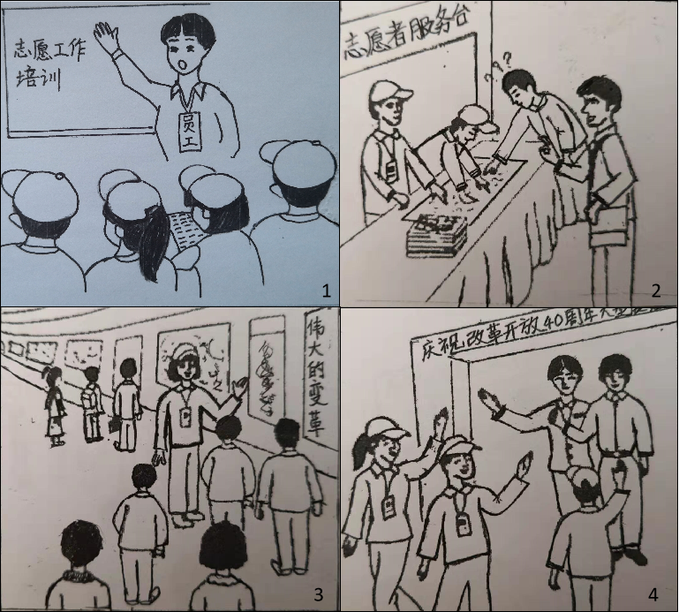
_______________________________________________________________________
________________________________________________________________________
________________________________________________________________________
________________________________________________________________________
________________________________________________________________________
________________________________________________________________________
________________________________________________________________________

延庆区2018—2019学年度高三模拟试卷
英语参考答案
第一部分：知识运用（共两节，45分）
第一节语法填空
1. introducing 2. to stare 3. fairly 4. but 5. kinds
6. which 7. in 8. impressive 9. Built 10. was started

第二节完形填空
11. A 12. B 13. C 14. A 15. B 16. D 17. C 18. C 19.D 20. A
21. B 22. D 23. A 24. C 25.A 26. D 27. C 28. D 29. B 30. B

第二部分阅读理解
31. B 32. D 33. C 34. C 35. A 36. A 37. C 38. D 39. C 40. A
41. D 42.A 43. D 44. B 45. C 46. A 47. E 48. B 49. C 50. G

第三部分书面表达（共两节，35分）
第一节（15分）
Dear Jim,
It’s so nice to hear from you. Knowing that you want to learn about the changes in Beijing these years, I’m more than willing to tell you.
In the past few years, great changes have indeed taken place in Beijing. To start with, Beijing boasts itself as a more and more international city with many big international events like Olympic Games held here. More and more foreign companies are set here which bring in more foreign people working and living here. Besides, there are more roads and subways built or being built, which relieved the problem of traffic jams in this busy capital. Shared bikes have become popular in Beijing as well. Speaking of the problem of air pollution, many measures like traffic control, using electricity or gas as fuel instead of coal…have been taken, which turn out well.
I am taking in all the advantages of all those changes as I am now riding a shared bike to school every day, breathing fresh air as well as keeping my body fit. You must have sensed my progress in my English wording, since I enjoy talking with my foreign teacher and learn from him in my Oral English Class.
Anyway, I can’t wait to have you here to witness all those changes yourself. Come, and you will be stunned.
Yours,
Li Hua
第二节（20分）
参考范文
Recently a large-scale exhibition was held in the National Museum of China to celebrate the 40th Anniversary of Reform and Opening-up. My classmates and I were extremely honored to have the opportunity to serve as volunteers.
Last Sunday, we arrived at the National Museum early in the morning. In order to learn how to provide better service, we were trained by a staff member for the volunteer work. We all listened attentively and eagerly, taking notes from time to time.
After the training, wearing the volunteer uniform and volunteer card, we got down to our work with great enthusiasm. Some of us worked at the Volunteer Service Counter and offered service to people who turned to us for help. We provided them with useful guidance and information for the exhibition. Inside the exhibition hall, some of us volunteer docents stood in front of a group of visitors, giving vivid introduction of the great achievements over the past 40 years, which attracted the visitors so much and brought us a great sense of achievement.
Time passed quickly before we knew it. Waving us goodbye, the museum staff thanked us and gave us a thumbs-up for our working the whole day. Their praise and thanks greatly encouraged us. Meanwhile, We all felt a sense of pride for our country’s great achievements.

