2019届高三模拟考试试卷
英 语2019.5
本试卷分第Ⅰ卷(选择题)和第Ⅱ卷(非选择题)两部分。满分120分，考试时间120分钟。
第Ⅰ卷(选择题 共85分)
第一部分：听力(共两节，满分20分)
第一节(共5小题；每小题1分，满分5分)
听下面5段对话。每段对话后有一个小题，从题中所给的A、B、C三个选项中选出最佳选项，并标在试卷的相应位置。听完每段对话后，你都有10秒钟的时间来回答有关小题和阅读下一小题。每段对话仅读一遍。
( )1. Which optional subject will the two speakers share?
A. AI. B. PE. C. French.
( )2. What does the man probably do?
A. A doctor. B. A conductor. C. A policeman.
( )3. How many copies will the woman make?
A. 12. B. 15. C. 27.
( )4. How does the woman feel after the yoga class?
A. Tired. B. Nervous. C. Refreshed.
( )5. Where does this conversation probably take place?
A. At a store. B. At a hotel. C. At a hospital.
第二节(共15小题；每小题1分，满分15分)
听下面5段对话或独白。每段对话或独白后有几个小题，从题中所给的A、B、C三个选项中选出最佳选项，并标在试卷的相应位置。听每段对话或独白前，你将有时间阅读各个小题，每小题5秒钟；听完后，各小题将给出5秒钟的作答时间。每段对话或独白读两遍。
听第6段材料，回答第6、7题。
( )6. What's the weather probably like today?
A. Windy. B. Rainy. C. Sunny.
( )7. Which city does Mary plan to visit next year?
A. London. B. Boston. C. Beijing.
听第7段材料，回答第8、9题。
( )8. What's the probable relationship between the two speakers?
A. Husband and wife. B. Boss and secretary. C. Customer and saleswoman.
( )9. Why does the woman refuse to keep a pet?
A. Her family are on vacation. B. They are expecting a baby.
C. She is too busy to care for it.
听第8段材料，回答第10至12题。
( )10. Why does the man go to the USA?
A. To do some business. B. To live with his brother.
C. To see his new－born nephew.
( )11. Who sponsors his trip?
A. His company. B. His brother. C. His neighbor.
( )12. What can we learn about the man from the dialogue?
A. He is unemployed. B. He is in debt. C. He is probably single.
听第9段材料，回答第13至16题。
( )13. When did the woman attempt to call the man?
A. At 8：00. B. At 8：30. C. At 9：00.
( )14. What did the man do for the woman?
A. He drove to pick her up. B. He prepared dinner for her.
C. He bought a new cell phone for her.
( )15. What product did the woman buy?
A. Laundry soap. B. Window cleaner. C. Dishwashing liquid.
( )16. Why did the woman choose the new brand?
A. It's much cheaper. B. It has a pleasant smell.
C. It's good for the environment.
听第10段材料，回答第17至20题。
( )17. What do we know about TikTok?
A. It has gained popularity. B. It was founded in America.
C. It is the biggest social media app.
( )18. Who probably likes TikTok best?
A. Company staff. B. Teenage users. C. English speakers.
( )19. Which helps TikTok take off?
A. The support from Twitter.
B. The foundation of Douyin.
C. The cooperation with Musical.ly.
( )20. What is special about TikTok?
A. Short and funny. B. Long and free. C. Private and popular.
第二部分：英语基础知识运用(共两节，满分35分)
第一节：单项填空(共15小题；每小题1分，满分15分)
请认真阅读下列各题，从题中所给的A、B、C、D四个选项中，选出最佳选项。
( )21. We live in this society now ________ literally someone is always helping.

A. when B. where C. that D. what
( )22. The maple trees turn a brilliant red in autumn, adding another ________ to the colors in the harvest season.
A. theme B. version C. category D. dimension
( )23. Patrick waited ________ all the luggage was cleared, but his never appeared.
A. until B. before C. when D. while
( )24. —Look! Mary is crazily looking for something again!
—________， she can't find her keys.
A. Typically B. Occasionally C. Accordingly D. Particularly
( )25. Cambridge gave a positive answer ________ inquiries on whether it recognizes gaokao scores.
A. in favor of B. in response to C. in salute to D. in consequence of
( )26. Wild animals in nature reserves need to develop their survival skills and ________ their wild nature.
A. display B. possess C. maintain D. monitor
( )27. I'd never wondered before whether or not he was kid－friendly. With one glance, I quickly ________ that he probably wasn't.
A. agreed B. reported C. explained D. decided
( )28. The same boiling water softens the potato and hardens the egg. It's about ________ you're made of, not the circumstances.
A. that B. what C. how D. who
( )29. —Excuse me, do you mind if I open the window?
—Well, if you ________ I can put on more clothes.
A. can B. may C. must D. shall
( )30. With the number of homecoming overseas students ________ up in recent years, the attraction of foreign degree holders has gradually faded.
A. shot B. being shot C. shooting C. to shoot
( )31. —Have you heard that they are working around the clock to compete for the prize?
—Don't worry. We are ready to ________ the challenge.
A. build up B. take up C. stick to D. lead to
( )32. —Is there any chance of my being promoted?
—If you want a promotion, you'd better ________ rather than get your way.
A. play the game B. cross your fingers
C. raise the red flag D. kill the fatted calf
( )33. —How could they misunderstand me like that?
—Just keep silent! It's the best way to let them know they ________ you wrong.
A. do B. did C. are doing D. had done
( )34. Our team is world－class and it was no surprise that we won by such a ________ margin.
A. low B. high C. wide D. narrow
( )35. —I'll take the blue one. This is twenty dollars.
—Here's the change. ________．
A. Best wishes B. My pleasure
C. Have a nice day D. Let's call it a day
第二节： 完形填空(共20小题；每小题1分，满分20分)
请认真阅读下面短文，从短文后各题所给的A、B、C、D四个选项中，选出最佳选项。
“What's all this tree－planting for？” I was asked when I began writing about __36__ a piece of land I had bought in Somerset. The truth is, I just love trees. And I am not __37__. “As I get older, all I really __38__ is to plant trees，” Prince Charles says in a BBC documentary in which he is __39__ in the wood he planted on the day Prince George was born.
There are __40__ and wonderful trees in our cities and villages. They were planted, or self－sown, years, even centuries ago. We take them for granted, __41__ the creatures living among them, remain in ignorance of the __42__ trees are doing us(cleaning the air, for instance) and cut them down for new __43__. Yet we keep a feeling of __44__ for them. This may account for the __45__ the government faced in 2010 when it sought to sell off publicly owned woods, and for the wide support that the Woodland Trust(a tree－protecting charity) __46__.
Trees need __47__， which is why I, a city－resident, bought my Somerset woodland in 1999. At that time, climate change was already well proved, __48__ my hopes of planting long－lived oaks and pines gradually developed into anxiety about their __49__. Tree diseases new to the UK, wind, drought and flood were all __50__ against them.
But I did not __51__ things to move so fast. The woodland is still good, the new trees are growing like mad, but the creatures are __52__. The rabbits have disappeared and the owl has moved. The bees and butterflies are __53__ there but in smaller numbers. How can this happen on land __54__ pesticides(杀虫剂)? Surely, it indicates we need to give nature the chance to restore its own __55__. Meanwhile, I love my wood, and so do many of its visitors. And tree－planting has done wonders for restoring my balance between town and country.
( )36. A. replacing B. restoring C. recycling D. returning
( )37. A. rich B. weak C. alone D. social
( )38. A. apply for B. wait for C. make for D. long for
( )39. A. filmed B. tracked C. reflected D. discovered
( )40. A. holy B. young C. mature D. mysterious
( )41. A. raise B. watch C. ignore D. abuse
( )42. A. honor B. good C. credit D. justice
( )43. A. use B. spirit C. life D. hope
( )44. A. trust B. sadness C. betrayal D. affection
( )45. A. approval B. opposition C. option D. dilemma
( )46. A. wins B. rejects C. requires D. withdraws
( )47. A. space B. time C. company D. nutrition
( )48. A. since B. for C. yet D. so
( )49. A. benefits B. chances C. location D. appearance
( )50. A. piling up B. speeding up C. keeping up D. mixing up
( )51. A. wish B. intend C. allow D. expect
( )52. A. in place B. in order C. in decline D. in question
( )53. A. even B. still C. ever D. once
( )54. A. short of B. sick of C. free of D. full of
( )55. A. glory B. function C. impact D. balance
第三部分： 阅读理解(共15小题；每小题2分，满分30分)
请认真阅读下列短文，从短文后各题所给的A、B、C、D四个选项中，选出最佳选项。
A
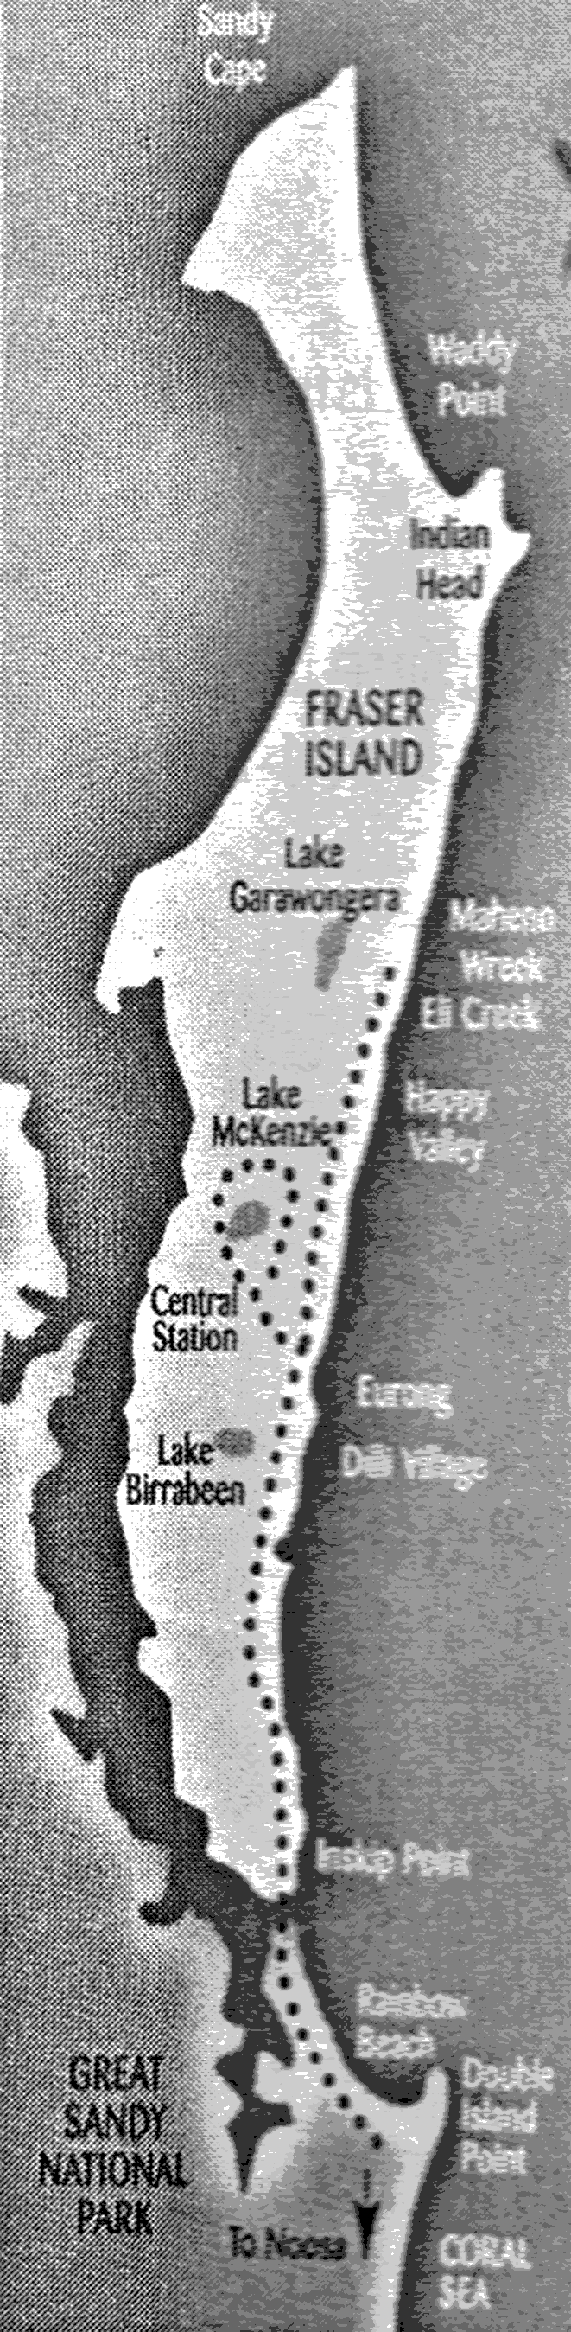 | Welcome to Fraser Island  Your adventure unfolds...  ●Once departing Rainbow Beach we start from Inskip Point by vehicle ferry. Watch out for dolphins.  ●Northward bound—travel by 4WD(4 wheel drive) along the endless golden highway of 75 Mile Beach.  ●Swim at crystal clear freshwater LAKE MCKENZIE—famous for its turquoise colors and white sands.  ●Delicious “Aussie style” sizzling bush BBQ with icy cold drinks.  ●Primitive rainforest—luxuriant canopy of palms and vines.  ●Eli Creek—time for a lazy dip.  ●Shipwreck of the SS Maheno—built in Scotland 1904—a permanent fixture to the Northern Beach since 1935.  ●Intriguing Colored Sands formations—part of this World's largest sand island.  ※ Remember this is a 4WD safari and may not be suitable if pregnant or if you have a bad back.  ※Dress comfortably—it's not a fashion parade! Bring your swimmers and camera. | 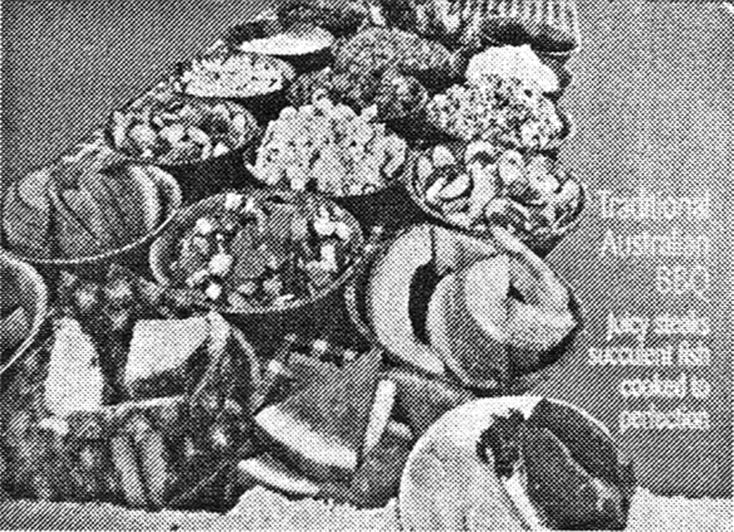Lunch Menu  Complimentary cold drinks  Prime 250g Rib Fillet Steak  OR local award winning 100% beef sausages and onions OR Fish—delicate white fillets with lemon, OR Vegetarian Burger—special blend seasonal vegetables  GENERAL CONDITIONS：  Tours may vary due to tidal or weather conditions. As we are a small company and prepare our own food, cancellation fees have to apply.  NOT RECOMMENDED FOR YOUNG CHILDREN.  Codford Pty. Ltd. Trading as Fraser Island Nature Tours  ABN 80 010 870 729
( )56. Which of the following is mentioned about Fraser Island?
A. Considerable size and cheap souvenirs.
B. Authentic food and impressive scenery.
C. Target visitors and modern architecture.
D. Convenient transportation and long history.
( )57. According to the leaflet, visitors should ________．
A. dress their fashionable clothes B. provide a health certificate
C. pay extra money for cancellation D. follow the fixed trip plans
B
Like a lot of health－care professionals, Dr. Brian Goldman finds it extremely difficult to draw boundaries between his work and personal lives. “There's this view that you should suck it up and do one more thing，” says the ER physician and host of CBC's White Coat, Black Art. But that “one more thing” often comes at Goldman's expense.
“You're exhausted and a patient or their family look at you with begging eyes，” he says. “So you have this dilemma: say that your shift is over or give until you're totally spent？” Goldman's work stress combined with family tension after his mother was diagnosed with dementia 20 years ago. Caring for her over a decade was difficult, as was dealing with his father's grief. “When someone else is drowning you, you have to grab a life preserver and save yourself，” says Goldman.
Setting boundaries isn't just important for busy professionals; everyone can benefit from managing situations that cause undue stress or pain. Here are some tips.
First, “If someone's behavior makes you unhappy—and it could be anything from the way they speak to you to repeatedly failing to stick to their promise—then there's room to set limits，” says Patrick Keelan, a Calgary psychologist. We often avoid setting limits because we prioritize the happiness and comfort of others over ours. In order to control this__impulse,__Goldman suggests framing the development of boundaries as a form of self－kindness. When facing an overwhelming situation like the one he was in with his father, Goldman suggests reflecting on what is making you feel uncomfortable, unhappy or unappreciated. “You can't relate to others or be kind to others if you aren't kind to yourself，” he says.
Second, once you've become more aware of your needs, setting and maintaining boundaries requires clear verbal communication. There are three obstacles to enforcing boundaries in a relationship: fear, guilt and self－doubt, says psychologist Nicole McCance. We often fear that if we set limits, the other person will reject us, or we feel bad claiming our needs. Keelan proposes setting ground rules before relationships become tense. Start by cooperatively listing values—like mutual respect, support, and loyalty—and then building the guidelines from these values. If you're struggling to reach a consensus, Keelan recommends engaging a third party, such as a therapist, to help.
Now, if you want a boundary to stick to, you can't enable someone in breaking it. As such, it's crucial to establish consequences for transgressions(越轨). Otherwise, McCance says, “you're giving them permission to violate that boundary.” If they won't respect your boundaries, you have to do some soul－searching about the value of the relationship. “When you feel bad more than you feel good in this person's presence, and when the relationship is impacting your self－worth and happiness, it's time to reassess，” says McCance. Saying no is hard, but she suggests framing it as saying yes to healthier relationships. “We're all better mothers and partners and brothers when we have boundaries.”
( )58. What do we know about Goldman?
A. He is in need of support in his work.
B. He is caught between his work and life.
C. He slides into the state of desperation.
D. He always puts his family at the first place.
( )59. What do the underlined words “this impulse” refer to?
A. Prioritizing others' happiness. B. Avoiding setting limits.
C. Failing to stick to their promise. D. Framing the development of boundaries.
( )60. What's the best title of the passage?
A. Do communicate B. Do not cross
C. Identify your limits D. Say no and mean it
C
Babies have an astonishing talent that adults entirely lose. By the age of one, they can recognise the significant noises around them and group them into a language. When we have lost this capacity as adults, it becomes enormously difficult to distinguish between sounds that are glaringly different to a native speaker. It all sounds Greek to us. This is because the range of possible sounds that humans use to convey meaning may be as high as 2，000, but few languages use more than 100 and even then the significant noises—the phonemes(音素) of a language—each cover a range of sounds and so vague distinctions which would change the meaning of a word in other languages.
But where do these phonemes come from and why do they shift over time? New research suggests that the apparently arbitrary distribution of some sounds around the world may be partially explained by diet. This is unexpected. We'd rather think of language as the product of our thought, rather than of the arrangement of our teeth. In reality, though, any given language must be both.
Hunter gatherer languages very seldom use the sounds known as labiodentals(唇齿音)—those such as f and v—that are made by touching the lower lip with the upper teeth. Only two of the hundreds of Australian aboriginal languages use them, for example. But in cultures that have discovered farming, these consonants(辅音) are much more common. The argument goes that farmers eat more cooked food and more dairy than hunter gatherers. Either way, they need to chew much less, and to bite less with their front teeth. So farmers grew up with smaller lower jaws and more of an overbite than their ancestors who had to bite through harder foods. It became easier for them to make the labiodental consonants instead of purely labial(唇音) ones: one example is that f came to take the place of p. Romans said “pater” but English speakers(unless they're Rees－Moggs) say “father”．
Beyond these particular changes, the story highlights the way in which everything distinctively human is both material and spiritual: speech must combine sound and meaning, and the meaning can't exist or be transmitted without a real object. But neither can it be reduced to the purely physical, as our inability to understand or even to recognise foreign languages makes clear. The food we eat shapes our jaws, and our jaws in turn shape the sounds of our language. The ease with which we eat probably shapes our thought too, as anyone who has suffered toothache could testify. What we eat may have shaped the sounds of our language, but how we eat changes how we feel and what we use language to express. A family meal is very different from a sandwich at the office desk, even if the calorie is the same. Food has purposes and meanings far beyond keeping us alive and pleasing the palate(味觉)．
( )61. Compared with adults, babies could more easily ________．
A. create significant noises B. classify the forms of noises
C. understand the Greek language D. distinguish meaningful sounds
( )62. According to the passage, which of the following factors help shape language?
A. Lips and teeth. B. Jobs and habits.
C. Age and regions. D. Food and thinking.
( )63. The reason for farmers' making sounds of “f” and “v” is ________．
A. enjoying more cooked foods B. biting more with front teeth
C. constantly chewing harder foods D. growing up with larger lower jaws
( )64. By writing this passage, the author intends to reveal ________．
A. jaws help shape our thought B. food determines our thought
C. diet has some influence on language D. language consists of sound and meaning
D
British children used to play conkers(板栗游戏) in the autumn when the horse－chestnut trees started to drop their shiny brown nuts. They would select a suitable chestnut, drill a hole in it and thread it onto a string, then swing their conker at that of an opponent until one of them broke. But the game has fallen out of favour. Children spend less time outdoors and rarely have access to chestnut trees. Besides, many schools have banned conkers games, worried that they might cause injuries or nut allergies.
That sort of risk－averseness(规避风险) now spreads through every aspect of childhood. Playgrounds have all the excitement designed out of them to make them safe. Many governments, particularly in societies such as America, have tightened up their rules, requiring parents to supervise(监管) young children far more closely than in the past. Frank Furedi of the University of Kent, a critic on modern parenting, argues that allowing children to play unsupervised or leaving them at home alone is increasingly described as a symptom of irresponsible parenting.
In part, such increased caution is a response to the huge wave of changes. Large－scale urbanization, smaller and more mobile families, the move of women into the labor market and the digitization of many aspects of life have unavoidably changed the way that people bring up their children. There is little chance that any of these trends will be changed, so today's more intensive(精细化的) parenting style is likely to go on.
Such parenting practices now embraced by wealthy parents in many parts of the rich world, particularly in America, go far beyond an adjustment to changes in external conditions. They mean a strong bid to ensure that the advantages enjoyed by the parents' generation are passed on to their children. Since success in life now turns mainly on education, such parents will do their best to provide their children with the schooling, the character training and the social skills that will secure access to the best universities and later the most attractive jobs.
To some extent that has always been the case. But there are more such parents now, and they__are__competing__with__each__other__for__what__economists__call__positional__goods. This competition starts even before the children are born. The wealthy classes will take their time to select a suitable spouse and get married, and will start a family only when they feel ready for it.
Children from less advantaged backgrounds, by contrast, often appear before their parents are ready for them. In America 60% of births to single women under 30 are unplanned, and over 40% of children are born outside marriage. The result, certainly in America, has been to widen already massive social inequalities yet further.
All the evidence suggests that children from poorer backgrounds are at a disadvantage almost as soon as they are born. By the age of five or six they are far less “school－ready” than their better－off peers, so any attempts to help them catch up have to start long before they get to school. America has had some success with various schemes involving regular home visits by nurses or social workers to low－income families with new babies. It also has long experience with programmes for young children from poor families that combine support for parents with good－quality child care. Such programmes do seem to make a difference. Without extra effort, children from low－income families in most countries are much less likely than their better－off peers to attend preschool education, even though they are more likely to benefit from it. And data from the OECD's PISA programme suggest that children need at least two years of preschool education to perform at their best when they are 15.
So the most promising way to ensure greater equality may be to make early－years education and care far more widely available and more affordable, as it is in the Nordics. Some governments are already rethinking their educational priorities, shifting some of their spending to the early years.
Most rich countries decided more than a century ago that free, compulsory education for all children was a worthwhile investment for society. There is now an argument for starting preschool education earlier, as some countries have already done. In the face of crushing new inequalities, a modern version of that approach is worth trying.
( )65. What can we learn from the first two paragraphs?
A. More attention is placed on children's safety.
B. More and more parents are becoming irresponsible.
C. Children are no longer interested in outdoor activities.
D. Parents are advised to spend more time with their children.
( )66. Which of the following about intensive parenting style is TRUE?
A. Chances are that this style could be changed.
B. Financial pressure forces parents to be stricter.
C. Rich families adopt such style to keep their advantages.
D. Such style is largely influenced by the size of the family.
( )67. What does the underlined sentence imply?
A. Economists offer practical advice to guide parenting.
B. A happy marriage secures children's social positions.
C. Unfair division of social resources drives parents mad.
D. Parents are struggling for their children's edge over peers.
( )68. Which is the proper measure to narrow the gap between the rich and the poor?
A. Parents are persuaded to give birth to babies in their later years.
B. Funds are provided for poor children after they are admitted to school.
C. New babies in low－income families are sent to nurses or social workers.
D. Children from low－income families are ensured to receive early education.
( )69. What's the author's attitude towards investment in pre－school education?
A. Supportive. B. Disapproving. C. Skeptical. D. Unconcerned.
( )70. The author begins the passage with the game of conkers to ________．
A. show competition overweighs cooperation
B. imply educational inequalities should be broken
C. make readers aware of the rules of the game
D. indicate the game has lost its appeal to children
第Ⅱ卷(非选择题 共35分)
第四部分：任务型阅读(共10小题；每小题1分，满分10分)
请认真阅读下面短文，并根据所读内容在文章后表格中的空格里填入一个最恰当的单词。注意：每个空格只填1个单词。
On the surface, one would be hard－pressed to find many similarities between German chancellor Angela Merkel, Bangladeshi prime minister Sheikh Hasina, and Liberian president Ellen Johnson Sirleaf—except for the fact that they are all female leaders of nations. Merkel, for example, spent more than a decade as a chemist before going into politics, while Hasina, the daughter of Bangladesh's first president, served as her father's political assistant while at college, and Johnson Sirleaf worked at multiple financial institutions before running for vice president. Is there something deeper than they share?
The researcher Susan R. Madsen of Utah Valley University interviewed women in some countries about their paths to leadership. She was surprised by the similarities among the women when they spoke about how they became leaders. “Every single one of them talked about finding their voices and their confidence at dinner－table conversations with their families. Their parents talked about politics, about what was happening in the community, and when the women had something to say, their parents didn't stop them，” Madsen said.
As part of a series of interviews on women and leadership, I spoke to three women from different countries who have each become leaders in their respective fields: Agnes Igoye of Uganda, who works with her government to counter human trafficking; Ikram Ben Said, the founder of Tunisian women's rights organization Aswat Nissa; and Sairee Chahal of India, who started a digital platform that helps women get back into the workforce.
All three of my interviewees pointed to the family environment they had been raised in—particularly a father figure who taught and empowered the women in the family to learn, ask questions, and form their own opinions. Also, mothers broke convention by displaying leadership within the family.
Igoye, for example, credited her father with having the foresight to send his daughters to school despite opposition from others in their village. Her mother went back to school as an adult to improve her career as a teacher, which Igoye described as being a big influence on her. Similarly, Ben Said talked about how her father encouraged political debate among the family when she was growing up, even when her opinions contradicted his. Meanwhile, Chahal said that even in her younger days, her parents went against the general convention of expecting their daughters to aim only for a good husband.
Another conclusion from Madsen's work is that women's leadership development doesn't look like men's. “Men tend to follow a more straight path to becoming a leader. Women's paths are much emergent. They tend to not necessarily look ahead and think, ‘I want to be on top.’ Women would point to a number of experiences—motherhood, or working with a non－profit, or sitting on a board, as shaping their path to becoming leaders，” she said.
Actually, women leaders tend to be held to higher standards than their male counterparts. Igoye has felt this in Uganda. “Women who take up leadership positions in my country have to be tough, it's not easy at all，” she said. “You are always aware that you are representing all women. You have to work extra hard to deliver, to perform, because if you do something wrong, they will say, ‘Ah, you see, women！’”
Therefore, merely having women leaders can change the opportunities available for generations of women in a country. What leadership looks like in their country, how much of a voice the women leaders are having, influences what leadership is and what it means to its women.
What do women leaders have in common?

Introduction | These female leaders come from different cultural and political backgrounds, but do they share any (71)________？
Findings ofMadsen's research | ●In their early years, these female leaders were enabled to express themselves (72)________ and develop their confidence at dinner table.  ●They got more chances to be (73)________ to politics.  ●Different from men, their previous experiences help them work their way to the (74)________ of their career ladder.
Findings of the author's research | ●All these female leaders (75)________ their success to their family environment.  ◇Unlike other children in her village, Igoye received (76)________ with her sisters.  ◇Ben Said was encouraged to debate among the family even when her opinions went (77)________ her father's.  ◇Despite the general convention of (78)________ well, Chahal was brought up otherwise.  ●Women leaders have to work (79)________ than men counterparts to live up to people's expectations.
Conclusion | Female leadership (80)________ a lot to a nation and its women as well.
第五部分：书面表达(满分25分)
请认真阅读下面图表和文字，并按照要求用英语写一篇150词左右的文章。
The Palace Museum, also known as the Forbidden City, began selling souvenirs and other peripheral (周边的) products on Alibaba's Taobao in October 2010. The latest statistics show sales reached 1.5 billion yuan in 2017，said Shan Jixiang, the former museum curator(馆长)．
Meanwhile, the number of cultural and creative products available for sale at the Palace Museum increased from 195 in 2013 to 9，170 in 2016.
“The income from the cultural and creative industries made it possible for the Palace Museum to hold 60，000 educational activities in 2018，bringing more visitors to our museum，” Shan added. 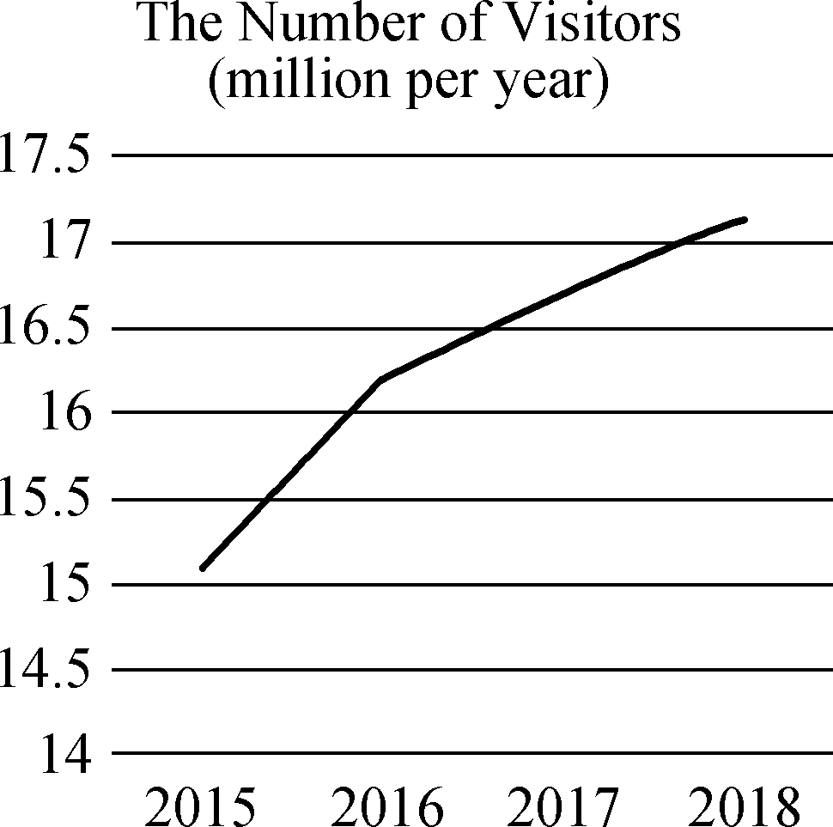
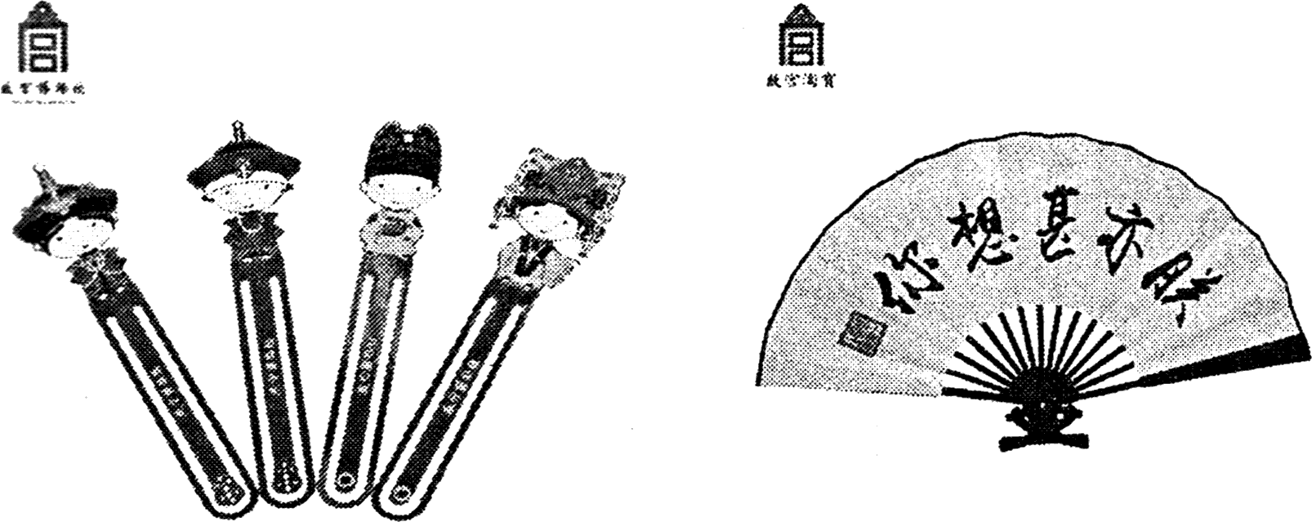
【写作内容】 1. 用约30个单词概括图表及文字的内容。2. 用约120个单词发表你的观点，内容包括：(1) 故宫推出文化创作产品的意义(不少于两点)；(2) 你想为故宫文化创作推出一款什么样的产品(右图仅供参考)并作简要说明。
【写作要求】 1. 表明个人观点，同时提供理由或论据。2. 阐述观点或提供论据时，不得直接引用原文中的句子。3. 文中不能出现真实姓名和学校名称。4. 不必写标题。
【评分标准】 内容完整，语言规范，语篇连贯，词数适当。

2019届高三模拟考试试卷(南京)
英语参考答案

听力
1～5 ACBCA 6～10 BAABC 11～15 BCBBA 16～20 CABCA
单项填空
21～25 BDAAB 26～30 CDBCC 31～35 BABCC
完形填空
36～40 BCDAC 41～45 CBADB 46～50 AADBA 51～55 DCBCD
阅读理解
56～57 BC 58～60 BAB 61～64 DDAC 65～70 ACDDAB
任务型阅读
71. similarity/similarities 72. freely/casually 73. exposed 74. top 75. owed/attributed
76. education/schooling 77. against 78. marrying 79. harder 80. means/matters
书面表达
One possible version：
The Palace Museum has witnessed a sharp rise in the sales of its cultural and creative products. Meanwhile, the number of visitors has increased dramatically in the past few years as well.
The benefits we enjoy from promoting cultural products far exceed our imagination. Firstly, these inventive art works function as ambassadors to spread our splendid culture, extending Chinese cultural influence and building up our cultural confidence. In addition, profits gained from the sales of artistic souvenirs can be spent on the restoration of cultural relics and the organization of educational activities, which in turn will attract more visitors.
To jump on the bandwagon of promoting Chinese culture, I will design a set of bookmarks with images of palaces or emperors on them. It not only is of practical use but also serves as a reminder of sweet memories at the Palace Museum. I hope my design will be a useful addition to those cultural and creative art works.

