北京大学附属中学2018-2019学年下高三第三次质量评估
英语 2019.5.17
注意事项：
1．答卷前，考生务必用黑色字迹的钢笔或签字笔在答题卡上填写自己的准考证号、姓名、试室号和座位号。用2B型铅笔把答题卡上试室号、座位号对应的信息点涂黑。
2．选择题每小题选出答案后，用2B型铅笔把答题卡上对应题目选项的答案信息点涂黑，如需改动，用橡皮擦干净后，再选涂其他答案，答案不能答在试卷上。
3．非选择题必须用黑色字迹钢笔或签字笔作答，答案必须写在答题卡各题目指定区域内的相应位置上；如需改动，先划掉原来的答案，然后再写上新的答案；不准使用铅笔和涂改液。不按以上要求作答的答案无效。
4．考生必须保持答题卡整洁。考试结束后，将试卷和答题卡一并交回。

第一部分：知识运用（共两节，45分）
第一节 语法填空（共10小题；每小题1.5分, 共15分）
阅读下列短文，根据短文内容填空。在未给提示词的空白处仅填写 1个适当的单词，在给出提示词的空白处用括号内所给词的正确形式填空。
Many high school students in the United States get training in construction skills by building real houses. The project _1__________ (run) by the Waterloo Career Center. The center offers students different programs designed _2__________ (prepare) them for careers in technical fields.
Students from the Waterloo Community School District _3__________ (recent) took part in construction training that centered on the skill of masonry (砖石建筑) -- work done with stone, brick or concrete materials. The students spent five days at their school learning _4__________experienced workers from the Masonry Institute of Iowa, a _5__________ (profession) organization. The workers taught the students _6______to mix mortar (灰浆) and build walls with bricks and blocks. The students moved the mortar onto _7__________ (piece) of wood and then added bricks and blocks to form walls.
Chris Busch helped oversee the students’ efforts. As the students worked, Busch _8__________ (offer) them an important piece of advice. He told the students to be sure to use a leveling tool to check that the wall stands straight and level. West High student Nathan Elliott told the Waterloo-Cedar Falls Courier newspaper that this kind of learning was much better _9__________ sitting at a computer. Other students also said it got them _10 __________ (excite) about future careers in construction.
- 完形填空（共 20 小题；每小题 1.5 分，共 30 分）
阅读下面短文，掌握其大意，从每题所给的 A、B、C、D 四个选项中，选出最佳选项，并在答题卡上将该项涂黑。

高三英语试卷第2页（共10页）
I used to go to the gym a lot, so when I started to get pains in my neck, I just assumed I had pulled something. But when I couldn’t __11__ my neck or look left, right, up or down, I went to the doctor and I was told that I had a rare type of cancer that __12__ the throat. It was __13__. At the time I was __14__ twenty.
Having cancer and getting __15__ influenced a lot of things. The side effects from my treatment were really bad. I couldn’t work, and I wasn’t able to go out with my friends. I would rather not go through it. _16__, the youth support volunteers encouraged me to keep going, which gave me the motivation to __17__ treatment. Besides, my family was really there to __18__ me, and it drew us __19__.
During my treatment, I __20__ new friends through Teenage Cancer Trust’s social events. They were __21__ people who had been through cancer as well. The conversation between us __22__ more easily as we had things in common. I __23__ them to stay optimistic.
As I __24__ working out, now I want to become a health __25__ to guide young people suffering from cancer. They often lose or gain a lot of weight, which can affect their _26__. So I can use my __27__ to help them get back to fitness. I lost much weight and I’m trying to __28__ it so I can be an inspiration for them. In a way, I see having cancer as a __29__ thing. It was a test for me and I am now going down a better __30__.
11. A. scratch | B. hold | C. lift | D. pull
12. A. demanded | B. injected | C. displayed | D. affected
13. A. scary | B. clumsy | C. lucky | D. exciting
14. A. also | B. still | C. only | D. even
15. A. experiment | B. treatment | C. donation | D. experience
16. A. Actually | B. Eventually | C. Fortunately | D. Gradually
17. A. focus on | B. carry on | C. take on | D. depend on
18. A. realize | B. believe | C. support | D. consult
19. A. closer | B. further | C. cleverer | D. worse
20. A. shared | B. exchanged | C. avoid | D. made
21. A. lovely | B. young | C. mature | D. smart
22. A. flowed | B. hit | C. applied | D. discussed
23. A. inspired | B. discouraged | C. warned | D. wished
24. A. admit | B. imagine | C. admire | D. love
25. A. patient | B. coach | C. minister | D. doctor
26. A. delight | B. process | C. trouble | D. health
27. A. grades | B. qualification | C. impression | D. problem
28. A. recall | B. return | C. regain | D. review
29. A. positive | B. negative | C. depressed | D. moved
30. A. role | B. concern | C. behavior | D. path
第二部分：阅读理解(共两节，40分)
第一节（共15小题；每小题2分，共30分）
阅读下列短文，从每题所给的A、B、C、D四个选项中，选出最佳选项，并在答题卡上将该项涂黑。
A
Get kids excited about reading and writing.
Enter our writing and drawing contest for a chance to win great prizes. Brought to you by Reader’s digest and Weekly Reader and noted children’s author Mary Pope Osborne(The Magic Tree House series).Prizes:
A $500 U.S. Savings Bond
A library of books (valued at $ 125)
Great LeapFrog prizes including the Tag Reading System
A certificate signed by contest judge Mary Pope Osborne
Your submissions posted on ReadersDigest. com
How to enter
Children aged 5-12 should respond in words and/or pictures to the questions, “Your favourite has jumped out of the book to spend the day with you. Tell us: What happens next?”
One winner will be chosen for each age group：
Ages 5-6：Please submit a drawing no larger than 8.5cm x11cm and an essay written in child’s own words—may be dictated to an adult – of up to 50 words. Essay must be typed or written in blue or black ink.
Ages 7-9: Please submit an essay of up to 150 words. Essay must be typed or written in blue or black ink. Drawings welcome(but optional). Must be no larger than 8.5 cm x 11cm.
Ages 10-12: Please submit an essay of up to 350 words. Essay must be typed or written in blue or black ink. Drawings welcome(but optional). Must be no larger than 8.5 cm x11cm.
Entry should be mailed along with their name, age, mailing address and e-mail address to:
Read, Write, Win! Contest
Reader’s Digest Magazine
260 Madison Avenue, 5th Floor, New York, NY 10016
All entries must be postmarked by October 31, 2016.
31.What’s the purpose of the text?
A. To persuade readers to attend the contest.
B. To give information about the contest.C. To get kids excited about reading and writing.
D. To give kids a chance to earn money.
32. Whoever wins the contest can ______.
A. gain a total of $625 in cash B. get a library of books valued at $ 500
C. see his work on ReadersDigest.com D. win a certificate to go to library
33.What’s the difference between Ages 7-9 and Ages 10-12 in request of entry?
A. The word number of the essay. B. The color of the submission.
C. The size of the submission. D. The form of the essay.
B
There are many programs for high school students today that help lonely teenagers deal with loneliness. However, loneliness is not only a problem for teens but also an important and rarely acknowledged one in the elderly.
In Britain, Tracey Crouch was appointed to be the first Minister of Loneliness in order to address the problems caused by loneliness. This is the first time such a position has been created.
In Britain, there are around 9 million people who say they are lonely frequently. In Germany, a study conducted by Ruhr University Bochum found that 20 percent of people over the age of 85 felt lonely, and 14 percent of those between age 45 and 65 felt socially lonely. In the United States, more than 25 percent of the population lives alone, more than 50 percent are unmarried.
Loneliness is generally associated with heart disease, overweight, and anxiety. Additionally, the stress from loneliness can cause your cells to change on a molecular(分子)level that reduces its abilities to defend your body against diseases. In fact, doctors believe having feelings of loneliness is equivalent to smoking 15 cigarettes per day in regard to its effect on health!
In Britain, the new Minister of Loneliness will help introduce government policies on the problem and fund a charity—an organization for helping people in need, to devote their efforts towards aiding loneliness. There are charities that link lonely seniors to high school students in order to give them a line of communication whenever they feel lonely!
The possibilities for the new Minister of Loneliness are endless. For example, she can provide education services to household businesses so that they can identify lonely customers if they see one. Loneliness fits into the category of being a social problem that must be monitored by the entire community in order to help those in need. Therefore, government involvement in medical services and care for seniors and others is vital for happy seniors.
34. How does the author develop Paragraph 3?
A. By listing some statistics．
B. By giving examples of lonely people．
C. By pointing out similarities and differences．
D. By comparing different cultures in different countries．
35. What does the underlined word “equivalent” in Paragraph 4 probably mean?
A. Relevant． B. Similar． C. Opposite． D. Superior．
36. What will the Minister of Loneliness do?
A. Do housework for lonely people．
B. Develop friendships with the elderly．
C. Help fund charities to aid lonely people．
D. Communicate with anxious school students．
37. What is the main idea of the text?
A. UK becomes the capital of loneliness．
B. Loneliness affects old people’s life worldwide.
C. Many teenagers suffer from loneliness．
D. UK’s Minister of Loneliness settles loneliness.
C
Drawing the line
In 2006, I decided to stop shopping for a year. I always used to go into stores and just buy things without thinking about it and it bothered me.
I learned from my year of no shopping. But in 2012, I noticed I had replaced this addiction with another-buying useless things on the internet. I would look at pictures of nice things on websites, and before I knew it, I would have wasted an hour looking at and sometimes buying things I didn’t need. So I stopped shopping again. This time, instead of buying the things I wanted, I drew them on the paper.
It was exciting to realize that there is nothing wrong with liking beautiful things. In fact, it’s hard not to like beautiful things in a world that’s filled with them, in a world that’s good at showing you the kind of beautiful thing you most want, and in a world where people try to make you want beautiful things. Why did I feel bad about wanting to shop?
At the same time, I was beginning to learn of fast fashion’s effects on the world. Besides all the money I was spending, I thought of the damage that was being done to the environment, as well as all the hard work that people do to the things I buy. Just by looking at a pretty dress in a window, I somehow felt part of all this.
Drawing the things I want makes me feel less guilty and doesn’t make me want to buy things that I don’t need any longer. But you don’t have to draw the things you want to stop you from buying them. It also works to take some time to stop and think about why you want that shiny new thing.
38. The author stopped shopping again because_______.
A. she had become addicted to buying things online
B. she was bothered that she was spending too much
C. she wasted too much time comparing online goods
D. she spent too much time looking in stores
39.What can we learn from paragraph 3?
A. It’s natural to love things.
B. She should feel guilty of loving beautiful things.
C. If more people stopped shopping, less will be produced.D. Producers are taking advantage of her desire for beautiful things.
40.In the last paragraph, the author suggests we should________.
A. not feel guilty about shopping
B. talk about the things we want to buy
C. reflect on what causes our desire to buy something
D. think of the harmful effects on the environment before we buy anything
41. What is the main purpose of the article?
A. To show how much shopping addiction costs.
B. To explain the damage shopping does to the planet.
C. To share the author’s story of why she stopped shopping.
D. To explain why people should feel guilty about wanting to shop.
D
What would it be like to be able to remember anything you ever learned? Would it be blessing or a curse?
Since the early 20th century, psychologists have identified countless cases of people with super memories that allow them to lean and retain (保持) new information with total accuracy. The most famous was Solomon Sherashevski, the subject of Alexander Luria’s classic book, The Mind of a Mnemonist (记忆大师).
Sherashevski could recall an amazing number of facts due to his talent for eidetic imagery(照相式记忆)，which allowed him to recall sights, sounds, smells etc. Sadly enough, he seemed to have significant difficulty living a normal life due to his inability to forget anything he learned and the continual daydreaming caused by his constant recall.
There are certainly other mnemonists, whose memory feats (功绩) are also surprisingly impressive. Strangely enough though, research suggests these professional mnemonists are no better than average peoples peaking of remembering events out of their own lives. iou
But there are also people whose memories seem to work differently. They are able to recall almost every moment of their lives even the early childhood, a condition commonly called hyperthymesia (超忆症).
Unlike mnemonists, people with hyperthymesia don’t rely on any techniques to memorize, it seems to happen automatically. While no former studies have found the reasons, a recent laboratory test shows they aren’t any better than average people in terms of learning new information.
Recently Neuropsychology presents a study of a 63-year-old man identified as “MM”: He didn’t realize his memory skills until 29 when he found he could recall events from American history with amazing accuracy. Despite his superior memory, his life seemed completely unaffected. He did poorly in school, no friends at all. Besides, though his recall resembled that of people with hyperthymesia, his memories weren’t quite as vivid.
So far there isn’t enough information to make any real conclusions about the super memory. However, as new studies become available, we are sure to learn about what makes these brains so unusual.
42. What made it difficult for Sherashevski to live a normal life?
A. His poor social skills.
B. His great interest in history.
C. His early childhood experience.
D. His inability to forget things.
43. People with hyperthymesia differ from mnemonists in that .
A. they remember things without intention.
B. they count on techniques to memorize
C. they are better at learning new information
D. they can’t recall as vividly as mnemonists
44. What can be learned from the passage?
A. Former studies have found the roots for unusual memory.
B. Super memory contributes to better academic performance.
C. MM’s life has been greatly improved by his memory.
D. It’s hard to tell whether super memory is good or not.
45. Where is the passage probably taken from?
A. A book review.
B. A popular science magazine.
C. A public speech.
D. A report on mental health.
第二节（共5小题；每小题2分，共10分）
根据短文内容，从短文后的七个选项中选出能填入空白处的最佳选项。选项中有两项为多余选项。
Since the 1980s eco-tourism has grown and grown. It is the fastest growing type of tourism.
If done well, eco-tourism has several advantages. It is kinder to the environment. 46 .This means that more natural habitat is protected and that the resources for building come from sustainable (可持续的) sources．Another advantage is that people in the developed world through eco-tourism get to experience places of great natural importance as well as communicating with local people. 47 .
However, there are some disadvantages of eco-tourism. It is felt by some environmentalists that any human activity will cause disorder in the routine of animals. 48 .
Another problem for local people is that they are expected to pose for cameras and dance etc. for money. 49 .The tourists are destroying the culture that they are paying to protect.
Eco-tourism tries to go to the places far away from other communities. 50 .There is nothing stopping people taking money from tourists as well as doing environmentally unfriendly activities.
It seems that the disadvantages often outweigh the advantages of eco-tourism. It might be better to take pictures of animals rather than kill animals, but given the choice the animals would sooner not have people around. It seems whether eco-tourism should be allowed should be judged case-by-case, and that the local people must be considered.
A. These places are often not well policed.
B. People walking through the forest may do much harm.
C. And these activities will also damage the eco-system.
D. It seldom ends people to untouched parts of the world.
E. This is good for both parties: they both can better understand each other.
F. And it encourages developers to consider the natural environment more.
G. It discourages the local people from pursuing their traditional life styles.

第三部分：书面表达(共两节，35分)
第一节（15分）
假设你叫李华，听闻《中国日报》（China Daily）为了宣传中国传统文化，正在招募志愿者向海外介绍中国著名历史文化景点（historical and cultural attractions），你很想参加本次宣传活动，请你就此给报社写一封英文自荐信，内容包括：
1. 写信目的；
2. 自荐理由（如你的相关技能和经历）；
3. 申请参与。
注意：1.字数100左右；2.可适当增加细节以使行文连贯。

Dear Sir/Madam,

Yours,
Li Hua
第二节（20分）
假设你是红星中学高三学生李华。请根据以下四幅图的先后顺序，给校刊“英语角”写一篇英文稿件，介绍你们班上个月参加学校“汉语成语大赛”的全过程。
注意：词数不少于60。
提示词：汉语成语大赛 Chinese Idioms Competition

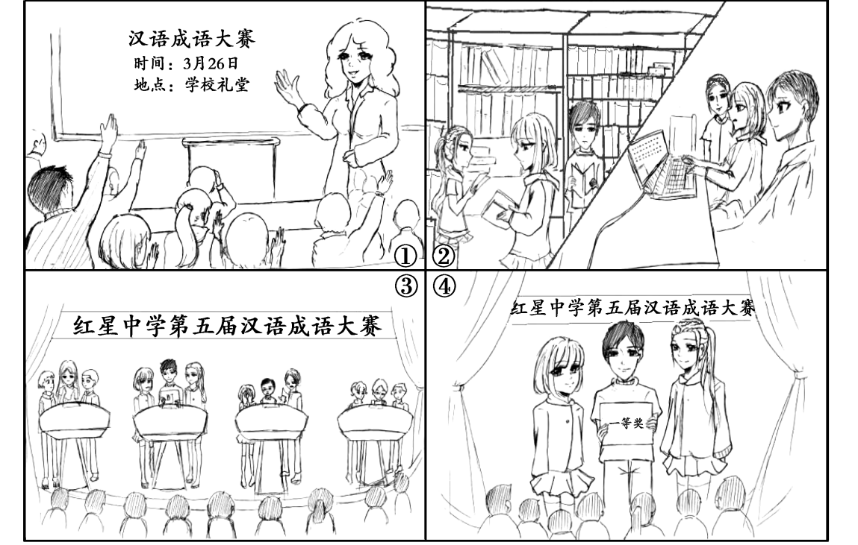
（请务必将作文写在答题卡指定区域内）
北京大学附属中学2018-2019学年下高三第三次质量评估
英语参考答案
第一部分
1. is run 2. to prepare 3. recently 4. from 5. professional
6. how 7. pieces 8. offered 9. than 10. excited
11-15 CDACB 16-20 CBCAD 21-25 BAADB 26-30 DBCAD
第二部分
第一节：阅读理解
31—33 BCA 34—37 ABCD 38—41 DDCA 42—45DADB
第二节（七选五） 46—50 AEBGF
第三部分
第一节（15分）
Dear Sir/Madam，
I’m Li Hua, a high school student. I’m so excited to hear that China Daily is in need of some volunteers to introduce Chinese culture overseas that I can’t wait to sign up at the first time.
First of all, I have been to numerous famous scenic spots, and developed an outgoing and open-minded personality, which makes it easy for me to get along well with others. Secondly, my hometown is a famous historical and cultural city. On holidays, I often act as a volunteer tour guide to show foreign tourists around and introduce them Chinese history and culture, from which I’ve gained relevant experience. Last but not least, it is worth mentioning that I got 7 points in IELTS early this year, which guaranteed my fluent expressing and effective communication with foreigners. So, I firmly believe that I’m the very person you’re looking for.
Give me a chance and I’ll try my best. Your prompt response will be appreciated.
Yours,
Li Hua
第二节（20分）
Last month, I with two of my classmates took part in the Fifth Chinese Idioms Competition of our school.
A few days before the competition, our head teacher announced the competition would be held in the school hall on March 26th. Two of my classmates and I were chosen as the competitors on behalf of our class. In the following days, we three spent all our spare time in the library, enriching our knowledge of Chinese idioms with the help of books, dictionaries and the internet. When the big day came, we were full of confidence and did an excellent job. After several rounds of fierce competition, we beat the other competitors and won the first prize. Standing on the stage with our certificate, we felt really proud of ourselves.
From this event, not only did we experience the great charm of Chinese idioms but also we learned to be confident and calm while facing challenges.

