学科教师辅导讲义
学生姓名 |  | 性别 |  | 年级 |  | 学科
授课教师 |  | 上课时间 | 年 月 日 |  | 第（ ）次课  共（ ）次课 |  | 课时：2课时
教学课题 | 人教版高一英语必修1 Unit 4 Earthquake 同步教案（2）
教学目标 | 知识目标：1.掌握定语从句  2.掌握记叙文基本写作  能力目标：掌握定语从句关系词的选择  情感态度价值观：熟悉地震灾难发生时必要性的措施，掌握地震常识
教学重点与难点 | 重点：熟练掌握现在进行时表示将来的用法。  难点：旅行日记基础写作
教学过程
- 语法：定语从句（1）
知识梳理
- 定语从句
在复合句中，修饰某一名词或代词，或修饰整个主句的从句叫做定语从句。它的作用相当于形容词。被定语从句修饰的名词或代词叫做先行词，引导定语从句的词叫做关系词，有关系代词who，whom，whose，which，that，as和关系副词when，where，why。关系词既联系定语从句和它的先行词，同时又充当定语从句中的一个成分(主语、宾语、介词宾语、定语、状语或表语)。[来源:学|科|网]

- that，which，who，whose, 引导定语从句
 | 关系代词 |  | 在从句中所作的成分 | 指代 | 例句
 | that |  | 主语，宾语，表语  (作宾语和表语时可省略) | 指物 | (1)A letter that is written in pencil is difficult to read.(主语)  (2)The trees(that)we planted grow well.(宾语)  (3)Hong Kong is not the city (that)it used to be.(表语)
 |  |  | 主语，宾语，表语  (作宾语和表语时可省略) | 指人 | (1)The passengers that were injured were sent to the nearest hospital .(主语)  (2)The doctor (that)we sent for arrived very soon.(宾语)  (3)Kate is no longer the girl (that)she was.(表语)
which |  |  | 主语、宾语(作宾语时可省略) | 指物[来源:学科网ZXXK] | (1)People will never forget the accident which happened here last year.(主语)  (2)The letter(which)I received yesterday was from my sister.( 宾语)
 |  | who | 主语，宾语(介词不前置时可作介宾)(作宾语时可省略) | 指人 | (1)A friend who helps you in time of need is a real friend.(主语)  (2)The boy (who)you saw sleeping in class is named Li Ming.(宾语)  (3)I know the boy (who)you talked to just now.(介宾)

whose | 定语 | 指人 | The girl whose work got the prize is the youngest in the class.(定语)
whose | 定语 | 指物 | At last we chose a room whose window faced south.(定语)

三、关系代词的选用[来源:Z&xx&k.Com]
1.指物时必须用that而不用which的情况：
(1)先行词是all，everything，anything，nothing，something，much，little，few，none，the one等不定代词时。
We should hand in all that, we have.
- 先行词前面有all，every，no，some，any，little，much，few，none，the only，the very，the same，the last以及序数词、形容词最高级等修饰词时。
This is the only, thing that, we can do.
It's the best, film that ,has been made on the subject.
(3)先行词是两个或两个以上分别表示人和物的并列名词或词组时。
We talked about the things and persons that, we saw and met during the trip.
(4)先行词是主句的表语时。
Tom is no longer the boy that, he used to be.
(5)主句以there be开头时。
There is, not much that, we can help.
(6)主句是以who，which开头的疑问句时。
Who ,is the man that, told you the news?
Who, is the man that, you spoke to?
Which ,is the cap that, you have decided to buy?

2．指物时必须用which而不用that的情况：
(1)在从句中作介词宾语而介词又前置时。
The floor is dirty but I haven't got a brush with which, I can sweep it.
(2)引导非限制性定语从句时。
Football，which ,is a very interesting game，is played all over the world.

3．指人时必须用who而不用that的情况：
先行词是one，ones，those，anyone，he时。
Those who, want to go for a walk please follow me.
He who, lives a more active life gets more time.

4．在从句中作宾语时只能用whom而不用who的情况：[来源:学_科_网Z_X_X_K]
在从句中作介词宾语而介词又前置时。
I like the villagers with whom, I worked in those years.

5．whose 表示所有关系，常用of which/whom短语代替：
whose＝the＋名词＋of＋which/whom
I want a room whose ,window faces south.＝I want a room the window of which ,faces south.
►典例剖析
【例】 The journey around the world took the old sailor nine months，________ the sailing time was 226 days.
A．of which B．during which C．from which D．for which
【解定语从句的关键步骤】：
1．找出被定语从句所修饰、限制的主句。
2．确定主句中(一般情况是这样)受定语从句修饰、限定的先行词。
3．从定语从句着手分析，准确找出定语从句中所缺句子成分，确定适合的关系词，即关系代词或关系副词。

巩固训练
一、从that，which，whose，who，whom中选择恰当的词填入下列句子中
1．Do you still remember the chicken farm ________ we visit three months ago?
2．People in Tangshan were struck by a big earthquake，from ________ effects the people are still suffering.
3．Women ________ drink more than two cups of coffee a day have a great chance of having heart disease.
4．I like the second book ________ I read in the summer holiday.
5．I returned his English book to him just now, ____________ was borrowed last week.

答案：1. which/that 2.whose 3.who/that 4.that 5.which
二、把下列句子改写成定语从句
1．I have a friend.He likes listening to classical music.
________________________________________________________________________
2．Yesterday Emily was wearing the new dress.I gave it to her.
________________________________________________________________________
3．The student's article was published.I know the student.
________________________________________________________________________源:学.科.网]
4．Betty is studying English very well.She has never been abroad.
________________________________________________________________________
5．My grandparents live in a house.It is more than 100 years old.
________________________________________________________________________

答案：1. I have a friend who likes listening to classical music.
2. Yesterday Emily was wearing the new dress that/which I gave her.
3. I know the student whose article was published.
4. Betty, who has never been abroad, is studying English very well.
5.My grandparents live in a house, which is more than 100 years old.

（二）单元写作任务——如何写一篇新闻报道
新闻报道的特点：
1．主题突出。通常有比较固定的写作格式，如文首通常有报道的地点或时间，第一句话常常是文章的导语，是对整篇文章的高度概括。通过这句话我们可以了解文章的大致内容和主题。
2．标题醒目。好的标题能使读者在最短的时间内了解新闻的主要内容，引起阅读兴趣。
3．正文简洁生动。避免使用被动语态，抓住一些显著的细节进行深入描写，语法要正确，准确选取动词及时态等。
4．格式通常采用经典的“倒金字塔”格式，由三个部分构成，即标题(title)、导语(leadin)和正文(body)。

新闻报道的格式：
先把你要写的事情概括一下，越简单越好。
接着把你概括的事件拓展一下，也就是写what is this about。然后写5w＋h，也就是what，who，when，where，why还有how。最后就是conclusion。
常用表达：
be determined to/make up one's mind to do...
make contributions to...
I would like to express...
pick up one's courage
No words are strong enough to express our...

【范文演练】
请根据下面的内容写一篇5句话作文。
高二(3)班的学生志愿者Li Yue 和 Zhang Hua开展了一次志愿者活动。假如你是校英语报的记者，请按下列要点用英语写一则新闻报道。
时间：2月1日
地点：阳光敬老院(Sunshine Nursing Home)
活动过程：
1．到达时受到欢迎；2．赠送鲜花和水果；3．帮助老人打扫卫生；4．坐在院子里与老人聊天。
老人们的反应：激动并感谢，并说他们将永远记住这美好的一天。
简短评论：Li Yue 和 Zhang Hua很高兴，因为……
写作内容：
1．时间、地点、任务、活动； 2．老人们的反应； 3．简短评论。
写作要求：
1．只能使用5个句子表达全部内容；2．文中不能出现真实姓名和学校名称。
写作内容：
1．时间、地点、任务、活动； 2．老人们的反应； 3．简短评论。
写作要求：
- 只能使用5个句子表达全部内容；2．文中不能出现真实姓名和学校名称。

Student Volunteers Brought Sunshine to the Elderly

______________________________________________________________________________________________
______________________________________________________________________________________________
______________________________________________________________________________________________
______________________________________________________________________________________________
______________________________________________________________________________________________
______________________________________________________________________________________________
______________________________________________________________________________________________
______________________________________________________________________________________________
_____________________________________________________________________________________________
______________________________________________________________________________________________
______________________________________________________________________________________________

By Chen Jie，School Newspaper
参考答案：
Student Volunteers Brought Sunshine to the Elderly
On February 1，it was Li Yue and Zhang Hua，students from Class Three，Grade Two，that went to Sunshine Nursing Home and did some voluntary work.On arrival，they were warmly welcomed，and respectfully，they presented the elderly with flowers and fruits.After cleaning the house，they sat in the yard chatting with the elderly people happily.
The elderly were grateful and thankful for their kindness，saying it was such a beautiful day that they would remember it forever.Li Yue and Zhang Hua are very happy because what they did has not only brought joy to others but also enriched their own lives.
By Chen Jie，School Newspaper
►即学即练
目前，家长开车接送孩子上下学已成为一个普遍现象，人们对此做法褒贬不一。下图是就此现象所做的问卷调查的结果。结果表明，支持者和反对者各占一半。请从中选一种你支持的观点，用英语描述关于这个观点的调查结果，并说明你支持的理由。
注意：1. 词数100～120。 2. 文章的开头已经给出，不计入总词数。
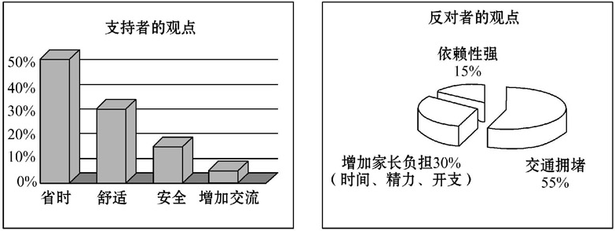

Nowadays it’s common for parents to drive their children to and from school. Recently a survey has been done on the issue. Half of the people surveyed _________________________________________________________________
______________________________________________________________________________________________________________________________________________________________________________________________
_____________________________________________________________________________________________
____________________________________________________________________________________________
____________________________________________________________________________________________
____________________________________________________________________________________________
____________________________________________________________________________________________
____________________________________________________________________________________________
____________________________________________________________________________________________
____________________________________________________________________________________________
____________________________________________________________________________________________
____________________________________________________________________________________________
____________________________________________________________________________________________
____________________________________________________________________________________________
____________________________________________________________________________________________
____________________________________________________________________________________________
____________________________________________________________________________________________

Key:
Nowadays it’s common for parents to drive their children to and from school. Recently a survey has been done on the issue. Half of the people surveyed are in favor of the practice. Among them, more than 50% of people believe that driving children to and from school saves time. About 30% of people think it comfortable to go by car. About 15% of people consider it a good choice just for the sake of children’s safety. Still others think it offers more chances for parents to communicate with their children.
Personally, I like the idea of driving children to and from school. The children may have more sleep time by getting up a bit later. Also, more and more families own private cars. The parents tend to drive to work. It would save a lot of trouble for children if they give their children a ride on their way to and from work.

课后作业
一、翻译下列句子，然后使用定语从句将两个句子合并成一句
1．他住在一个小村庄。小村庄离学校大约有3公里。
________________________________________________________________________
________________________________________________________________________
________________________________________________________________________
2．这个城市叫唐山。1976年，那里发生了大地震。
________________________________________________________________________
________________________________________________________________________
________________________________________________________________________来源:Z#xx#k.Com]
3．人们被解放军救起。他们的房子在地震中都毁了。
________________________________________________________________________
________________________________________________________________________
________________________________________________________________________
4．我认识那个学生。他昨天在马路上和你讲话。
________________________________________________________________________
________________________________________________________________________
________________________________________________________________________[来源:学科网]

二、写作
针对城市街道上出现的越来越多的宠物，21st Century Teens向你约稿，请你谈谈你校学生对“城市内是否可以饲养宠物”的看法。经过详细的问卷调查，你发现同学们对此态度泾渭分明：支持饲养宠物者认为宠物可以陪伴孤寡、空巢老人，可以……等；反对饲养动物者认为饲养宠物花费不菲，……
根据以上提示的部分问卷信息，请你适当增加信息内容，撰文介绍同学们的看法，并对此做出简要评论。
注意：1. 词数：100～120。开头已给出，不计入总词数。 2. 内容丰富，行文连贯。
Recently we have carried out a detailed survey of whether people should keep pets in cities, _______________
____________________________________________________________________________________________
____________________________________________________________________________________________
____________________________________________________________________________________________
____________________________________________________________________________________________
____________________________________________________________________________________________
____________________________________________________________________________________________
____________________________________________________________________________________________
____________________________________________________________________________________________
____________________________________________________________________________________________
____________________________________________________________________________________________
____________________________________________________________________________________________
____________________________________________________________________________________________
- 阅读理解
Camping wild is a wonderful way to experience the natural world and，at its best，it makes little environmental influence.But with increasing numbers of people wanting to escape into the wilderness，it is becoming more and more important to camp unobtrusively and leave no mark.
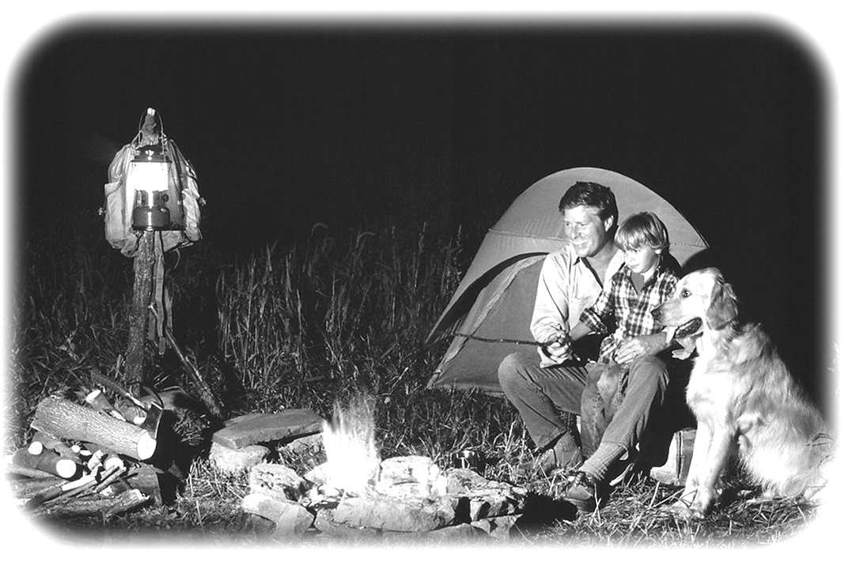
Wild camping is not permitted in many places，particularly in crowded lowland Britain.Wherever you are，find out about organizations responsible for managing wild spaces，and contact them to find out their policy on camping and shelter building.For example，it is fine to camp wild in remote parts of Scotland，but in England you must ask the landowner's permission，except in national parks.
Camping is about having relaxation，sleeping outdoors，experiencing bad weather，and making things without modern conveniences.A busy，fullyequipped campsite (野营地) seems to go against this，so seek out smaller，more remote places with easy access to open spaces and perhaps beaches.Better still，find a campsite with no road access：walking in makes a real adventure.
Finding the right spot to camp is the first step to guaranteeing a good night's sleep.Choose a campsite with privacy and minimum influence on others and the environment.Try to use an area where people have obviously camped before rather than creating a new spot.When camping in woodland，avoid standing by a dead tree，which may fall on a windy night.Avoid animal runs and caves，and possible homes of biting insect.Make sure you have most protection on the windward side.If you make a fire，do so downwind of your shelter.Always consider what influence you might have on the natural world.Avoid damaging plants.A good campsite is found，not made—changing it should be unnecessary.
1．You needn't ask for permission when camping in ________.
A．national parks in England B．most parts of Scotland
C．crowded lowland Britain D．most parts of England
2．What does the underlined word “unobtrusively”in parogroph 1 probably mean?
A.Unofficially. B.Unattractively. C.Unnoticeably. D.Uncomfortably.
3．The author thinks that a good campsite is one____________.
A．with easy access B．used previously C．with modern conveniences D．far away from beaches
4．The last paragraph mainly deals with ________.
A．protecting animals B．building a campfire C．camping in woodland D．finding a campsite with privacy
5．The passage is mainly about ________.
A．the protection of campsites B．the importance of wild camping
C．the human influence on campsites D．the dos and don'ts of wild camping

课后作业答案
一、1. He lives in a small village.
It is about 3 kilometers away from their school.
He lives in a small village which is 3 kilometers away from their school.
2. The city is called Tangshan.
A powerful earthquake took place there in 1976.
In 1976 a powerful earthquake took place in the city which is called Tangshan.[
3. People were rescued by the soldiers.
Their houses were destroyed in the earthquake.
The people whose houses were destroyed in the earthquake were rescued by the soldiers.
4. I know the student.
He talked with you on the street yesterday.
I know the student who talked with you on the street yesterday.

二、 Recently we have carried out a detailed survey of whether people should keep pets in cities，which shows we students hold entirely different ideas.
Some students think it’s a good idea to keep pets because unaccompanied old people can get some comfort from pets. Besides, getting along well with animals will make our life interesting. On the contrary, the other students are against the idea. In their opinion, raising pets costs a large amount of money and it is bad for the environment. What is worse, pets may make too much noise disturbing the neighbors and even attack people sometimes.
I like animals and I find it amazing to bond with pets such as dogs. I don’t think it is bad to keep pets at home. But we must take some measures to prevent them from polluting our environment or causing other troubles.

三、ACBCD

