2018年高考及最新模拟分类汇编之书面表达
2018年高考书面表达
【2018·全国I】假定你是李华，你的新西兰朋友Terry将去中国朋友家做客，发邮件向你询问有关习俗。请你回复邮件。内容包括：
(1).到达时间；
(2).合适的礼物；
【答案】略
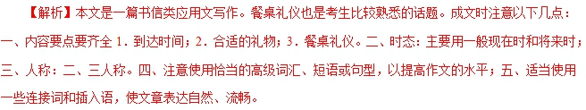
点睛：本文虽然看起来比较容易，但学生真正动起笔来，还是比较困惑的。原因为：1.看起来中国餐桌礼仪很熟悉，但内容很多，一时间不知道该写什么；2.100单词左右，写出到达时间；合适的礼物；餐桌礼仪三个内容，信息量大，选择有困难；
应对方法：近年来高考写作的命题常用的思想就是高起点低落点。高起点题目很高，中国文化，中国故事，中国礼仪等等，但最终都把它们落在应用文的框架里，这就是低落点。写这样的作文，一定要注意不能写过于具体的内容，要找最重要的，最熟悉的写，不要面面俱到，中国餐桌礼仪内容太多，100单词无法写。找重点，以点带面。但选择重要内容本身就是一种能力。
【2018·全国II】你受学生会委托为校宣传栏“英语天地”写一则通知，请大家观看一部英语短片Growing Together，内容包括：
(1)短片内容：学校的发展；
(2)放映时间、地点；
(3)欢迎对短片提出意见。
注意：
(1)词数100左右；
(2)可以适当增加细节，以使行文连贯。
【答案】略
【解析】英语书面通知的时态应该以一般将来时为主，多使用被动语态、简单句。在通知中不应当过度的使用较复杂的词语和读起来拗口的句子。
第二个注意点：层次一定要清晰，一个层次要表达一件事情，使人看起来一目了然。
【2018·全国III】假定你是李华，你的英国朋友Peter 来信询问你校学生体育运动情况。请给他回信，内容包括：
1. 学校的体育场馆；
2. 主要的运动项目；
3. 你喜欢的项目。
注意：1. 词数100左右：
2. 可以适当增加细节，以使行文连贯。
____________________________________________________________________________________________
____________________________________________________________________________________________
____________________________________________________________________________________________
____________________________________________________________________________________________
____________________________________________________________________________________________
__________________________________________________________
【答案】Dear Peter,
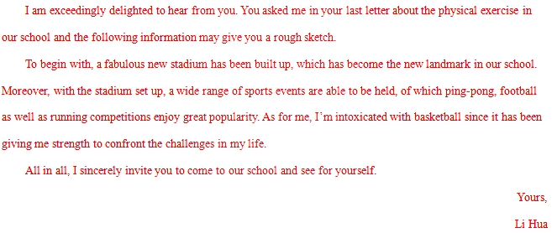
【解析】本题作文为提纲式作文，形式依然是书信，即给英国朋友Peter介绍学校体育运动情况，属于学校生活话题。这一话题贴合学生生活的实际，学生并不陌生，有话可说。
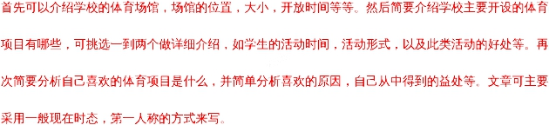
【2018·北京】假设你是红星中学高三学生李华，你的英国朋友Jim在给你的邮件中提到他对中国文化感兴趣，计划明年来北京上大学。他向你咨询相关信息。请给他回邮件，内容包括：
(1) 表示欢迎；
(2) 推荐他上哪所大学；
(3) 建议他做哪些准备工作。
注意：(1). 词数不少于50；
(2). 开头和结尾已给出，不计入总词数。
Dear Jim,
____________________________________________________________________________________________________________________________________________________________________________________________________________________________________________________________________________________________________________________________________________________________________________________________________________________________________________________________________________
____________________________________________________________________________________________
Yours,
Li Hua
【答案】Dear Jim,
I’m so glad to hear your future education plan in Beijing in your last letter. First I would like to express my warmest welcome to you and I am sure you will have the most unforgettable experience during your college in Beijing.
Learning your keen interest in Chinese culture, I suggest you apply for Peking University, one of the best universities in China. Its Chinese Literature major is perfect for you where you can be completely soaked in Chinese profound history and rich culture. As for preparation, some reading in advance in needed like The Story of the Stone while some online courses of spoken Chinese can be helpful for you to adapt into the Chinese language environment.
I sincerely hope your dream will come true and it’s my pleasure to show you around in Beijing when that day comes. If you have further questions, please feel free to let me know.
Yours,
Li Hua
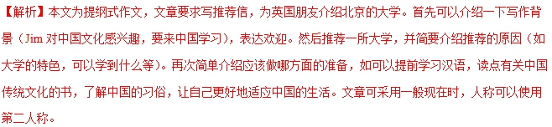亮点说明：文章中巧妙使用非谓语Learning your keen interest in Chinese culture, 使句子结构紧凑。
使用定语从句Its Chinese Literature major is perfect for you where you can be completely soaked in Chinese profound history and rich culture. 使句子表达更完美；巧妙使用连接词while引出来中国前的准备，使句子结构对称。
(请务必将作文写在答题卡指定区域内)
第二节
57. 假设你是红星中学高三学生李华，请根据以下四幅图的先后顺序，写一篇英文周记，记述你们上周接待外国学生，带领他们体验中国茶文化的全过程。
注意：词数不少于60。
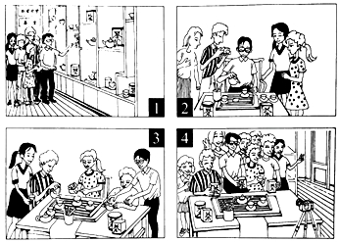
(请务必将作文写在答题卡指定区域内)
【答案】Last week, we took the foreign students in our school to experience the authentic tea culture, which turned out be to extremely rewarding.
On arriving at the tea house, the foreign students were impressed by the unique tea pots and tea cups. I gave them a vivid and informative introduction of tea culture, including its profound history, its rich variety, and the exquisite craftsmanship of making tea with their interest greatly sparked, I then began to teach them how to make tea.
In order to deliver a clear presentation, I slowly explained the traditional procedure of making tea in detail. Absorbed in every move of mine, the foreign students were once again amazed by this unique culture and they couldn’t help taking pictures from time to time.
Next came the moment when I asked them to have a try themselves. Washing the tea pots, adding tea leaves, and pouring water into the cups, they followed my instructions and were really immersed in charming tea culture. The tea house witnessed a really enjoyable time for all of us.
At the end of the activity, holding the tea bags in our hands, we took a picture to memorize the unforgettable day. It suddenly hit me that traditional culture like tea culture was of great charm and huge value. And I swelled with pride to spread our own culture to people all over the world.
【解析】本文为图片介绍类作文，这类作文是根据给出的一幅或几幅图画所提供的信息写短文。此类题的体裁较广泛，可以是记叙文、说明文，也可以是议论文。按照本文的要求可知，是写一篇记叙文。
1. 认真读图，把握中心。
根据提示可知，内容是带领外国学生体验中国茶文化的全过程，介绍了茶具，泡茶，沏茶，品茶的过程，所以这是这组图画所要表达的中心。
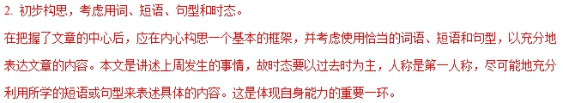 3. 连词成句，然后再连句成文。
运用适当的单词或短语正确表达各图的意思。然后再将各图的单个句子串连起来。
串连时，要注意使用适当的连接词语或过渡性语句，不至于让读者觉得文章中出现跳跃现象，更使上下文更为紧凑、自然。
4. 反复审核，修改错误。
一篇文章写好后，应进行检查，看短文中是否有错，如拼写、用词、时态、语态及表达方面的错误。
5. 宜详则详，该略则略。
对于一些细节方面的内容，如果是文章必不可少的，在写作过程中是不可将其忽略的。
如果是可有可无的细节，则可视具体情况进行增删。据此，我们在读图时一定要注意阅读各图中的一些细节内容，看其是否影响文章的内容。
亮点说明：
巧妙使用定语从句，提升了文章档次：Last week, we took the foreign students in our school to experience the authentic tea culture, which turned out be to extremely rewarding.
使用非谓语动词，使句子表达更简洁：
On arriving at the tea house…
I gave them a vivid and informative introduction of tea culture, including its profound history, its rich variety,
Absorbed in every move of mine, the foreign students were once again amazed by this unique culture
holding the tea bags in our hands, we took a picture to memorize the unforgettable day.
使用倒装句突出重点。
Next came the moment when I asked them to have a try themselves.
使用it做形式主语，使表达更地道。
It suddenly hit me that traditional culture like tea culture was of great charm and huge value.
【2018·浙江】写作
第一节 应用文写作
66. 假定你是李华，你校英语协会招聘志愿者，接待来访的国外中学生。请你写信应聘，内容包括：
（1）. 口语能力：
（2）. 相关经验；
（3）. 应聘目的。
注意：
（1）. 词数80左右；
（2）. 可以适当增加细节，以使行文连贯。
【答案】略
【解析】本篇书面表达属于应用文，要求写应聘信。
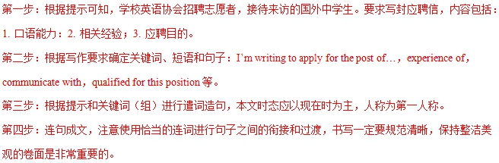第二节 读后续写
阅读下面短文，根据所给情节进行续写，使之构成一个完整的故事。
67. It was summer, and my dad wanted to treat me to a vacation like never before. He decided to take me on a trip to the Wild West.
We took a plane to Albuquerque, a big city in the state of New Mexico. We reached Albuquerque in the late afternoon. Uncle Paul, my dad’s friend, picked us up from the airport and drove us up to his farm in Pecos.
His wife Tina cooked us a delicious dinner and we got to know his sons Ryan and Kyle. My dad and I spent the night in the guestroom of the farm house listening to the frogs and water rolling down the river nearby. Very early in the morning, Uncle Paul woke us up to have breakfast. "The day starts at dawn on my farm," he said. After breakfast, I went to help Aunt Tina feed the chickens. while my dad went with Uncle Paul to take the sheep out to graze(吃草). I was impressed to see my dad and Uncle Paul riding horses. They looked really cool.
In the afternoon, I asked Uncle Paul if I could take a hose ride, and he said yes, as long as my dad went with me. I wasn’t going to take a horse ride by myself anyway. So, my dad and I put on our new cowboy hats, got on our horses, and headed slowly towards the mountains. "Don’t be late for supper," Uncle Paul cried, "and keep to the track so that you don’t get lost!" "OK! " my dad cried back. After a while Uncle Paul and his fam house were out of sight. It was so peaceful and quiet and the colors of the brown rocks, the deep green pine trees, and the late afternoon sun mixed to create a magic scene. It looked like a beautiful woven(编织的）blanket spread out upon the ground just for us.
Suddenly a little rabbit jumped out in front of my horse.
注意：
（1）所续写短文的词数应为l50左右；
（2）至少使用5个短文中标有下划线的关键词语：
（3）续写部分分为两段，每段的开头语已为你写好；
（4）续写完成后，请用下划线标出你所使用的关键词语。

Paragraph 1: Suddenly a little rabbit jumped out in front of my horse. ____________
________________________________________________________________________
________________________________________________________________________
________________________________________________________________________
________________________________________________________________________
________________________________________________________________________
Paragraph 2: We had no idea where we were and it was getting dark. _____________
________________________________________________________________________
________________________________________________________________________
________________________________________________________________________
________________________________________________________________________
________________________________________________________________________
【答案】略
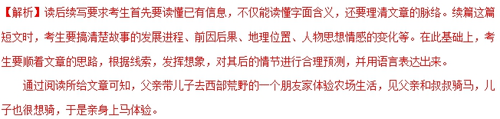
根据第一段所给首句Suddenly a little rabbit jumped out in front of my horse.这一句是故事发展的转折点，可从rabbit出现后带来的反应扩展开，可以写马的反应，也可以写人的反应，但要注意与第二段首句相呼应。
第二段首句是We had no idea where we were and it was getting dark.这一句呼应前文Uncle Paul的叮嘱——不要误吃晚饭，可从如何寻路返回农场去写。
续写时注意要使用5个以上短文中标有下划线的关键词语，我们要熟悉所给划线词语，恰当的时候加以运用。最后还要注意所续写短文的词数应为150左右；续写完成后要用下划线标出你所使用的关键词语。
【2018·天津卷】书面表达（满分25分）
61. 假设你是晨光中学的机器人兴趣小组组长李津，你的美国朋友Chris就读于天津某国际学校，他普在机器人技能竞赛中获奖。你打算邀请他加入你的团队，参加即将于7月底在天津举行的世界青少学机器人技能竞赛。请根据以下提示代表兴趣小组给他写一封电子邮件。
（1）比赛的时间、地点；
（2）邀请他的原因；
（3）训练计划将发送其邮箱，请他提出建议。
注意：（1）词数不少于100；
（2）可适当加入细节，使内容充实、行文连贯；
（3）开头和结尾已给出，不计入总词数。
参考词汇：
世界青少年机器人技能竞赛 the World Adolescent Robotics Competition
Dear Chris,
I have good news to tell you. ______________________________________________________________
____________________________________________________________________________________________
____________________________________________________________________________________________
____________________________________________________________________________________________
__________________________________________________________________________
I’m looking forward to your reply.
Yours,
Li Jin
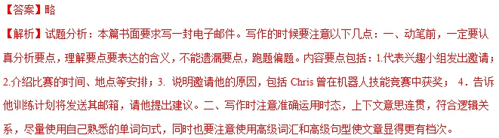
【点睛】书面表达考查大家所熟悉的提纲类作文，我们需要用正确的英语把给出的要点表达出来。动笔前，一定要认真分析要点，理解要点要表达的含义，不能遗漏要点，跑题偏题。本作文中给出的要点比较具体，故需要准确表达。考生写完之后要检查是否有语法错误，看能否运用所学的知识将简单句变为复杂句，当然，没有把握的句子不要写。
【2018·江苏】书面表达(满分25 分)
81. 请阅读下面文字,并按照要求用英语写一篇150 词左右的文章。
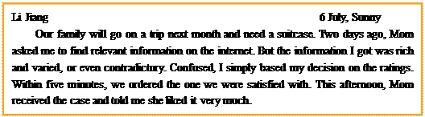
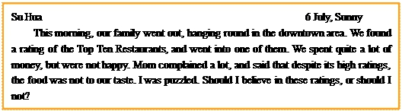
【写作内容】
1. 用约30个词概括上述利用排名（ratings）进行消费的现象；
2. 谈谈你如何看待消费排名，然后用2-3个理由或论据支撑你的看法。
【写作要求】
1. 写作过程中不能直接引用原文语句；
2. 作文中不能出现真实姓名和学校名称；
3. 不必写标题。
【评分标准】
内容完整，语言规范，语篇连贯，词数适当。
____________________________________________________________________________________________
____________________________________________________________________________________________
____________________________________________________________________________________________
____________________________________________________________________________________________
____________________________________________________________________________________________
____________________________________________________________________________________________
____________________________________________________________________________________________
__________________________________________________________
【答案】Possible version one:
As a major channel of consumption information, the rating is an efficient source of information for shopping in our own consumption. Interestingly, the same rating may have different influences on different consumers.
I tend to consult consumption ratings whatever I purchase. Firstly, the higher rating means the higher quality of the product, or better service. Based on the ratings, I bought my beloved backpack, saw interesting films and tasted delicious foods. Secondly, ratings can save time to make decisions in shopping. For example, there are huge amounts of reference books which I am often confused to choose from. In that case, it is both convenient and economical to buy books according to the ratings.
There is no doubt that it is unwise to depend completely on the ratings in consumption. The advantages and disadvantages of ratings are often closely related. It is necessary to hold an objective attitude towards ratings.
Possible version two:
Nowadays, most commodities or services are rated through certain channels. These ratings, easy to access, are playing an increasingly important role in customers' purchase decision. However, results are sometimes unsatisfactory.
There is no denying that such ratings might bring convenience to consumers, but they are often misleading and unreliable. As we all know, most of the ratings are based on others’ judgment on the product or service concerned. Every judgment comes from a specific need or a unique psychological state. Apparently, blindly following others' advice will affect our own judgment. Another fact should not be neglected that some of the ratings are the outcome of a careful manipulation of companies or sellers. It has become a common practice for some to pay
for good ratings on their products or services so as to increase their sales.
Therefore, we should give a second thought to these ratings whenever we go shopping.
【解析】今年作文仍然是读写作文，即先用30词概括阅读材料，然后针对材料中的话题写一篇议论文谈看法。首先要认真阅读两段有关消费排名现象及观点的纯文字材料，然后进行比较和分析，表明态度，作出价值判断。
文章首段要简要介绍两段材料，第一段材料为一对母子买旅行箱看了网上的评论，结果买回来的旅行箱质量很好。第二段材料为一帮人去餐馆吃饭，看了on-line rating，结果饭菜很不好吃，从而凸显出online rating的不靠谱。
然后写你对online rating的看法，表明观点，注意用2-3个论据来支撑自己的看法。
文章属于议论文，要注意主题句的使用，论点之间要注意有条理。文章可主要采用一般现在时，第三人称来写。
2018高考模拟
【吉林省长春市2018届高三年级四模】假定你是李华，你校将在暑假期间开办一个留学生京剧训练营(Peking Opera Training Camp). 请给你班的美国交换生Peter 写封邮件，告诉他相关信息。内容包括;
1. 介绍训练营的相关安排;
2. 说明训练营的目的;
3. 表达希望对方参加的愿望。
注意:1. 词数100左右;
2. 可以适当增加细节，以使行文连贯。
____________________________________________________________________________________________
____________________________________________________________________________________________
____________________________________________________________________________________________
____________________________________________________________________________________________
____________________________________________________________________________________________
__________________________________________________________________
【答案】Dear Peter,
I’m writing to share a piece of good news with you.
Our school will run a Peking Opera Camp for exchange students this summer vacation. It starts from July 11th and ends on July 20th, lasting ten days. Some famous artists will offer basic courses on this national treasure, including singing, dialogues, movements as well as facial make-up. What they want to communicate through the courses is that Peking Opera is not just an art, but a symbol of traditional Chinese culture which deserves to be passed down from generation to generation.
Since you’re always keen on Peking Opera, so I sincerely hope you’ll take this chance. Join the camp and have a good time there!
Yours,
Li Hua
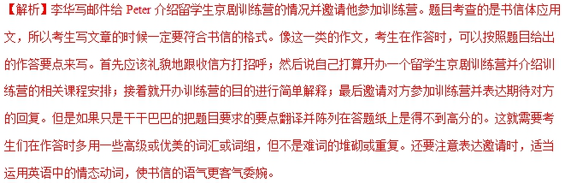【范文亮点】
I’m writing to share a piece of good news with you.这里运用了动词不定式表目的。
Some famous artists will offer basic courses on this national treasure, including singing, dialogues, movements as well as facial make-up.这里很好的运用了as well as固定短语。
What they want to communicate through the courses is that Peking Opera is not just an art, but a symbol of traditional Chinese culture which deserves to be passed down from generation to generation. 这里运用了比较复杂的句式，特别是名词性从句的运用，显示了考生较高的语法水平。
【湖南省长沙市雅礼中学、河南省实验中学2018届高三联考】假设你是红星中学高三学生李华，你的英国朋友George要来北京，其间他想参加中国传统文化方面的课程，来信希望你能推荐一个课程。请你给他回信，内容包括：
1. 你推荐的课程,
2. 该课程的内容,
3. 你推荐的理由。
注意：词数100左右。
____________________________________________________________________________________________
____________________________________________________________________________________________
____________________________________________________________________________________________
____________________________________________________________________________________________
____________________________________________________________________________________________
______________________________________________________________
【答案】Dear George,
I am delighted to hear that you want to take a course about Chinese traditional culture. I am writing to recommend one on Beijing Opera.
This course, “Introduction to Beijing Opera”, which will be held in Beijing next month for two weeks, contains two sections. A lecture on the history of Beijing Opera will introduce its time-honored development, including the detailed process of how it spread. What takes the course to a new height is a theater trip. Stepping into Mei Lanfang Theatre, you’ll get a taste of the performance techniques by appreciating how the voices and motions are perfectly combined on the stage.
I heartily recommend this course to you based on the following reasons. I know you love drama so much, so you will be able to more easily understand Sheng, Dan, Jing, Mo, Chou, the five main characters of Beijing Opera. It is also an interactive course, in which you will have a chance to communicate with opera performers face to face.
I hope my introduction is helpful. Please let me know if you have further questions.
Yours,
Li Hua
【解析】本文书面表达属于应用文，要求写一封回信。
第1步：根据提示可知，本篇是一篇回信：假设你是红星中学高三学生李华，你的英国朋友George要来北京，其间他想参加中国传统文化方面的课程，来信希望你能推荐一个课程。请你给他回信，内容包括：你推荐的课程；该课程的内容；你推荐的理由。
第2步：根据写作要求确定关键词，如：take a course选课；Beijing Opera京剧；Introduction to Beijing Opera对京剧的介绍；on the stage.在舞台上；have a chance to communicate with与---有一个交流的机会；face to face面对面；等。
第3步：根据提示及关键词（组）进行遣词造句，注意主谓一致和时态语态问题。
第4步：连句成文，注意使用恰当的连词进行句子之间的衔接与过渡，书写一定要规范清晰，保持整洁美观的卷面是非常重要的。
本文内容完整，语言规范，鱼片连贯，词数适当。另外全文中没有中国式英语的句式，显示了很高的驾驭英语的能力。
【湖北省襄阳四中2018届高三5月第四次模拟】假设你是李华，在伦敦做交换生，昨天你的室友Tony在校园摔倒后被人救助。请你给校求助中心写封邮件，寻找那名帮助Tony的中国学生。
注意: 1.字数 100 左右；
2.可以适当增加细节，使文章行文连贯。
Dear Sir/Madam,
_________________________________________________________________________________________________________________________________________________________________________________________________________________________________________________________________________________________________________________________________________
【答案】Dear Sir/Madam,
I am Li Hua, an exchange student from China. I am writing to ask you to help look for a Chinese student. Yesterday, my roommate Tony was on the way to the classroom when he fell down and could hardly move.
Just at that moment, a Chinese girl came to him. She gave him first aid and called an ambulance. Thanks to the kind girl, Tony was sent to hospital in time. But the girl left quietly before Tony could express his gratitude. The girl is about 18 years old and of medium height with short hair. Tony is eager to meet her to convey his sincere appreciation. Could you please help to find her?
I am looking forward to your prompt reply.
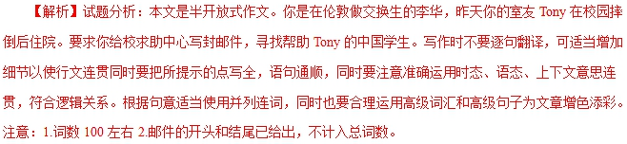
【亮点说明】
本文是一篇电子邮件，文章格式正确，内容齐全，布局合理，使用高级句子。I am Li Hua, an exchange student from China.句子看似简单却，其实用了同位语；Yesterday, my roommate Tony was on the way to the classroom when he fell down固定句式，when的特殊用法；Tony was sent to hospital in time.使用一般过去时态的被动语态，显得句子丰富多彩；the girl left quietly before Tony could express his thanks. Before引导时间状语从句；Could you please help find her?问句的运用别具一格；另外，Just at that moment, Thanks to the kind girl, But等的使用，为文章增色添彩。
【河南省郑州市2018届高三下学期第三次模拟】假定你是李华,正在你校学习汉语的美国交换生Albert对中国古诗词很感兴趣。请用英语给他写封邮件,邀请他一同观看央视频道《经典咏流传》中的一期节目。内容包括：
1. 时间、地点和观看人员；
2. 内容：欣赏以歌曲形式咏唱的经典古诗词；
3. 提醒：提前简要了解一些中国经典古诗词,观后一起谈感受。
注意：1. 词数100左右；
2. 可以适当增加细节,以使行文连贯。
参考词汇：《经典咏流传》Everlasting Classics
Hi Albert,
____________________________________________________________________________________________
____________________________________________________________________________________________
____________________________________________________________________________________________
____________________________________________________________________________________________
____________________________________________________________________________________________
____________________________________________________________________________________________
________________________________________________________________
Best,
Li Hua
【答案】Possible Version:
Hi Albert,
How is everything? As you are into classical Chinese poetry, I’m writing to invite you to join us in watching an attractive variety show called Everlasting Classics at 7:00 p.m. on May 10th in Room 603 in the Office Building.
It is a hit program on CCTV 3, where a lot of classic Chinese poems are chanted in beautiful tunes. We plan to exchange our reviews after watching the show together, so you’d better learn in advance some poems to be shown and their background. The list of them is attached to the email, handy for you to refer to.
I’m looking forward to your participation and I believe you will enjoy it and learn a lot.
Best wishes,
Li Hua
Possible Version II
Hi Albert,
How is it going? I know you show great interest in classical Chinese poetry. I warmly invite you to appreciate one episode of a TV program named Everlasting Classics on CCTV this week.
It helps people enjoy some beautiful classic Chinese poems performed in the form of popular songs. All exchange students are welcome to watch it at the lecture hall at 5 o’clock p.m. on Friday. It’s a good idea to learn some of classic Chinese poems in advance, which can help you understand them better then. After watching the program, we can share what impresses us most with others.
I sincerely expect you to come and see you then.
Best wishes,
Li Hua
【解析】本文是一篇应用文。要求写一封邮件。首先要根据提示，可知是写一封电子邮件邀请外国朋友一起观看央视节目，并告知节目的相关内容。文章的要点相当详细，只要把以上要点内容稍加扩展，用适当的连词，运用各种句式遣词造句最终成文即可。书写时要规范清晰，保持卷面整洁美观。
亮点分析：两篇文章内容完整，结构合理，语言规范，语篇连贯。句式灵活。
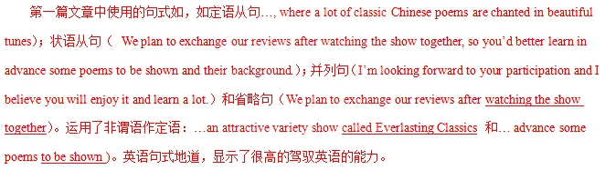
第二篇使用了一些高级词汇如show great interest in；invite sb to appreciate, in advance, be welcome to 等，给文章增添了色彩。此外运用了非谓语作定语（… a TV program named Everlasting Classics。.和… classic Chinese poems performed in the form of popular songs）。本文句式灵活多变，既有省略句（After watching the program, we can share what impresses us most with others.），又有各种复合句，如定语从句（…, which can help you understand them better then.）； 名词从句（we can share what impresses us most with others.）丰富多彩的句式表达使文章更有文采，增加文章的可读性，提高了文章得分等级。
【河北省石家庄市第二中学2018届高三仿真模拟（一）】假定你是李华，你的美国朋友Peter对中国春联（Spring Festival couplets）产生了浓厚兴趣，来信向你了解中国的春联文化。请你用英语写一封回信，为他介绍春联的用途、内容和寓意等。
注意：1. 词数100左右；
2. 可以适当增加细节，以使行文连贯；
____________________________________________________________________________________________
____________________________________________________________________________________________
____________________________________________________________________________________________
____________________________________________________________________________________________
____________________________________________________________________________________________
____________________________________________________________________________________________
________________________________________________________________
【答案】Dear Peter,
I’m glad to know you have interest in Spring Festival couplets. Now, let me introduce some details of them to you.
As a symbol of Chinese traditional culture, Spring Festival couplets are always stuck on the door or the wall of a house. They are necessities for Chinese people to celebrate the Spring Festival. Written with a writing brush on red paper, Spring Festival couplets use some positive words showing wishes for love, health, success, wealth, happiness and so on. They always have a theme, and they represent better life or successful future, and some of them include wishes and expectations. Of course, the topic of singing the praises of our motherland is another good choice.
Hope you find my introduction useful.
Yours,
1.i Hua
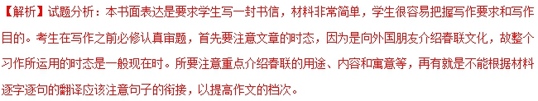
【亮点说明】文中使用了非常好的短语和句子为文章增色不少，比如be glad to，and so on，of course，等。另外Written with a writing brush on red paper, Spring Festival couplets use some positive words showing wishes for love, health, success, wealth, happiness and so on..这句运用了过去分词作状语和现在分词作定语等等。并注意了句子的衔接等等。
【山西省太原市2018届高三第二次模拟】假定你是李华,你的英国朋友Mark希望向你了解国画的有关知识,原定见面时间，因故需要推迟,请给Mark写一封邮件,说明情况。要点包括：
1.表示歉意并说明原因；
2. 重约见面讨论时间；
3. 推荐先参观国画展览。
注意：1.词数100左右；
2. 可以适当增加细节,以使行文连贯。
____________________________________________________________________________________________
____________________________________________________________________________________________
____________________________________________________________________________________________
____________________________________________________________________________________________
____________________________________________________________________________________________
_____________________________________________________________________
【答案】Dear Mark,
I hate to say sorry, but there is a change in my school arrangements. So I am afraid I won’t be able to keep my appointment to discuss traditional Chinese paintings with you. I sincerely apologize to you for any inconvenience caused by the unexpected change. I suggest we put it off from 3 pm this weekend until the same time next Thursday. Will that be fine for you? Good news is that an exhibition of Chinese paintings is to be held this weekend. Works by some nationwide famous painters will be included in the exhibits. A visit there will definitely help better your understanding of the paintings.
Looking forward to your reply.
Yours,
Li Hua
【解析】本文是道歉信，要注意道歉信的格式，开头真诚地向朋友道歉，说明道歉的原因——因自己有事所以不能如期和朋友见面；然后重约见面讨论时间，并推荐朋友参观国画展览。最后期待朋友答复。写作时要注意条理清楚，要点全面，态度诚恳，主动语态和被动语态交替使用。
亮点说明：使用了宾语从句So I am afraid I won’t be able to keep my appointment to discuss traditional Chinese paintings with you.和I suggest we put it off from 3 pm this weekend until the same time next Thursday.表语从句Good news is that an exhibition of Chinese paintings is to be held this weekend.
【河南省洛阳市2018届高三第三次统一考试】假定你是李华，想申请加入你校留学生俱乐部，以帮助外国学生学习汉语并了解中国文化．请给俱乐部负责人Mr．Blake 写一封邮件．内容包括：
1．目的；
2．个人情况．
注意：1．词数100左右，邮件开头和结尾已为你写好，不计入总词数；
2．可以适当增加细节，以使行文连贯．
Dear Mr．Blake，
____________________________________________________________________________________________
____________________________________________________________________________________________
____________________________________________________________________________________________
____________________________________________________________________________________________
____________________________________________________________________________________________
_________________________________________________________________________
Yours，
Li Hua．
【答案】Dear Mr．Blake，
I'm Li Hua，a girl student in Grade Two．I'm writing to apply to join the Foreign Students Club to help the foreign students learn Chinese well and get a good understanding of Chinese culture．（高分句型一）
I'm sure I can be a qualified member．Firstly，I'm easy-going and love to make friends throughout the world．Secondly，my family has so far hosted five foreign students，so I'm experienced in communicating with foreigners．Besides，I can speak English fluently as well as having a rich knowledge of Chinese culture．（高分句型二）I do hope you can accept my application and I promise to do all I can to help them．（高分句型三）
Looking forward to your early reply．
Yours，
Li Hua
【解析】本文书面表达属于应用文，要求写一封电子邮件。
第1步：根据提示可知，本篇是一篇电子邮件：想申请加入你校留学生俱乐部，以帮助外国学生学习汉语并了解中国文化．请给俱乐部负责人Mr．Blake 写一封邮件．内容包括：目的；个人情况．
第2步：根据写作要求确定关键词，如：apply to join the Foreign Students Club（申请加入外国学生俱乐部）；get a good understanding of（对---有一个好的理解）；experienced in communicating with（在与---交流上有经验）；having a rich knowledge of（对---掌握得好）等。
第3步：根据提示及关键词（组）进行遣词造句，注意主谓一致和时态语态问题。
第4步：连句成文，注意使用恰当的连词进行句子之间的衔接与过渡，书写一定要规范清晰，保持整洁美观的卷面是非常重要的。
本文内容完整，语言规范，鱼片连贯，词数适当。另外全文中没有中国式英语的句式，显示了很高的驾驭英语的能力。
【亮点说明】
