2018年高考及最新模拟分类汇编之从句
2018年高考从句
1.【2018·北京】2. _________ we don’t stop climate change, many animals and plants in the world will be gone.
A. Although B. While C. If D. Until
【答案】C
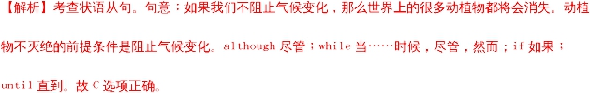
点睛：条件状语从句通常由引导词if或unless引导。条件是指某一件事情实现之后（状语从句中的动作），其它事情（主句中的动作）才能发生，通常译作“假如”。
2.【2018·北京】5. She and her family bicycle to work, _________ helps them keep fit.
A. which B. who C. as D. that
【答案】A
【解析】考查非限制性定语从句。句意：她和家人骑自行车去上班，这有助于她们保持健康。“____ helps them keep fit”是非限制性定语从句，该从句修饰整个主句，引导词在从句中做主语，故该从句应用关系代词which引导。A选项正确。
点睛：非限制性定语从句即可修饰主句的一部分，也可以修饰整个主句。其引导词的选择和限制性定语从句的判断规则一致，即：第一、找准先行词；第二、看先行词在定语从句中所作的成分。需要注意的是，that不能引导非限制性定语从句。
3.【2018·北京】8. In any unsafe situation, simply _________ the button and a highly-trained agent will get you the help you need.
A. press B. to press C. pressing D. pressed
【答案】A
【解析】考查祈使句。句意：在任何不安全的情况下，仅仅摁一下这个按钮，一个训练有素的特工就会使你得到你需要的帮助。and是连词，连接并列结构，and后面是一个句子，那么，前面也应是句子，选项中只有动词原形可以构成祈使句，其余的都是非谓语动词，无法构成句子。故A选项正确。
点睛：祈使句+and/or+陈述句是一种常见结构。当前后两部分间为承接关系时，用and；前后意思为相反关系时，用or。该句式中的陈述句部分常用一般将来时态。
4.【2018·北京】11. Without his support, we wouldn’t be _________ we are now.
A. how B. when C. where D. why
【答案】C
【解析】考查名词性从句。句意：没有他的支持，我们是不会在现在这个位置的。how表方式，when表时间，where表地点，why表原因。“_________ we are now”是表语从句，结合句子的意思可知，该处指我们所处的位置，故该从句应用where引导。C选项正确。
点睛：表语从句是指一个句子充当表语，通俗的说就是系动词be后面接一个句子。连接表语从句的连接词有that，what，who，when，where，which，why，whether，how等。
5.【2018·北京】15. This is _________ my father has taught me—to always face difficulties and hope for the best.
A. how B. which C. that D. what
【答案】D
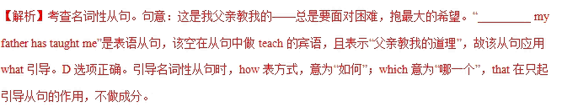点睛：what是常见的名词性从句引导词之一，它除了引导从句作用之外，还在从句中做主语，宾语，表语或者定语。根据不同的语境，what可以表示不同的意思，例如“……的东西或事情”，“……的人或样子”等。
6.【2018·天津】14. It was only when the car pulled up in front of our house ___________we saw Lily in the passenger seat.
A. which B. that
C. when D. where
【答案】B
【解析】考查强调句。句意：只有当汽车在我们房子前停下来我们才看到在乘客位置的莉莉。这里考查强调句，强调句型结构为：It is/ was + 被强调部分(通常是主语、宾语或状语)+ that/ who(当强调主语且主语指人)+ 其他部分。本题强调时间状语only when the car pulled up in front of our house。故选B。
点睛：本题考查强调句，要求有学生掌握好强调句的常用句型以及相关知识的能力。分析句子时首先要看清楚结构，It is / was…开头而后面跟句子时就要看它是不是强调句了。强调句有一个特点：拿掉It was/is…that…后不影响整个句子的完整性，则是强调句。判断完是不是强调句后再根据强调的部分是人还是物来选择连接词that或者是who。
7.【2018·天津】9. The gold medal will be awarded ___________to wins the first place in the bicycle race.
A. whomever B. wherever
C. whoever D. whatever
【答案】C
【解析】考查名词性从句连接词。句意：无论谁获得自行车比赛第一名，金牌将授予他。分析句子可知，宾语从句中缺少主语，故用whoever，表示“任何人，无论谁”。故选C。
点睛：分析句子可知，空格处做be awarded to的宾语，同时在后面的从句中做主语，再根据句意可知，这里主语指人，故用whoever。
8.【2018·天津】4. Let's not pick these peaches until this weekend ___________they get sweet enough to be eaten.
A. ever since B. as if
C. even though D. so that
【答案】D
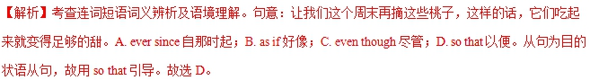
点睛：本题考查连词短语词义辨析。解题时要区分清选择项的含义与区别，再联系句意可以判断，这里考查so that引导的目的状语从句。
9.【2018·天津】2. Kae, _________sister I shared a room with when we were at college, has gone to work in Australia.
A. whom B. that
C. whose D. her
【答案】C
【解析】考查定语从句关系词。句意：凯特已经去澳大利亚工作了。我们在大学的时候，我和她的姐姐共住一室。分析句子，句中先行词为Kate，在非限定性定语从句中作名词sister的定语，故用关系代词whose。故选C。
点睛：本题考查定语从句。定语从句是高考重点考查知识之一，分析定语从句需抓住两点：1.找准先行词；2.看先行词在从句中所作的成分。抓住这两点，再根据句意，从而能够判断出正确的关系词。
10.【2018·江苏】29. _______ you can sleep well, you will lose the ability to focus, plan and stay motivated after one or two nights.
A. Once B. Unless
C. If D. When
【答案】B
【解析】考查连词词义辨析及语境理解。句意：除非你睡得好，否则一两个晚上之后，你会失去专注、计划和保持动力的能力。A. Once一旦；B. Unless除非；C. If如果；D. When当……时候。故选B。
点睛：本题考查连词辨析。解题时要区分清选择项的含义与区别，再联系句意进行判断，从而选出正确答案。
11.【2018·江苏】23. Self-driving is an area _______ China and the rest of the world are on the same starting line.
A. that B. where
C. which D. when
【答案】B
【解析】考查定语从句。句意：自动驾驶是一个中国和世界其它国家都在同一起跑线的领域。句中先行词为area，在从句中作地点状语，故用关系副词where，相当于in which。故选B。
点睛：本题考查定语从句。定语从句是高考重点考查知识之一，分析定语从句需抓住两点：1.找准先行词。2.看先行词在从句中所作的成分。抓住这两点，再根据句意，从而能够判断出正确的关系词。
12.【2018·江苏】21. By boat is the only way to get here, which is _______ we arrived.zx.x.k
A. where B. when
C. why D. how
【答案】D
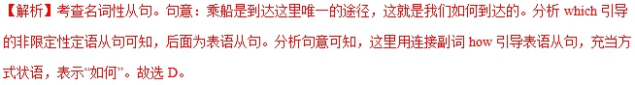点睛：本题考查表语。首先需要弄清句意及分析句子结构，然后根据前句By boat is the only way to get here提示可知作方式状语，就不难选出正确答案。
13.【2018·海淀二模】12. ________some people criticize graffiti for being ugly and destructive, those graffiti lovers still see it as real art.
A. As B. While
C. Once D. Until
【答案】B
【解析】考查连词词义辨析。句意：尽管一些人批评涂鸦，认为它非常丑陋而且具有破坏性，但是，涂鸦爱好者们仍然将涂鸦看作是真正的艺术。as因为，尽管，正如；while尽管，当……时候；once一旦；until直到。表示“尽管”并引导让步状语从句用while。as引导让步状语从句时，从句必须用倒装。故选B。
14.【2018·海淀二模】8. 40 grams of meat per day is ______ people should consume in order to stay fit.
A. that B. why
C. how D. what
【答案】D
【解析】考查名词性从句连接词。句意：为了保持健康，人们每天应该消耗40克肉。“_____ people should consume”是表语从句，该从句中consume缺少宾语，且表示“所需消耗的东西”，故要用what引导该从句。D选项正确。
15.【2018·海淀二模】7. The stadium ________ stands a theatre will be reconstructed.
A. beside which B. for which
C. when D. which
【答案】A
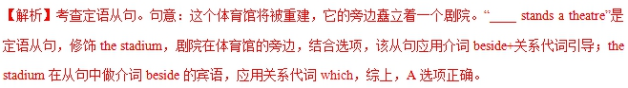
16.【2018·海淀二模】5. You don’t need an invitation to help others. Give help _____you are asked.
A. if B. as
C. though D. before
【答案】D
17.【2018·海淀二模】2. I need help now! I have to fix a leaking pipe in my bathroom but I’m not sure ______to begin.
A. what B. which
C. where D. when
【答案】C
【解析】考查疑问词。句意：我现在需要帮助。我不得不修理洗手间里一个正在漏水的管子，但是我不确定从何处着手。代入句子，只有C选项符合语境，是管子哪里漏水，表示地点，故选C。
18.【2018·海淀二模】1. —Excuse me, sir. Can you spare me a dollar ________ I can buy this book?
—Sure, no problem.
A. for B. so
C. but D. or
【答案】B
【解析】考查连词词义辨析。句意：——打搅了，先生。你可以给我一元钱吗，这样我就可以买这本书了。——好的，没问题。for因为；so所以，以便；but但是；or或者，否则。根据语境，第一个说话者向对方要钱的目的是为了买书，故该处应填so。B选项正确。
19.【2018·滨海7校联考】13. There are various things on sale, so you can choose ______ interests you.
A. whoever B. no matter who
C. whatever D. no matter what
【答案】C
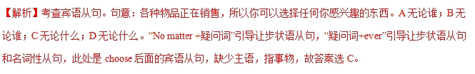
20.【2018·滨海7校联考】11. I went to the classroom as usual. But there, next to my desk, ______ I had never seen before．
A. a girl did sit B. a girl sat
C. did a girl sit D. sat a girl
【答案】D
【解析】考查全部倒装。句意：我像平常一样去了教室。但是，在我桌子旁边坐着一个我以前从没见过的女孩。表示地点方位的状语位于句子开头，主语如果是名词，则句子用全部倒装。故答案为D。
【名师点睛】
全部倒装（平衡倒装句型）：
①句首是地点状语和表语时：
In front of the house sat an old man smoking a pipe.在房屋前面坐着一位老人在抽烟斗.（句首是状语）
②句首有 here,there,out,in,up,down,off,away 等副词时：Out rushed a cat from under the table.从桌子底下窜出一只猫来.
③句首有 so（表肯定）,neither (nor) （表否定）,表示前面所说的情况也适合与另一个人或事.He can swim.他会游泳.So can she.她也会.
④在there be 结构中.There are fifty students in our class.我班有50个学生.
⑤在某些祝愿句中.
Long live the People's Republic of China!中华人民共和国万岁!
⑥在某些感叹句中.
How proud we are of our great motherland!我们为伟大的祖国感到多么自豪!
21.【2018·滨海7校联考】10. It was ______ we were returning home ______ I realized what a good feeling it was to have helped someone in trouble.
A. when; before B. when; that
C. before; where D. how; that
【答案】B
【解析】考查定语从句。句意：当我们回到家的时候，我意识到帮助陷入困境的人是一种多么好的感觉。这是一个强调when引导的时间状语从句的强调句型。根据句意可知答案为B。
22.【2018·滨海7校联考】9. Creating an atmosphere ______ employees feel part of a team is a big challenge.
A. where B. whose
C. that D. which
【答案】A
【解析】考查定语从句。句意：创造一种氛围，让员工觉得自己是团队的一员，这是一个巨大的挑战。这是一个定语从句，先行词为atmosphere，通过分析从句_______employees feel part of a team 的句子成分，得知主语（employees），宾语（part of a team）齐全，而atmosphere跟employees不是所属关系，故排除选项B．句子有主语和宾语所以此处应该是一个作状语的词，再根据 in the atmosphere“在氛围中，可知应该是地点状语，故选A。
23.【2018·滨海7校联考】3. ______ he was 12, Einstein had learned advanced mathematics by himself.
A. The first time B. At the time
C. By the time D. During the time
【答案】C
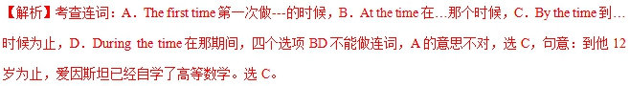
24.【2018·江苏97校联考】12. The best student of the year shared his experience of he had managed to achieve excellence in his preparation for the college entrance examination.
A. if B. how
C. what D. that
【答案】B
【解析】考查宾语从句。A. if是否；B. how如何；C. what什么；D. that无实意。句意：今年最优秀的学生分享了他在准备高考时如何做到优秀的经历。此处表示如何取得优秀的，故选B.
25.【2018·江苏97校联考】9. It is broadcast on TV that the 88th Academy Award Ceremony was held in Dolby Theatre seats an audience of approximately 4000.
A. where B. whose
C. which D. when
【答案】C
【解析】考查定语从句。A. where在那里；B. whose谁的；C. which那一个；D. when在那时。句意：在Dolby剧院举行的第88届奥斯卡颁奖典礼在电视上播出，这个剧院能容纳约4000观众。That从句是句中的真正主语，里面包含定语从句，先行词是Dolby Theatre指物，后面是定语从句，先行词在定语从句中做主语用关系代词引导，故选C.
26.【2018·江苏97校联考】8. —How do you like the advertisement of the way to losing weight?
—Don’t fall for it. In the beginning, that may do, but after a while you will end up back ________ you started.
A. as if B. where
C. even if D. when
【答案】B
【解析】考查连词。A. as if好像；B. where在…的地方；C. even if即使；D. when当…时。句意：你觉得这个减肥方法的广告怎么样?—不要信以为真。开始的时候，可能会这样，但是很快你就会回到原来的样子。此处开始的地方指原来的样子，故选B.
27.【2018·江苏97校联考】3. Parents should be aware of the fact that children, who are raised on a diet of soap operas and online games, seldom, participate in a variety of activities.
A. if never B. if not
C. if ever D. if so
【答案】C
