2018年高考及最新模拟分类汇编之非谓语动词和交际用语
2018年高考非谓语动词和交际用语
1.【2018·北京】3. _________ along the old Silk Road is an interesting and rewarding experience
A. Travel B. Traveling C. Having traveled D. Traveled
【答案】B
【解析】考查动名词。句意：沿着丝绸之路旅行是一次既有趣又有益的经历。“____ along the old Silk Road”做主语，要用动名词，故B选项正确。
点睛：动名词是动词-ing形式的一种，兼有动词和名词特征。在句子中可以作主语、宾语、表语、定语。
2.【2018·北京】6. During the Mid-Autumn Festival, family members often gather together _________ a meal, admire the moon and enjoy moon cakes.
A. share B. to share C. having shared D. shared
【答案】B
【解析】考查非谓语动词。句意：在中秋节期间，家人们通常会聚在一起吃饭，赏月，品尝月饼。gather是谓语动词，“_________ a meal, admire the moon and enjoy moon cakes”是状语，家人聚在一起的目的是吃饭，赏月，品尝月饼，表目的用动词不定式，故B选项正确。
点睛：动词不定式可以做主语，状语，定语，宾语，表语等。动词不定式做目的状语时，可以置于主句之前也可以置于主句之后，通常译为“为了”。
3.【2018·北京】10. Ordinary soap, _________ correctly, can deal with bacteria effectively.
A. used B. to use C. using D. use
【答案】A
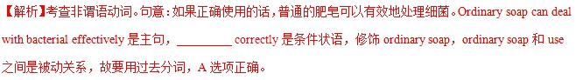
点睛：过去分词所表示的一个含义就是“被动”。
4.【2018·天津】12. I didn't mean ___________anything but the ice cream looked so good that I couldn’t help_______ it.
A. to eat；to try B. eating；trying
C. eating；to try D. to eat； trying
【答案】D
【解析】考查短语固定搭配。句意：我不打算吃任何东西，但冰淇淋看起来如此的好以至于我忍不住的要试一试。固定短语短语mean to do（打算做），couldn’t help doing忍不住做。故选D。
点睛：本题考查动词短语固定搭配。同学在平时学习中要多把握动词不同搭配的不同含义，本题需要区分“mean to do打算做”与“mean doing意味着做”和“can’t help to do sth.不能帮助做”与“couldn’t help doing忍不住做”之间的含义。
5.【2018·天津】7. I need a new passport so I will have to have my photographs___________.
A. taking B. taken
C. being taken D. take
【答案】B
【解析】考查非谓语动词。句意：我需要一个新护照，所以我将不得不拍照片。本题考查非谓语动词作宾语补足语，宾语my photograph与补足语之间为被动关系，故用过去分词作宾语补足语。C项表示正在进行。故选B。
点睛：本题考查的非谓语动词为高中重点语法之一。在分析题目的时候，首先要抓住非谓语动词在句中所作的成分，找出该非谓语动词所对应的逻辑主语，再分析二者之间的关系，最后根据句意选择正确的答案。
6.【2018·天津】5. —I'm moving in a few days and I wonder if you could help.
—___________. Just let me know when, and I'll be there.
A. You bet B. It depends
C. Forget it D. No kidding
【答案】A
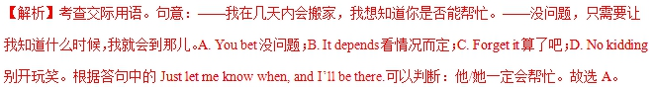
点睛：本题考查日常交际用语，首先读懂对话，弄清句意及各选择项在语境中的具体运用，然后抓住关键答句Just let me know when, and I’ll be there.，就不难选出正确答案。
7.【2018·天津】1. —Wasn't Joan supposed to be here by now?
一She will be here in about twenty minutes.z.x.xk
A. All right B. Don't worry
C. No wonder D. Enjoy yourself
【答案】B
【解析】考查交际用语。句意：——琼现在不是应该在这儿吗？——不用担心，在大约20分钟内她将会到这儿的。A. all right好，行；B. Don’t worry别担心；C. No wonder难怪；D. Enjoy yourself玩得开心。根据答句中的She will be there in about twenty minutes.可以判断：不需要担心琼，她一会儿就到。故选B。
点睛：本题考查日常交际用语，首先读懂对话，弄清句意及各选择项含义，然后抓住答句，就不难选出正确答案。
8.【2018·江苏】35. —What happened? Your boss seems to _______.
—Didn’t you know his secretary leaked the secret report to the press?
A. be over the moon B. laugh his head off
C. be all ears D. fly off the handle
【答案】D
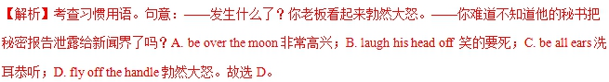
点睛：本题考查习惯用语。英语习语是英语中使用最普遍、表达力最强、文化内涵最丰富的一部分，包括成语、谚语、格言、典故、俚语、俗语、歇后语等，是英语语言的精粹。同学们在学习过程中准确掌握英语中的习语，能帮助同学们深刻理解英语词汇中的文化内涵及文化差异，从而更加准确、传神地使用英语。
9.【2018·江苏】28. —You know what? I’ve got a New Year concert ticket.
—Oh, _______ You’re kidding.
A. so what? B. go ahead.
C. come on. D. what for?
【答案】C
【解析】考查交际用语。句意：——你知道是什么吗？我已经得到一张新年音乐会的票了。——哦，得了吧，你开玩笑的吧。A. so what?那又怎么样？B. go ahead.去吧。C. come on.得了吧。D. what for?为什么？交际用语中come on表示“得了吧！算了吧！”，用来指责别人或表示不耐烦。故选C。
【点睛】本题考查交际用语。对于交际用语的考查，首先平时要多积累常用的交际用语，尽量避免汉语式的表达。解题时要在上下文中进行，特别要注意与语境语义的联系。本题选项中的come on.是大家熟悉的交际用语，我们常见的含义有：①加油！②赶快！(用于催促别人快点) ③赶快！(用于催促别人快点) 但这些含义与本题都无关。所以我们要多积累，多了解短语在不同交际用语中的不同用法。
10.【2018·江苏】26. Around 13,500 new jobs were created during the period, _______ the expected number of 12,000 held by market analysts.
A. having exceeded B. to exceed
C. exceeded D. exceeding
【答案】D
【解析】考查非谓语动词。句意：在这期间，大约创造13,500个新的工作，超过市场分析师持有的12,000的预期数量。分析全句可知，这里指前一件事情所带来自然而然的结果，故用现在分词作结果状语。故选D。
点睛：本题考查非谓语动词。非谓语动词主要有动词不定式、现在分词和过去分词形式。
having exceeded强调时间先后，指的是此动作发生在谓语动词create的动作之前；to exceed表示将要超出；exceeded过去分词表示被动。分析句意可知，这里用现在分词作结果状语。
11.【2018·海淀二模】14. _______naturally by the skin when exposed to sunlight, Vitamin D is needed for healthy bones, teeth and muscles.
A. Making B. To make
C. Made D. Make
【答案】C
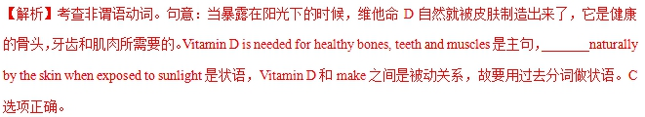12.【2018·海淀二模】9. Dream of the Red Chamber is believed to be semi-autobiographical, _______the fortunes of Cao’s own family.
A. mirrored B. to mirror
C. mirroring D. mirror
【答案】C
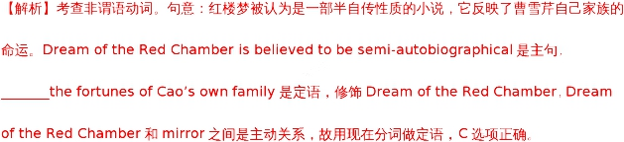
13.【2018·海淀二模】3. Personally speaking, ________the grand blueprint into reality is a long process.
A. turning B. turn
C. turned D. having turned
【答案】A
【解析】考查动名词。句意：在我看来，将这个宏伟的蓝图变成现实是一个漫长的过程。“_____ the grand blueprint into reality”做主语，所以要用动名词形式，故该空填turning。A选项正确。
14.【2018·滨海7校联考】12. Nowadays, more and more Chinese homes have the technology and equipment ______ to do online shopping.
A. needed B. needing
C. need D. to need
【答案】A
15.【2018·滨海7校联考】1. —May I help you? You seem to be having some problems.
— ______, thanks. I think I can manage.
A. All right B. No problem
C. It’s all right D. There’s no way
【答案】C
【解析】句意：——我可以帮助你吗？你好像遇到了一些麻烦。——没事儿，谢谢。我想我能处理。第一个说话人主动提出为第二个说话人提供帮助，根据答语中的“I think I can manage.”可知，第二个说话人婉言拒绝了，故选C，意为“没事儿，没什么”。
16.【2018·江苏97校联考】15. —Will Mr. Black pull us through the crisis of money?
—He is ________ and I don’t think he’ll help us with anything.
A. a tough nut B. Jekyll and Hyde
C. the salt of the earth D. a Scrooge
【答案】D
【解析】考查情景交际。A. a tough nut难对付的人；B. Jekyll and Hyde双重人格者；C. the salt of the earth高尚的人；D. a Scrooge吝啬鬼。句意：--布莱克先生会拉我们渡过难关吗?—他是一个吝啬鬼,我认为他不会帮助我们的。根据句意选D.
17.【2018·江苏97校联考】11. A new bridge has been built in recent years, only it much easier for cars to reach the hotel on the mountain top.
A. having made B. making
C. to make D. to have made
【答案】B

