2018年高考及最新模拟分类汇编之动词的时态和语态及情态动词
2018年高考动词的时态和语态及情态动词
1.【2018·北京】1. —Hi, I’m Peter. Are you new here? I haven’t seen you around?
—Hello, Peter. I’m Bob. I just _________ on Monday.
A. start B. have started C. started D. had started
【答案】C
【解析】考查时态。句意：——嗨，我是彼得。你是新来的吗？我没有在附近见过你。——你好，彼得。我是鲍勃。我周一刚刚开始住在这儿。根据两人谈话内容可知，Bob现在在这儿，他开始(start)住在这儿是发生在周一的事情，周一是一个过去的时间，故该句应用一般过去时态，C选项正确。
点睛：一般过去时表示过去某个时间里发生的动作或状态或过去习惯性、经常性的动作、行为。一般过去时常与表示过去的时间状语或从句连用，如：yesterday，last week，in the past，in 2017，once，a few days ago等。
2.【2018·北京】4. Susan had quit her well-paid job and _________ as a volunteer in the neighborhood when I visited her last year.
A. is working B. was working C. has worked D. had worked
【答案】B
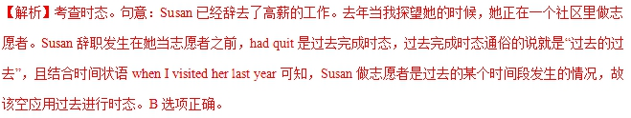点睛：过去进行时表示在过去某一时间段或某一段时间内正在发生或进行的动作或状态。
3.【2018·北京】7. China’s high-speed railways _________ from 9,000 to 25,000 kilometers in the past few years.
A. are growing B. have grown C. will grow D. had grown
【答案】B
【解析】考查时态。句意：在过去的几年里，中国的高速铁路已经从9,000公里增长到25,000公里。该句时间状语为in the past few years。中国高速铁路的增长是从过去一直到现在几年里的情况，故该句应用现在完成时态。B选项正确。
点睛：现在完成时可以表示过去的事情对现在的影响，也可以表示持续到现在的动作或状态，动词一般是延续性的。常见的时间状语有：since + 时间点/从句，for two months，so far，recently，in the past/last few days等。
4.【2018·北京】9. A rescue worker risked his life saving two tourists who _________ in the mountains for two days.
A. are trapping B. have been trapped C. were trapping D. had been trapped
【答案】D
【解析】考查语态和时态。句意：一个救援人员冒着生命危险挽救了两个被困在山里两天的旅游者。“who ___ in the mountains for two days”是定语从句，修饰two tourists，two tourists和trap之间是被动关系，该空应用被动语态。由risked可知，营救人员救游客是过去的事情，被困两天发生在营救人员救了他们之前，即“过去的过去”，该空应用过去完成时态。综上，D选项正确。
点睛：过去完成时表示过去某一时间或动作以前已经发生或完成了的动作，即“过去的过去”，其表达形式为had done，被动语态的表达形式为had been done。
5.【2018·北京】12. In today’s information age, the loss of data _________ cause serious problems for a company.
A. need B. should C. can D. must
【答案】C
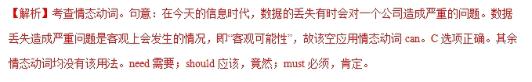
点睛：can的基本用法：1. (表示能力、功能)能，会；2. (表示推测)可能，可能会；3.（表示允许，请求）可以；4.（表示客观可能性）有时会。
6.【2018·北京】13. They might have found a better hotel if they _________ a few more kilometers.
A. drove B. would drive C. were to drive D. had driven
【答案】D
【解析】考查虚拟语气。句意：如果他们多开几公里的话，他们也许会找到一个更好的旅馆。由“they might have found a better hotel”可知，该句是表示对过去的虚拟。if ____ a few more kilometers是条件句部分，表示对过去的虚拟，条件句部分要用过去完成时态，故D选项正确。
点睛：1. 表示对现在的虚拟：if条件句用一般过去时，主句用would/might/could/should+do；2. 表示对过去的虚拟：if条件句用过去完成时，主句用would/might/could/should+have done；3. 表示对将来的虚拟： if条件句用were to do/should do/一般过去时，主句用would/might/could/should+do。
7.【2018·天津】15. If we ___________the flight yesterday, we would be enjoying our holiday on the beach
A. had caught B. caught
C. have caught D. would catch
【答案】A
【解析】考查虚拟语气。句意：如果我们昨天赶上飞机的话，现在我们正在海滩享受我们的假日了。根据时间状语yesterday可知，从句表示与过去事实相反，故用had + v-ed。故选A。
点睛：本题考查虚拟语气。虚拟语气重要做题原则：根据题干中主句或从句中动词形式判断所考查的动词的虚拟时间，一般要保持一致，但要注意错综时间虚拟语气要根据各自所表示的虚拟时间做出调整。本题就是错综条件虚拟语气，从句与过去事实相反，故用had + v-ed，主句与现在事实相反。
8.【2018·天津】13. My washing machine ___________this week, so I have to wash my clothes by hand.
A. was repaired B. is repaired
C. is being repaired D. has been repaired
【答案】C
【解析】考查时态。句意：这周我的洗衣机正在修，所以我不得不手洗衣服。根据后句so I have to wash my clothes by hand.可知，洗衣机正在修，故用现在进行时态的被动语态。故选C。
点睛：本题考查时态。分析选项可以知道，4个选项都用了被动语态，本题考查的其实是不同的时态。选项A是过去时；选项B是一般现在时的被动；选项C是现在进行时；选项D是现在完成时。再结合语境进行分析，最终判断出最佳答案。
9.【2018·天津】10. I can't find my purse. I___________ it in the supermarket yesterday, but I'm not sure.
A. should leave B. must have left
C. might leave D. could have left
【答案】D
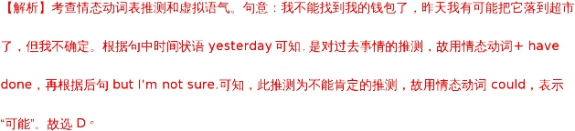
点睛：情态动词是每年高考的热点也是难点。本题抓住两点：第一、时态。根据句中时间状语可以判断出是对过去事情的推测，故用情态动词 + have done；如果是对现在事情的推测，才用情态动词+v原形。第二、情态动词的选择。must为肯定推测，表示“一定”，could为不肯定推测，表示“可能”，这样就能选出正确答案。
10.【2018·江苏】31. Hopefully in 2025 we will no longer be e-mailing each other, for we _______ more convenient electronic communication tools by then.
A. have developed B. had developed
C. will have developed D. developed
【答案】C
【解析】考查时态。句意：希望在2025年，我们不再互相发电子邮件，因为到那时候我们将开发更方便的电子通信工具。根据时间状语in 2025，可知用将来时；再根据时间状语by then到那时，可知用完成时。结合两者可知用将来完成时。故选C。
点睛：本题考查时态。句中包含的时间状语是解答此题的突破点。所以要做好此类题，一定要注意题中有没有明确的时间点，或者其他可以代替时间点的词，所以根据时间状语可以看出正确答案。本题的关键在于抓住题干中的两个时间状语in 2025和by then，从而得出答案。
11.【2018·江苏】30. I was sent to the village last month to see how the development plan _______ in the past two years.
A. had been carried out B. would be carried out
C. is being carried out D. has been carried out
【答案】A
【解析】考查时态。句意：上个月我被派到村里去看看在过去的两年里发展计划是如何执行的。根据句中时间状语last month和in the past two years可知用过去完成时。故选A。
点睛：本题考查时态。句中包含的时间状语是解答此题的突破点。所以要做好此类题，一定要注意题中有没有明确的时间点，或者其他可以代替时间点的词，所以根据时间状语可以看出正确答案。本题的关键在于抓住题干中的两个时间状语last month和in the past two years，从而得出答案。
12.【2018·江苏】27. There is a good social life in the village, and I wish I _______ a second chance to become more involved.
A. had B. will have
C. would have had D. have had
【答案】A
【解析】考查虚拟语气。句意：在这个村里有很好的社交生活，并且我希望我再有机会去更多的参与。本题考查wish引导的宾语从句，表示与现在事实相反的愿望，所以从句用一般过去时。故选A。
点睛：本题考查wish引导的虚拟语气。由wish引起的表示愿望的虚拟语气：1．用wish表示对现在的愿望时，它所引起的宾语从句中谓语动词形式为：过去式（be动词用were）。2．用wish表示对将来的愿望时，它所引起的宾语从句中谓语动词形式为：would, could, might+ 动词原形。3．wish用于对过去的事实表示一种不可能实现的愿望时，宾语从句中的谓语动词形式为：had+动词过去分词或could, would + have +动词过去分词。分析此题需抓住前句There is a good social life in the village的时态是一般现在时，可以判断出此题wish用于对现在的事实表示一种不可能实现的愿望。
13.【2018·江苏】24. It’s strange that he _______ have taken the books without the owner’s permission.
A. would B. should
C. could D. might
【答案】B
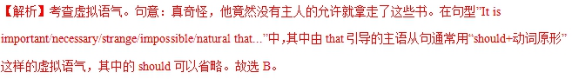
点睛：本题考查虚拟语气。It is important/necessary/strange/impossible/natural that... 主语从句多数情况下用虚拟语气，表达一种要求、命令或者责备、建议或主观看法。但是如果只是表示陈述一个事实而不是强烈的感情，完全可以用一般的陈述语气。试比较： It is strange that he had made a mistake.（陈述一个事实：他犯了错误让人有点奇怪。） It is strange that he (should) have made a mistake. （虚拟语气，说话者是在责备他本不应该犯错。）
14.【2018·海淀二模】13. —How was your vacation in Seattle?
—Pretty good. In the evenings I __________ to pubs to enjoy beer.
A. have gone B. go
C. had gone D. went
【答案】D
【解析】考查时态。句意：——你在西雅图的假期怎么样？——相当好。晚上我去酒吧里喝啤酒。由“How was your vacation”可知，第二个说话者在西雅图度假是过去的事情，晚上去酒吧喝啤酒是在西雅图度假时的行为，故该空应用一般过去时态。故D选项正确。
15.【2018·海淀二模】11. He messed the project up, but he behaved as if nothing __________.
A. had happened B. happened
C. would happen D. would have happened
【答案】A
【解析】考查虚拟语气。句意：他把这个项目搞糟了，但他表现的好像什么也没发生一样。as if引导的从句表示与事实相反的情况时，应用虚拟语气。该句表示对过去的虚拟，根据as if的虚拟规则，该处应用过去完成时态。A选项正确。
16.【2018·海淀二模】10. When I was small, my mom ________read me stories at night.
A. could B. should
C. might D. would
【答案】D
【解析】考查情态动词辨析。句意：当我小时候，我母亲常常在晚上给我读故事。could能够；should应该；might可能，可以；would过去常常，表示过去的习惯性的行为，故选D。
17.【2018·海淀二模】6. By now 516 Confucius Institutes ______in 142 countries and regions, according to the Confucius Institute Headquarters.
A. founded B. would found
C. have been founded D. had been founded
【答案】C
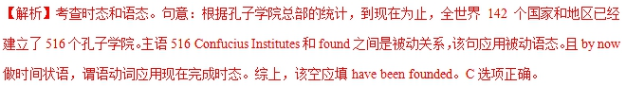 18.【2018·海淀二模】4. I _____up my mind what I was going to say in the seminar, but it was cancelled.
A. have made B. had made
C. was making D. would make
【答案】B
【解析】考查时态。句意：我已经决定了在研讨会上要说什么，但是，研讨会被取消了。“make up one’s mind”这个行为发生在研讨会被取消之前，根据“it was cancelled”可知，研讨会被取消是过去的事情，那么，make up one’s mind是发生在过去某个动作之前的行为，故该空应用过去完成时态。B选项正确。
19.【2018·滨海7校联考】15. But for your instruction, I ______ such great progress in so short a time. Thanks a lot.
A. wouldn’t make B. hadn’t made
C. won’t make D. wouldn’t have made
【答案】D
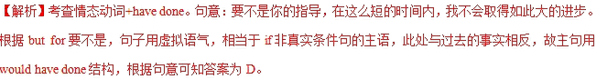20.【2018·滨海7校联考】7. — Is Peter coming?
— No, he ______ his mind after a phone call at the last minute.
A. changes B. changed
C. was changing D. had changed
【答案】B
【解析】试题分析：句意：彼得来了吗？没有，刚才接到一个电话后改变主意了。根据at the last minute在最后一秒可能发生在过去，故用一般过去时。
考点：考查动词的时态。
21.【2018·滨海7校联考】2. —Are you coming to Jeff’s party?
—I’m not sure. I ______ go to the concert instead.
A. must B. would
C. should D. might
【答案】D
【解析】试题分析：句意，上文，你来参加Jeff的聚会吗？下文，我不确定。我可能会去看电影。Must必须；would将要；should应该；might可能，故选D。
考点：情态动词辨析
22.【2018·江苏97校联考】14. —Dora, do you think Jack’s proposal reasonable?
—I’m sorry I have missed that, but actually I ________ about another one.
A. thought B. have thought
C. had thought D. was thinking
【答案】D
【解析】考查动词时态。句意：--多拉，你认为杰克的建议合理吗？--对不起，我没听见。实际上我刚才在考虑另外一种想法。表示刚才正在进行的动作，用过去进行时。故选D.
23.【2018·江苏97校联考】6. —You look pretty tired today!
—I an environmental report over the last few days, which should be submitted to the boss tomorrow.
A. wrote B. was writing
C. had written D. have been writing
【答案】D
【解析】考查动词时态。句意：--你今天看起来很累！-- 在过去的几天里我一直在写一个环境报告，这个报告明天应要提交给老板。表示从几天前开始一直进行持续到现在的动作，用现在完成进行时，故选D.
24.【2018·江苏97校联考】5. —Why didn’t you call me then?
—Oh, my cell-phone was power off. I ________ you otherwise.
A. would call B. had called
C. have called D. would have called
【答案】D
