2018年高考及最新模拟
分类汇编之词、短语辨析（名词、动词、形容词、副词、代词和介词）
2018年高考词、短语辨析（名词、动词、形容词、副词、代词和介词）
1.【2018·北京】14. —Good morning, Mr. Lee’s office.
—Good morning. I’d like to make an appointment _________ next Wednesday afternoon.
A. for B. on C. in D. at
【答案】A
【解析】考查介词。句意：——早上好，Lee先生办公室。——早上好。我想预约下周三下午（和Mr. Lee见面）。make an appointment for意为“为……预约”，是固定搭配，故A选项正确。
点睛：make an appointment with sb.和某人预约；make an appointment for为……预约。
2.【2018·天津】11. Bob thought he couldn't go to the party because he had to write a report, but he went ___________.
A. at first B. after all
C. above all D. at random
【答案】B
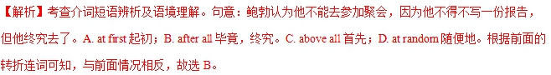
点睛：本题侧重考查在特定的语境中辨析短语的能力。对于短语而言，没有捷径可言，只有老老实实的记忆。考生除了要充分利用特定语境理解词义，还需要重点关注他们用法上的区别。
3.【2018·天津】8. It took him a long time to___________ the skills he needed to become a good dancer.
A. display B. acquire
C. teach D. test
【答案】B
【解析】考查动词词义辨析及语境理解。句意：他花了很长时间才获得了成为一名优秀舞蹈家所需的技能。A display显示；B. acquire获得；C. teach教；D. test测试。故选B。
点睛：本题考查动词辨析。动词和动词短语的考查是高考重点考查的知识点，解题时要区分清选择项的含义与区别，再联系句意进行判断，从而选出正确答案。
4.【2018·天津】6. The__________ that there is life on other planets in the universe has always inspired scientists to explore the outer space.
A. advice B. order
C. possibility D. invitation
【答案】C
【解析】考查名词词义辨析及语境理解。句意：宇宙中其它星球上存在生命这种可能性总是激励科学家们去探索外部空间。A. advice建议；B. order命令；C. possibility可能性；D. invitation邀请。故选C。
点睛：本题考查名词辨析。名词和动词及短语的考查是高考重点考查的知识点。本题语法上是一个同位语从句，从句that there is life on other planets in the universe是来解释说明前面所选择的名词。根据常识可以判断，宇宙中其它星球上存在生命只是一种可能性，目前无法证明，从而选出正确答案。
5.【2018·天津】3. At first Robert wouldn't let his daughter go diving, but eventually he___________ as she was so confidence about her skills.
A. gave in B. dressed up
C. broke in D. turned up
【答案】A
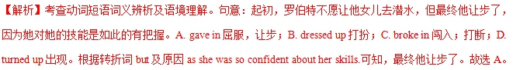
点睛：本题考查动词短语辨析。分析后句的原因状语可以判定出罗伯特最终让步，再联系所学短语就不难选出正确答案。同学平时学习过程中要多注意词汇和短语的积累，尤其是含义比较多的词汇和短语。
6.【2018·江苏】34. Despite the poor service of the hotel, the manager is _______ to invest in sufficient training for his staff.
A. keen B. reluctant
C. anxious D. ready
【答案】B
【解析】考查形容词词义辨析及语境理解。句意：尽管旅馆服务不好，经理还不愿投入为员工提供足够的培训。A. keen敏锐的；B. reluctant不情愿的；C. anxious渴望的；D. ready准备好的。故选B。
点睛：本题侧重考查在特定的语境中辨析形容词词义的能力。因此，考生必须充分利用这一特定语境。同时，考生应注意多积累由形容词组成的固定短语。本题中4个选择项中都可以与to连用。be keen to渴望；be reluctant to不情愿做；be anxious to急于；be ready to乐意，再分析句意可以得出答案。
7.【2018·江苏】33. China’s soft power grows _______ the increasing appreciation and understanding of China globally.
A. in line with B. in reply to
C. in return for D. in honour of
【答案】A
【解析】考查介词短语词义辨析及语境理解。句意：中国的软实力增长与日俱增全球对中国的赏识和理解相一致。A. in line with按照；与...一致；B. in reply to答复；C. in return for作为 ... 的报酬；D. in honour of为纪念。故选A。
点睛：本题侧重考查在特定的语境中辨析介词短语的能力。考生平时在学习中多积累之外还需要充分利用特定语境理解词义，还应注意多辨析意思相近的介词短语，重点关注他们用法上的区别。
8.【2018·江苏】32. Try to understand what’s actually happening instead of acting on the _______ you’ve made.
A. assignment B. association
C. acquisition D. assumption
【答案】D
【解析】考查名词词义辨析及语境理解。句意：试着去理解实际发生的事情，而不是按照你所做的假设行事。A. assignment分配；B. association交往；C. acquisition获得；D. assumption假设。故选D。
点睛：本题考查名词辨析。名词考查是高考重点考查的知识点。本题抓住句中的关键词actually happening实际发生和instead of而不是，可知是假设，从而选出正确答案。
9.【2018·江苏】25. Developing the Yangtze River Economic Belt is a systematic project which _______ a clear road map and timetable.
A. calls for B. calls on
C. calls off D. calls up
【答案】A
【解析】考查动词短语词义辨析及语境理解。句意：发展长江经济带是一项需要清晰的路线图和时间表的系统工程。A. calls for需要；B. calls on号召；C. calls off取消；D. calls up使想起。故选A。
点睛：本题考查动词短语辨析。分析全句句意，再联系所学短语就不难选出正确答案。同学平时学习过程中要多注意词汇和短语的积累，尤其是含义比较多的词汇和短语。
10.【2018·江苏】22. Kids shouldn’t have access to violent films because they might _______ the things they see.
A. indicate B. investigate
C. imitate D. innovate
【答案】C
【解析】考查动词词义辨析及语境理解。句意：孩子不应该接触暴力电影，因为他们也许会模仿他们所见的事情。A. indicate指示；B. investigate调查；C. imitate模仿；D. innovate改革。故选C。
点睛：本题考查动词辨析。动词和动词短语的考查是高考重点考查的知识点，解题时要区分清选择项的含义与区别，再联系句意进行判断，从而选出正确答案。考生在平时学习过程中要注重动词和动词短语的识记与掌握。
11.【2018·海淀二模】15. This view is common _________ all sections of the community.
A. across B. above
C. around D. along
【答案】A
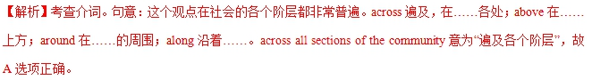12.【2018·滨海7校联考】14. We arranged to meet at the cinema at 7:30, but Jack failed to ______.
A. break up B. set up
C. turn up D. give up
【答案】C
【解析】考查动词词组。A. break up 打碎，解散； B. set up建立； C. turn up出现，调高； D. give up放弃。句意：我们安排在7:30在电影院见面，但杰克没能来。根据句意可知答案为C。
13.【2018·滨海7校联考】8. “Made in China 2025” aims to transform China from a product-making factory into a product-making power, ______ driven by innovation and emphasizing quality over quantity.
A. the one that B. one that
C. one D. the one
【答案】C
【解析】试题分析：考查代词的用法。one表示泛指，相当于“a(an)+名词”，代替的是同类事物中的“一个”；that表示特指，相当于“the+名词”；代词one=" a/" an +n处one="a" product-making power；而________driven by innovation and emphasizes quality over quantity中driven by 只是一个非谓语短语（be driven by 被……驱使）作定语，因此不需要连词引导。所以排除A、 B。one表示泛指，相当于“the+名词”可以排除D。句意：“2025中国制造”的目标是把中国从一个产品制造工厂变成一个产品制造大国，一个以创新为导向、强调质量而不是数量的大国。故选C。
考点：考查考查代词的用法。
14.【2018·滨海7校联考】6. Jane’s grandmother had wanted to write ______ children’s book for many years, ______ but one thing or another always got in ______ way.
A. a; 不填 B. the; the
C. 不填; the D. a; the
【答案】D
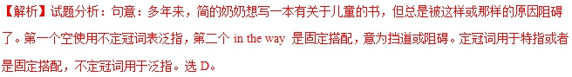
【考点定位】考查冠词的使用
15.【2018·滨海7校联考】4. The guidance teacher was their adviser, offering them suggestions and solutions when they ______ difficulties.
A. arose B. encountered
C. emerged D. evaluated
【答案】B
【解析】考查动词。A. arose出现； B. encountered 遇到；C. emerged浮现，暴露； D. evaluated评估。指导老师是他们的导师，当他们遇到困难时，给他们提供建议和解决方案。可知答案为B。
16.【2018·滨海7校联考】5. The police officers decided to conduct a thorough and ______ review of the case.
A. comprehensive B. complicated
C. conscious D. constant
【答案】A
【解析】考查形容词。句意：警官决定对这起案件进行一次彻底全面的审查。A项“综合的，全面的，有理解力的”；B项“复杂的”；C项“有意识的”；D项“经常的”。故选A项。
17.【2018·江苏97校联考】13. —Congratulations on your girlfriend’s being offered the job.
—Thank you, but she’s got it ________ her greater perseverance.
A. in terms of B. in response to
C. by virtue of D. with respect to
【答案】C
【解析】考查介词短语。A. in terms of根据；B. in response to响应；C. by virtue of由于，凭借；D. with respect to关于。句意：--祝贺你的女朋友找到了工作。--谢谢，她是凭借更大的毅力得到的。根据句意选C.
18.【2018·江苏97校联考】10. More and more people tend to go to E-libraries in that they have access to books when they are unable to get to a library.
A. accidentally B. physically
C. voluntarily D. appropriately
【答案】B
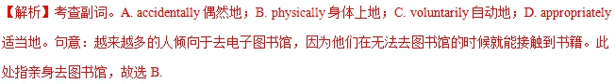19.【2018·江苏97校联考】7. Evidence begins to that the earth and the rest of the universe are in fact changing with time.
A. accumulate B. accelerate
C. accompany D. approve
【答案】A
【解析】考查动词。A. accumulate累积；B. accelerate加速；C. accompany陪伴；D. approve批准。句意：地球和宇宙的其他部分实际上在随着时间而改变的证据开始累积。指证据积累，故选A.
20.【2018·江苏97校联考】4. Nowadays when travelling, travelers usually use the We-chat to share their feelings about their trips with descriptions of their experiences, offering viewers a(n) for the imagination of reality.
A. feast B. account
C. landscape D. principle
【答案】A
【解析】考查名词。A. feast盛宴；B. account账户；C. landscape风景；D. principle原理。句意：如今旅行时，旅行者通常会利用微信来描述他们的旅行体验，并向观看者提供真实想象的盛宴。故选A.
21.【2018·江苏97校联考】1. Courage, according to some successful persons, is as to pioneering work as the intelligence, even more so.
A. accessible B. alternative
C. essential D. commercial
【答案】C
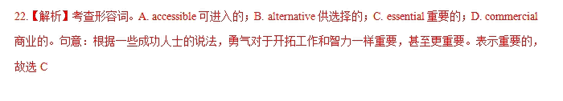23.【2018·江苏97校联考】2. The police have anyone with information to come forward and talk to them.
A. appealed to B. attended to
C. responded to D. attached to
【答案】A
【解析】考查动词短语。A. appealed to呼吁；B. attended to出席，参加；C. responded to做出反应；D. attached to附属于。句意：警方呼吁任何知道信息的人站出来与他们交谈。表示呼吁，故选A.

