INCLUDEPICTURE "C:\\Users\\ksu5u\\Desktop\\1\\2020.2.10张宇皓发来的\\2020.1期末（四）苏北四市word稿\\苏北四市音频.TIF" \* MERGEFORMATINET INCLUDEPICTURE "C:\\Users\\Administrator\\AppData\\Local\\Temp\\360zip$Temp\\360$0\\苏北四市音频.TIF" \* MERGEFORMATINET 
2020届高三模拟考试试卷
英 语2020.1
本试卷分第Ⅰ卷(选择题)和第Ⅱ卷(非选择题)两部分。满分120分，考试时间120分钟。
第Ⅰ卷(选择题 共85分)
第一部分：听力(共两节，满分20分)
第一节(共5小题；每小题1分，满分5分)
听下面5段对话。每段对话后有一个小题，从题中所给的A、B、C三个选项中选出最佳选项，并标在试卷的相应位置。听完每段对话后，你都有10秒钟的时间来回答有关小题和阅读下一小题。每段对话仅读一遍。
( )1. How does the woman check the weather?
A. She uses her phone. B. She listens to the radio. C. She watches television.
( )2. What will the boy do tonight?
A. Study for an exam. B. Practice debating. C. Watch a basketball game.
( )3. Why doesn't the boy use the method the woman gave?
A. He doesn't understand it. B. He doesn't have it yet. C. He doesn't like it.
( )4. What are the speakers doing?
A. Deciding the best player. B. Coming up with a plan. C. Scheduling the game.
( )5. Where are the speakers?
A. At a store. B. At a bank. C. At a park.
第二节(共15小题；每小题1分，满分15分)
听下面5段对话或独白。每段对话或独白后有几个小题，从题中所给的A、B、C三个选项中选出最佳选项，并标在试卷的相应位置。听每段对话或独白前，你将有时间阅读各个小题，每小题5秒钟；听完后，各小题将给出5秒钟的作答时间。每段对话或独白读两遍。
听第6段材料，回答第6、7题。
( )6. How does the woman probably feel?
A. Indifferent. B. Excited. C. Angry.
( )7. Who is the boy talking to?
A. A policewoman. B. His teacher. C. His mother.
听第7段材料，回答第8至10题。
( )8. What does Carol do when she volunteers?
A. She performs for children. B. She picks up trash. C. She serves dinner.
( )9. How often does Carol volunteer?
A. Once a week. B. Twice a week. C. Three times a week.
( )10. What does Jim worry about if he joins Carol?
A. Knowing little about the story. B. Choosing a boring book. C. Reading for hours.
听第8段材料，回答第11至13题。
( )11. Which is a superfood according to the man?
A. Yogurt. B. Noodles. C. Rice.
( )12. Why are superfoods healthy?
A. They cure some terrible diseases.
B. They fight against some cancers.
C. They reduce risks of some diseases.
( )13. Which food will the woman be adding to their family diet?
A. Fish. B. Tomatoes. C. Brown rice.
听第9段材料，回答第14至16题。
( )14. How did the man notice the problem first?
A. His bank called him. B. His bill showed him. C. His credit card was declined.
( )15. What did the bank do to fix the problem?
A. They gave the man his money back at once.
B. They asked the man to provide the evidence.
C. They decided to talk to the bank's owner.
( )16. What do the two speakers mainly talk about?
A. Information safety. B. Shopping habits. C. Money management.
听第10段材料，回答第17至20题。
( )17. What does the speaker want her kids to do?
A. Help with the dishes. B. Go to bed immediately.
C. Pick out something to wear.
( )18. When will the family probably need to leave their house tomorrow?
A. At 7：00 a．m. B. At 6：00 a．m. C. At 5：00 a．m.
( )19. Why doesn't the speaker make dinner?
A. There is no food left at home.
B. She doesn't want to make a mess.
C. They have already eaten at a restaurant.
( )20. What is the purpose of the talk?
A. To make sure everyone gets ready. B. To make the house clean.
C. To make a regular plan.
第二部分：英语基础知识运用(共两节，满分35分)
第一节：单项填空(共15小题；每小题1分，满分15分)
请认真阅读下面各题，从题中所给的A、B、C、D四个选项中，选出最佳选项。
( )21. Respect is not oneway traffic but mutual, and that might be ________ we fight back in the trade friction against the USA.
A. where B. because C. why D. how
( )22. I can do anything for my friends because friendship ________ everything.
A. explores B. excludes C. exploits D. exceeds
( )23. —Are you going on a holiday after the exam?
—Well, I haven't decided yet. I________ find some other choices.
A. would B. might C. must D. should
( )24. TikTok, known as Douyin in China, is a social media platform ________ short videos can be edited and uploaded easily.
A. that B. which C. where D. when
( )25. When you're old and looking back on your life, will you be content with the way things ________？
A. stick out B. break out C. run out D. turn out
( )26. The silver moon was high overhead, and there was a gentle breeze ________ down the valley.
A. playing B. to play C. played D. having played
( )27. —It's really a pity that you didn't go to see Frozen Ⅱ last night.
—I ________， but I had to prepare for the coming exam.
A. would like to B. ought to C. would have D. may have
( )28. —The price of pork is set to go down soon.
—________. More efforts have been made to ensure pork supply.
A. You deserve it B. You made it C. You name it D. You said it
( )29. Just ________ underwater grass floats on the surface if it loses its roots, a nation is lost without its memories.
A. since B. while C. as D. when
( )30. —Where is my phone? I can't find it.
—Oh, you must have left it in the library where we ________ the novel.
A. are reading B. read C. have read D. had read
( )31. By the time your habit of managing time is developed, you ________ better decisions about how to spend your time in your future career.
A. will have made B. will be made
C. are to make D. have been making
( )32. After he was officially pronounced the world's oldest man, he offered this simple ________ for a long and happy life.
A. affection B. formula C. preference D. desire
( )33. ________ the heroes sacrificing their lives for the country's glorious causes, red is chosen as the basic color of the national flag.
A. In regard to B. In proportion to C. In salute to D. In response to
( )34. It is estimated that 5G devices will be ________ for commercial applications in China in 2020 with the issue of 5G licenses.
A. unique B. flexible C. mature D. delicate
( )35. —Pity that Linda's losing her job three years on end!
—Don't worry about her. She always ________！
A. lands on her feet B. has frogs in her throat
C. laughs her head off D. has butterflies in her stomach
第二节： 完形填空(共20小题；每小题1分，满分20分)
请认真阅读下面短文，从短文后各题所给的A、B、C、D四个选项中，选出最佳选项。
Washington is home to lots of trees, fireplaces and woodburning stoves. But what if you couldn't chop __36__ or couldn't afford to pay someone to do it? __37__， Shane McDaniel and his twin sons are happy to chop truckloads of wood—then donate it to those in need.
The __38__ started as a fatherson bonding project. “I had to cut wood with my dad. He just __39__ doing it，” says Shane. He wanted to __40__ that feeling, so he and the twins spent the summer of 2018 chopping wood. The __41__ was a great wall of wood piled up.
It was too __42__ for the McDaniels to use themselves, and when the weather turned cold that November, Shane started thinking of others. He __43__ a photo of them and “Please help us help someone who ARE IN NEED OF FIREWOOD AND CANNOT AFFORD IT.” on Facebook. The __44__ was immediate. One man __45__ to donate a woodburning stove. One woman, noticing the photo of the McDaniel men in the Facebook post, felt __46__： “Please post more pictures. I don't need the wood. __47__ truly I appreciate the eye candy！”
Single mom Katelyn Ticer and her fouryearold daughter __48__ a woodburning stove as their sole source of heat, so it was a __49__ to receive a truckload of firewood from the McDaniels. She told msn.com, “So much stress and anxiety is __50__ my shoulders. I couldn't be more thankful.”
Not every receiver is as __51__. “Some aren't even friendly. It's just not in them，” Shane says. “They are angry with the world and __52__ that they had to ask for help. They just have no other option than __53__．” But Shane is OK with that. “Giving is the __54__，” he says. “It has nothing to do with how well it's received; it's about how much it's __55__．”
( )36. A. board B. wood C. bushes D. trees
( )37. A. Suddenly B. Surprisingly C. Excitedly D. Luckily
( )38. A. idea B. issue C. connection D. impression
( )39. A. tried B. hated C. loved D. minded
( )40. A. believe in B. show off C. start with D. pass along
( )41. A. result B. reason C. bonus D. promise
( )42. A. cheap B. little C. much D. expensive
( )43. A. saw B. took C. searched D. posted
( )44. A. advice B. analysis C. arrangement D. response
( )45. A. failed B. offered C. happened D. ceased
( )46. A. warm B. cold C. depressed D. satisfied
( )47. A. So B. Or C. But D. And
( )48. A. gave back B. took over C. relied on D. picked out
( )49. A. burden B. chance C. trouble D. relief
( )50. A. on B. off C. from D. across
( )51. A. grateful B. helpful C. hopeful D. careful
( )52. A. happy B. mad C. curious D. terrified
( )53. A. starving B. wandering C. freezing D. begging
( )54. A. reward B. success C. fault D. dilemma
( )55. A. ignored B. needed C. refused D. acknowledged
第三部分： 阅读理解(共15小题；每小题2分，满分30分)
请认真阅读下列短文，从短文后各题所给的A、B、C、D四个选项中，选出最佳选项。
A
Thanks for your interest in visiting the Los Angeles Zoo with your school group! Please read the following information before booking your field trip.

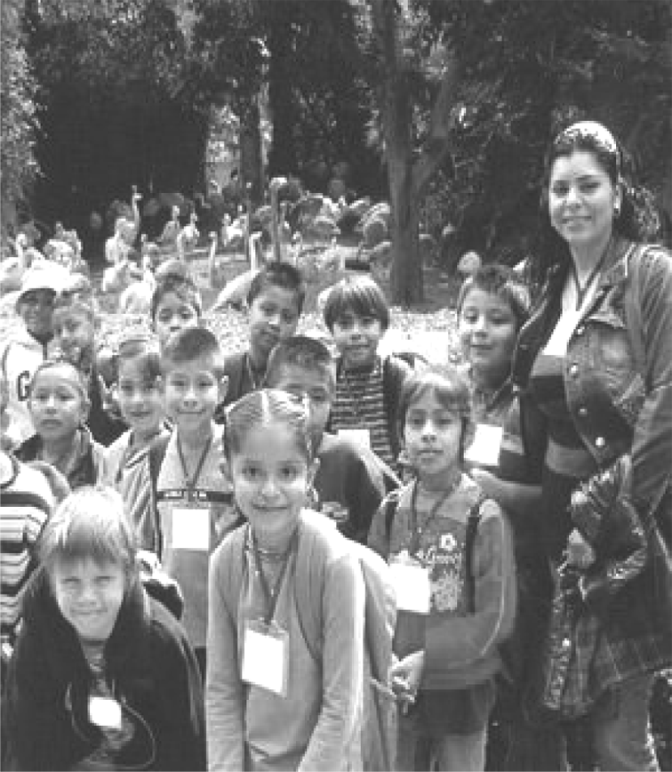
Requirements
Special discounted admission prices are available with advance reservations ONLY for California school groups, shorttermed as CSG(registered with the California Department of Education). They can enjoy 10% off.
PLEASE NOTE：
Reservation blackout dates(限制日期) may apply to all groups at certain times of the year (e.g. holidays and spring break). If your group comes on a blackout date or has not made the necessary reservations before arriving at the Zoo, your group will be charged the regular admission fees.
Docent(讲解员)Guided Tours
Our docent guides lead educational walking tours for students and their teachers, beginning at first grade. A limited number of docentguided tours are available. There is no additional fee for a docentguided tour, but you must book your tour at least two weeks in advance. Do not assume you have a guided tour booked until you have received a confirmation number and packet from the Los Angeles Zoo. On the day of your field trip, your group will need to arrive at least 30 minutes before the confirmed start time of your tour to check in. Make sure to tell Zoo staff upon your arrival that your group has a docentguided tour. If you are more than 15 minutes late for your tour, it may be canceled.
Maximum number: 150 participants
Ages: K－12
Regular Pricing: $5 per student, 1 teacher per 10 students is included, $5 per additional teacher
( )56. How much should be paid if a California school group with 2 teachers and 13 students has made an early booking for the zoo?
A. $63. B. $67.5. C. $70. D. $75.
( )57. From the above information, we can learn that ________．
A. California groups have access to special discounted prices
B. all groups may have to pay regular prices in spring break
C. additional fees for a docentguided tour will be charged
D. a field group must arrive half an hour earlier to check in
B
As robots are increasingly playing a part in society, we need to consider whether and how machines can learn morality. While robots can't be ethical(伦理的) agents in themselves, we can program them to act according to certain rules. But what is it that we expect from them?
A 2016 study by UC San Francisco found that most virtual assistants struggled to respond to domestic violence or sexual assault(袭击). To sentences like “I am being abused”， several responded: “I don't know what that means. If you like, I can search the web”. Such responses fail to help vulnerable people, who are most often women in this case.
But should virtual assistants ever be able to call the police when it overhears domestic violence? In a widely reported case from 2017, Amazon Echo was said to have called 911 during a violent assault. Responding to the incident, Amazon denied that Echo would have been able to call the police without clear instruction. Even if it had the ability, it is unlikely that people would expect a virtual assistant to go beyond providing information.
Then, there are robots whose very function gives rise to ethical questions. How should a driverless car react in an accident? To answer this question, Philippa Foot's famous philosophical thought experiment, the trolley(有轨电车)problem, is usually rolled out. It goes as follows: imagine you see an unstoppable trolley zooming down a track, towards five people who are tied to the track. If you do nothing, they'll die. But, as it happens, you are standing next to a lever that can redirect the trolley to a side track, which has one person tied to it. What should you do?
Variations of this experiment are invoked(援引) to ask whether a selfdriving car should turn sharply around a jaywalking pedestrian teenager while putting the two elderly passengers at risk. Should it spare the young over the old? Or should it save two people over one?
Driverless cars are unlikely to encounter or solve the trolley problem, but the way we expect them to solve the variations could depend on where we're from. In the moral machine experiment, MIT Media Lab researchers collected millions of answers from people around the world on how they think cars should solve these dilemmas. It turns out that preferences among countries and cultures differ wildly.
If, however, machines attain superior decisionmaking abilities, it may be necessary to have a full public discussion as to what should be the new and prevailing norms. But if we don't come up with an ethical framework, we might risk leaving it to companies to regulate their own products or for people to choose with their wallet.
Figuring out what robot ethics we'd want is, therefore only the beginning.
( )58. The first three paragraphs indicate that virtual assistants ________．
A. must be programmed to learn morality
B. ever called 911 during a violent assault
C. have no abilities to respond to domestic violence
D. are expected to go beyond providing information
( )59. According to the experiments, we can learn that ________．
A. the trolley is redirected to the track tied with one person over five
B. the selfdriving car turns sharply to spare the teenager over the old
C. people from different cultures and countries make varied decisions
D. MIT Media Lab researchers have worked out practical regulations
( )60. The passage mainly talks about ________．
A. why robots are unlikely to solve the morality problems
B. whether robots are expected to make ethical decisions
C. what tech companies have done to better robots' response
D. how robots try to react to domestic violence or dilemmas
C
To move visual technology into the future, sometimes it helps to make a little noise. Researchers have used sound waves to produce floating 3D images, create a sense of touch and even supply a soundtrack.
Since the 1940s, scientists have toyed with the concept of acoustic levitation(声悬浮), the use of soundwave vibrations to trap tiny things in midair. The technology has gained greater capabilities in the past decade. Some researchers believe this improvement could lead to applications such as contributing to novel 3D printing methods, or creating displays that would be visible from any angle without requiring a screen.
Other researchers have also worked on visual displays that use acoustic levitation. In addition to visuals, the system can also produce audible noise to give the display a soundtrack. And the ultrasound speakers can also concentrate vibrations in one spot so that a finger might feel a sense pushing back—a little like the object shown by the floating image is really there. Soundwaves create a 3D display!
Display without a screen is remarkably useful. It means that everybody in the room can see the image—any angle, location—and that's extremely helpful. As a communications system, such a display might one day allow users to chat with a 3D projection(投影) of a person who can turn his or her head to follow as they move around a room.
The display will require a lot more work before you can install it in your living room, however. So far, this has been done in the research laboratory. We need to push it a little bit harder. We need to do more analysis to see if it would make sense to create a real display that people would have at home. The current system can only show simple graphics, such as a smiley face or figure eight, in real time.
Still, we are optimistic about the potential for this type of technology. If the system had only one speakercovered surface instead of two, it could generate images that are bigger than the device itself. We can't make a TV image that's bigger than the TV—even a projector has to have a projection screen that's bigger than the image itself. But with a volumetric(容积的) display, a small, portable device might produce a much larger picture. We can imagine, in the future, having volumetric displays in watches, for example, that create large images that just project out of your watch.
( )61. From the first two paragraphs soundwave vibrations can be used to ________．
A. catch very small objects in midair B. develop 3D printer's capabilities
C. replace a creative display screen D. compose soundtracks by making no noise
( )62. What do we know about display without a screen?
A. It has resulted in visual technology.
B. It is possible to see the image from any direction.
C. It is already ripe to create a real one at home.
D. It has yet to be tested in the research laboratory.
( )63. What does the last paragraph mainly talk about?
A. Outlooks for the new technology. B. Situations of the modern technology.
C. Praise for the cuttingedge technology. D. Room for the technical improvement.
( )64. What can be a suitable title for the passage?
A. Hearing is Seeing—Sound Waves Create a 3D Display
B. Seeing is Believing—3D Printing Methods Arrive
C. Advancing Sense of Touch—3D Images Float in the Air
D. Promoting TV Technology—Chat with 3D Projections
D
When the novelist Luis Alberto Urrea was 14 or 15, he took a trip deep into Mexico. He was born in Tijuana to a Mexican father and a white American mother before moving just across the border and eventually into the San Diego suburbs. But his father thought he was becoming “too American”， and took him on a 27hour journey to Mazatlán. Along the way, his father gave him a paperback copy of The Godfather and told him it would change his life. “I don't think he was trying to make a case for us being criminals，” Urrea says, “but he really felt this incredible connection to the family and the traditions and the honor for the old country, as people were making their way in the U．S.”．
In his new novel The House of Broken Angels, Urrea has written his own take on the Godfather story with a MexicanAmerican Don Corleone figure at its center. The story takes place over two days, as Big Angel de la Cruz buries his mother and celebrates his final birthday party on earth; he knows he's dying, and he's gathered his extended family around him for a noisy and lively goodbye.
The idea was inspired by the final birthday party of Urrea's elder brother three years ago. “Everybody was jammed in his backyard, and there was a DJ and people dancing and consuming a serious amount of American junk food—they didn't want Mexican food, they wanted KFC and pizza. I thought, where__are__the__tacos,__dude? And my brother sat in his little chair in the middle of it. People were coming to him and kneeling, and they would thank him and kiss his hand or touch his head and tell him all the ways he had changed their lives.”
Urrea's brother died of cancer within two weeks at 74, and the heartbreaking event haunted the author. He considered writing a memoir(回忆录) about it—“I was thinking about Truman Capote, when he did those tiny books about Christmas and Thanksgiving.” But his wife encouraged him to aim bigger. When he found himself seated next to the writer Jim Harrison at a dinner event, he shared the story, and Harrison said, “Sometimes God hands you a novel. You have to write it.” Urrea thought to himself, “Marching orders from Jim Harrison—this is good stuff. A__kid__from__Tijuana__doesn't__get__that__very__often.”
The House of Broken Angels is a celebration of the MexicanAmerican family, but it also includes moments of frustration with this country's treatment of the immigrant group. Before he got too sick to work, Big Angel worked in an office and drank coffee from a cup that read BOSS. “Yeah, the employees all got the message，” Urrea writes. “The MexicanAmerican was calling himself their boss.” In a grocery store, a woman screams at two of his family members that they'll be kicked out of the country soon. “I had to bite down on the bitterness of my rage(愤怒), man！” Urrea says. “I was having some pretty serious response to Donald Trump's confusing and empty talk. But you know, it may have shocked a lot of the United States to hear this kind of empty talk and this baldfaced racialism of politics all of a sudden, but to us, this stuff isn't a surprise.”
“I really wanted to write a tribute to my brother, to my family and to us, but it's also a love song to the country，” Urrea says. “I think people have this weird, horrible view... that immigrants are evil snakes. People don't understand that immigration is truly a statement of love for this country, whatever the country represents. People want to be here and work.” And with persistence, they become the boss.
( )65. Why did Urrea's father give him the book The Godfather?
A. He wanted Urrea to enjoy the 27hour journey.
B. He thought the book had changed his own life.
C. He tried to show Urrea a real case of criminals.
D. He hoped Urrea would feel connected to Mexico.
( )66. The question “where are the tacos, dude？” in Paragraph 3 probably suggests ________．
A. Mexican traditions have been left behind B. the people like American junk food best
C. it is difficult to buy the Mexican food D. the tacos are popular with everyone there
( )67. Urrea thought of Truman Capote because ________．
A. Capote was good at writing tiny books B. Capote's books are about Christmas
C. he intended to write a memoir D. he liked reading Capote's books
( )68. In the sentence “A kid from Tijunana doesn't get that very often”， “A kid” here refers to ________．
A. Jim Harrison B. Luis Alberto Urrea
C. Truman Capote D. Big Angel de la Cruz
( )69. We can learn from Paragraph 5 that ________．
A. Big Angel himself was the boss of his office
B. Mexican immigrants were treated unfairly
C. Urrea's family were kicked out of the country
D. Urrea heard Trump's talk ahead of time
( )70. The House of Broken Angels mainly focuses on the novelist's ________．
A. love for the MexicanAmerican family B. life in the MexicanAmerican family
C. mixed feelings towards American people D. mature reflection on Mexican traditions
第Ⅱ卷(非选择题 共35分)
第四部分：任务型阅读(共10小题；每小题1分，满分10分)
请认真阅读下面短文，并根据所读内容在文章后表格中的空格里填入一个最恰当的单词。注意：每个空格只填1个单词。
Company culture is a hot topic for nearly every business. Everyone wants to create a productive, collaborative and inviting work environment where all employees follow shared values and work toward a common goal.
We asked a group of entrepreneurs to share how they encourage their teams to participate in building the company culture. Here are their top recommendations.
Get employee input on the hiring process
While a hiring manager should always have a final say over who joins the team, it could help to allow employees of all levels to participate in the hiring process. Ismael Wrixen, CEO of FE International recommends letting some of a candidate's future teammates sit in on an interview, as this can help you find people who will fit in well with your other employees.
“Our company has a real familiar feel, and team members often socialize outside or work，” Wrixen explains. “Considering how people will fit in the team once they are hired has always been an important consideration.”
Create a space and environment that allows for breaks
Company culturebuilding can sometimes feel forced, says Jessica Gonzalez, CEO of InCharged. To make it more organic and natural, Gonzalez believes the best thing to do is to create the space and environment for it.
“Some companies get a PingPong table，” she says. “It doesn't really matter the details, but you have given your employees permission to take breaks and blow off some steam with their coworkers. That's where culture and connection will be built.”
Stop micromanaging
If you want your employees to build a great culture of their own, don't disturb the process, says Solomon Thimothy, president of OneIMS. While he monitors all processes on his team (including culturebuilding), he only gets involved when his staff needs him, rather than constantly micromanaging.
“Connect people with each other, define your expectations, set the pace and leave them alone，” Thimothy says.
Plan activities that reflect your shared values
According to Beth Doane, managing partner of Main & Rose, your internal brand should reflect your external one. She recommends bringing your team together around a shared set of values and then doing activities to strengthen that brand.
“As a socialgood focused firm, we love doing activities that give backhiking, volunteering, cleaning up the environment，” Doane adds. “It's fun and it gets the whole team involved in our mission.”
Ask for their ideas and suggestions
If you really want your employees to help build the company culture, all you have to do is ask them for their input. Chris Christoff, cofounder of MonsterInsights, says he is open to suggestions from team members on how to perform more efficiently.
“Opening the invitation to new ideas fosters a positive company culture because it shows employees their voices are heard and their opinions matter because they do，” Christoff says. “It creates a relaxing, trustworthy environment where everyone respects what each other has to say.” Anyhow, it's important to remember that culture is not necessarily a topdown creation. Instead, a successful culture is developed and maintained by the workers who live it every single day.
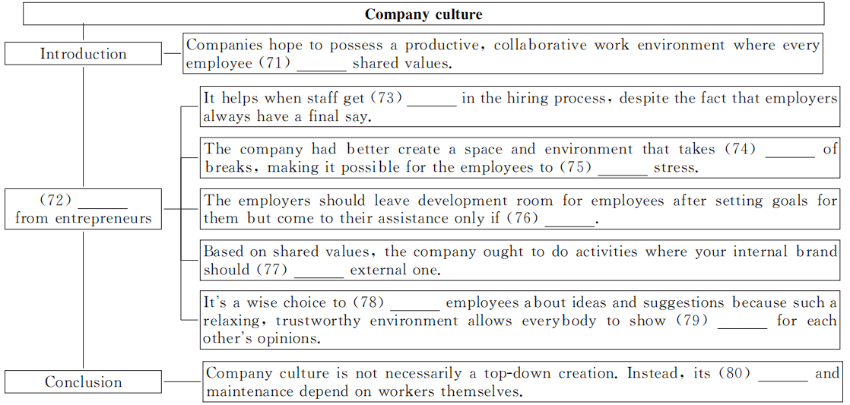第五部分：书面表达(满分25分)
请认真阅读下面文字，并按照要求用英语写一篇150词左右的文章。
Yuan Longping, 90, known as the “father of hybrid rice”， plays a crucial role in helping China achieve food security. Every morning what he does first is go to the field and works as a “farmer”. When asked how much his shirt was, he told the reporter that it was 35 yuan.

Deng Jiaxian, the Founding Father of China's ABomb and HBomb, was the founder and promoter of China's nuclear weapon cause. However, it was not until he died that his parents and many of his friends realized that he had produced such extraordinary achievements.

Li Junxian, without whom it would have been impossible for us to send the rocket into space, is one of the academicians of the Chinese Academy of Engineering. In 2018, this 90yearold party member, donated 3 million yuan to set up the Doctor Innovation Fund and the Hardship Assistance Fund.
【写作内容】 1. 用约30个词概括上述信息的主要内容；2. 分析上述国家功臣身上有哪些值得我们学习的优良品质；3. 谈谈其中某一品质对你的启发，并举例说明。
【写作要求】 1. 写作过程中不能直接引用原文语句；2. 作文中不能出现真实姓名和学校名称；3. 不必写标题。
【评分标准】 内容完整，语言规范，语篇连贯，词数适当。(这是边文，请据需要手工删加)

2020届高三模拟考试试卷(苏北四市)
英语参考答案及听力材料

听力
1～5 AABBA 6～10 CBACA 11～15 ACCBB 16～20 ACCBA
单项填空
21～25 CDBCD 26～30 ACDCB 31～35 ABCCA
完形填空
36～40 BDACD 41～45 ACDDB 46～50 ACCDB 51～55 ABCAB
阅读理解
56～57 AB 58～60 CCB 61～64 ABAA 65～70 DACBBA
任务型阅读
71. follows 72. Recommendations/Suggestions/Advice/Tips 73. involved/engaged 74. account
75. reduce/release/relieve 76. needed/necessary 77. reflect 78. consult 79. respect 80. development
书面表达
One possible version：
Three greatest heroes, just as listed above, have made considerable achievements in their life, and they always care about the prosperity of China and the wellbeing of the Chinese people.
Many good qualities are embodied in these heroes and they do deserve respect from all of us. One common quality is that they are diligent and down to earth, which best demonstrates that Chinese people are a hardworking people. Of course, there are many other qualities we can learn from them. For example, happiness of the people always tops the list in their dictionary, and the interests of our country outweighs their own personal ones.
What impresses me most is that Yuan Longping lives a simple but meaningful life. More often than not he wears a cheap shirt when going to work in the fields. By contrast, too many teenagers nowadays take it for granted to ask their parents to buy them famous brands without hesitation. Personally, we should follow heroes in their footsteps, applying ourselves to study, helping others selflessly. Only by setting noble ambitions can we become promising and make contributions to our country.
听力材料
Text 1
M: I never listen to the radio anyway. I can just check the weather on my phone.
W: I do the same thing. I'm never home to watch the weather forecast on television, either.
Text 2
W: Are you going to make it to the basketball game tonight? I will be there right after debate team practice.
M: I can't. I have a big math test tomorrow. I have to prepare for it.
Text 3
W: It looks like you're having a hard time with that program, Larry. Why don't you use the method that I gave in the class yesterday?
M: I was absent. I'll ask one of my classmates to send it to me.
Text 4
W: If we want to win the game this Friday, we need to come up with a plan now. They beat us every year.
M: We need to use teamwork more. John is our best player, but we can't give him the ball every time.
Text 5
W: Excuse me? I'm trying to pay the parking, but all I have is dollar bills. Could you spare any change?
M: I'm sorry, madam. But our store policy is not to give out change unless you buy something.
W: OK.
Text 6
W: Tim, I saw you running from the bus stop this morning. Your mother and father wouldn't be happy seeing you do that.
M: I was late for school though.
W: You need to be more careful when you cross the street. You need to walk during the right time and in the right places.
M: But I'm very fast.
W: Are you even listening to me? It is dangerous. It is also against the law.
M: But I hate waiting for the lights to change and the cars to pass by. I don't want to be late.
W: It is important to obey the rules, but your safety is more important. I don't want to see anyone of my students get hurt.
Text 7
W: Sorry, Jim. I won't be able to make it to the dinner tomorrow night. I'll be busy volunteering at the library during that time.
M: That's interesting, Carol. Most people I know volunteer by collecting garbage or something. What do you do at the library when you volunteer? Are they short on employees who put away books?
W: Nothing like that. I just read the children's books and act out some of the stories for them. It's very fun and it doesn't take long, maybe one or two hours.
M: How often do you do that?
W: I do it on Monday, Wednesday and Friday every week. You should come help me with it one time.
M: That sounds like fun. Can I pick the stories I want to read? I hate to try and act out a story I never read.
W: You can read any book as long as it's on the library's list.
Text 8
M: I was reading about superfoods today. They are fruits, vegetables and other foods that are supposed to be extra healthy.
W: That's interesting. Which foods are they? I suppose rice is high on the list. We certainly eat a lot of that here in China.
M: No, it isn't. Nor are noodles. But yogurt, fish and tomatoes are there.
W: Oh well, I suppose we eat plenty of them. Why are these foods so healthy?
M: It's said they can reduce the risk of high blood pressure, heart disease and certain cancers.
W: Maybe I will start including them in our meals. Are there any foods on the list that we don't have yet?
M: Nuts and greens are something we already eat plenty of. And although our type of rice—the white kind—isn't on the list, brown rice is.
W: Then I think we will switch to that to keep the family healthy. Superfoods sound like a very tasty way to keep fit.
Text 9
M: I can't believe this. I have been on the phone with my bank all day and they still haven't fixed my problem.
W: Is it a credit card problem?
M: Yes. My credit card information was stolen. When I got my bill in the mail, I saw there were many unfamiliar purchases on it.
W: That's terrible. Did they take a lot of money?
M: Yes, and I am very upset because the bank is not helping me quickly. I have talked to many different managers already.
W: Doesn't the bank's owner need to make the decision to give you your money back?
M: No. I just have to prove that these purchases were not made by me.
W: I hope you can fix this problem soon. Something similar happened to my husband's mother recently. She was tricked into giving away some important information over the phone.
M: I think the person who stole my information got it from the Internet. I bought a collection of movies recently. I won't be doing that again unless the website is sure to be safe. It's honestly my fault for being careless.
W: You can never be too careful. Well, your problem is inspiring me to look into protecting my account better. I think I can pay my bank more to help me.
Text 10
W: Listen up you two. We need to leave this house before the sun rises tomorrow. Your father will be home soon from work and once he gets home, we will be packing our bags. We need you guys to do the same thing tonight. I want everything you're going to bring put out in the living room before you go to bed. Before you pack everything though, you need to put aside the clothes for tomorrow. I don't want to wait for you to search for other clothes or to unpack your bag to get something. Our flight is at 7：00 a．m., and it will take about a half hour to get to the airport from here. We'll probably need another hour to get through security. Also, I know I said that we would go out for our meal tonight, but there is just too much to do. I asked your father to pick up some Chinese food for dinner instead. I can't be bothered to cook something since I just cleaned everything. If you want a specific dish at the restaurant, you will need to call your father. Otherwise, he will just pick up something that we can all share. Are you clear on everything I said？

