2017年高考试题及模拟题分项解析之 专题10书面表达
1.
假定你是李华，正在教你的英国朋友Leslie学习汉语。请你写封邮件告知下次上课的计划。内容包括：
1. 时间和地点；
2. 内容：学习唐诗；
3. 课前准备：简要了解唐朝的历史。
注意：1.词数100左右；
2．可以适当增加细节，以使行文连贯。
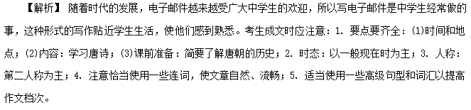【参考范文】
Dear Leslie，
I am very happy that you have made great progress in learning Chinese and you are interested in Chinese culture. Now I'll tell you the next learning programme. On July 20, we are going to learn poems of the Tang Dynasty which you are interested in in the Lecture Hall. As a foreign learner, it is difficult for you to understand the true meaning and the culture of them. Therefore, before class, you can read some books related to the history of the Tang Dynasty to better appreciate the poems.
Be sure to go to the Lecture Hall on time. You cannot miss the wonderful poems.
Best wishes.
Yours，
Li Hua
2.
假定你是李华，想邀请外教Henry一起参观中国剪纸(papercutting)艺术展。请给他写封邮件，内容包括：
1．展览时间、地点；
2．展览内容。
注意：1.词数100左右；
2．可以适当增加细节，以使行文连贯。
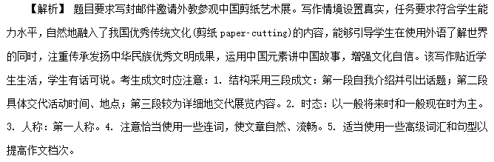【参考范文】
Dear Henry，
I'm Li Hua, one of your students in your cultural class. I know you're interested in one of Chinese traditional art forms—papercutting. So I invite you to attend an exhibition of it.
It'll be held from June 10 to July 10 this year and the opening time is from 9：00 am to 7：00 pm from Monday to Saturday and the place of the exhibition is at the City Gallery, which is located at 118, Jian Guo Road, Hai Dian District. Shall we go there together this Friday afternoon? I will meet you at 2：00 pm at the teaching building gate if you like.
You know we Chinese have a lot of traditional art forms, of which papercutting is one of the most popular. In the exhibition, you will enjoy many special kinds of papercuttings. Maybe you can learn one or two skills of the cutting.
Looking forward to your early reply.
Regards,
Li Hua
3．
假定你是李华。你所在的校乒乓球队正在招收新队员。请给你的留学生朋友Eric写封邮件邀请他加入，内容包括：
1．球队活动；
2．报名方式及截止日期。
注意：1.词数100左右；
2．可以适当增加细节，以使行文连贯。
________________________________________________________________________
________________________________________________________________________
________________________________________________________________________
________________________________________________________________________
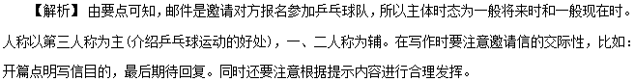【参考范文】
Dear Eric，
I was informed that our school Pingpong Team is looking for new members among us students. I know you show great fancy in ball games, especially pingpong.
As you know, playing pingpong can not only build up your body but also shape your character. Additionally, it can help you make more friends, which is essentially beneficial to you.
Would you like to join? If so, please go to sign up at the Student Union office, which is on the second floor of the Teaching Building. You can go there any time this Saturday afternoon. If you want me to accompany you, please let me know. I will be available any time.
Looking forward to your early reply.
Yours,
Li Hua
4.
61. 假设你是李津，与你以前的外籍教师Mrs Green 一直保持联系。近日她来信询问你的近况，请根据以下提示给她回复一封邮件。
1．简要介绍自己的学习和生活；
2．告知你已成为八月底在津举办的第十三届全运会的志愿者，并介绍为此所做的准备(如深入了解天津等)；
3．希望她有机会重访天津。
注意： 1.词数不少于100；
2．可适当加入细节，使内容充实、行文连贯；
3．开头已给出，不计入总词数。
参考词汇：第十三届全运会 the 13th National Games
Dear Mrs Green，
I'm so glad to hear from you. _________________________________________________
________________________________________________________________________
________________________________________________________________________
Yours，
Li Jin
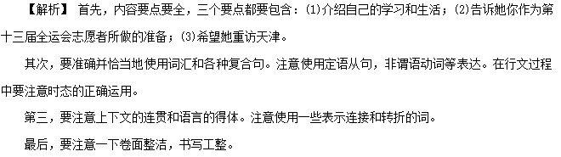One possible version:
Dear Mrs Green,__
I'm so glad to hear from you. In your last letter, you asked me about my study and life. I'm very pleased to tell you that I have made great progress in my spoken English since you left. As for my life, I take exercise regularly and do more outdoor activities, which builds up my body and character as well.
I have good news to tell you that I have been chosen to be a volunteer in the coming 13th National Games to be held in Tianjin at the end of August. To be a qualified volunteer, I made some preparations. I interviewed many people from all walks of life, which improved and deepened my understanding of Tianjin.
I hope you can revisit Tianjin if you have a chance. Looking forward to seeing you again.
Yours，
Li Jin
5.
第一节 应用文写作(满分15分)
假定你是李华，计划组织一次郊游，请给你的英国朋友Chris写封邮件邀请他参加。内容包括：
1. 参加者；
2. 时间、地点；
3. 活动：登山、野餐等。
注意：1. 词数80左右；
2. 可以适当增加细节，以使行文连贯。
________________________________________________________________________
________________________________________________________________________
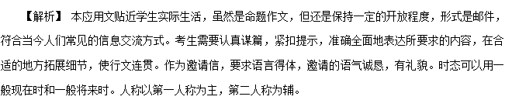【参考范文】
Dear Chris,
How are you doing? I am writing to invite you to a tour to the Green Hill this Saturday. As planned, we will leave by bus at 7：00 am at the school gate. About two hours will be spent climbing the mountain. After that we will have a picnic by the lake at the foot of the mountain.
Up till now, 3 boys and 4 girls have joined the team. I do hope that you could join us because Green Hill is such a fun place to relax and surely we will have a great time. However, if you don't have spare time for this trip, it is fine. It's just up to you.
Looking forward to hearing from you.
Yours，
Li Hua
读后续写

阅读下面短文，根据所给情节进行续写，使之构成一个完整的故事。
On a bright, warm July afternoon, Mac Hollan, a primary school teacher, was cycling from his home to Alaska with his friends. One of his friends had stopped to make a bicycle repair, but they had encouraged Mac to carry on, and they would catch up with him soon. As Mac pedalled (骑行) along alone, he thought fondly of his wife and two young daughters at home. He hoped to show them this beautiful place someday.
Then Mac heard quick and loud breathing behind him. “Man, that's a big dog！” he thought. But when he looked to the side, he saw instantly that it wasn't a dog at all, but a wolf, quickly catching up with him.
Mac's heart jumped. He found out his can of bear spray. With one hand on the bars, he fired the spray at the wolf. A bright red cloud enveloped the animal, and to Mac's relief, it fell back, shaking its head. But a minute later, it was by his side again. Then it attacked the back of Mac's bike, tearing open his tent bag. He fired at the wolf a second time, and again, it fell back only to quickly restart the chase(追赶)．
Mac was pedalling hard now. He waved and yelled at passing cars but was careful not to slow down. He saw a steep uphill climb before him. He knew that once he hit the hill, he'd be easy caught up and the wolf's teeth would be tearing into his flesh.
At this moment, Paul and Becky were driving their car on their way to Alaska. They didn't think much of it when they saw two cyclists repairing their bike on the side of the road. A bit later, they spotted what they, too, assumed was a dog running alongside a man on a bike. As they got closer, they realized that the dog was a wolf. Mac heard a large vehicle behind him. He pulled in front of it as the wolf was catching up fast, just a dozen yards away now.
注意：
1. 所续写短文的词数应为150左右；
2. 应使用5个以上短文中标有下划线的关键词语；
3. 续写部分分为两段，每段的开头语已为你写好；
4. 续写完成后，请用下划线标出你所使用的关键词语。
Paragraph 1：
The car abruptly stopped in front of him.________________________________________
______________________________________________________________________
Paragraph 2：
A few minutes later, the other two cyclists arrived.________________________________
_______________________________________________________________________ _
_____________________________________________________________________ ___
【解析】 本文主要讲述了Mac在骑自行车前往阿拉斯加的途中，被一只狼追赶的故事。时态要考虑以一般过去时为主，人称以第三人称为主。同时要兼顾字数的要求，不要过多，关键词列出5个以上，需要均匀分布在两段中。考生要注意几个关键信息和情节变化并结合给出的内容提示进行合理构思。
【参考范文】
The car abruptly stopped in front of him. Paul and Becky got out of the car immediately to give the help. With nothing on the hand, they didn't dare to fight against the wolf. However, they still approached to the wolf bravely. At the same time, the wolf also noticed them and turned its head back, howling angrily towards Paul and Becky. Mac then jumped off the bicycle and was ready to fight against the wolf. Then came the deadlock.
A few minutes later, the other two cyclists arrived. They found the dangerous situation, where three men circled the wolf. Mac's friends also jumped off their bicycles and joined the fight with the wolf. More and more cars stopped. Some drivers took out the sticks from the cars, and some took out the knives, even the guns towards the wolf. In the meanwhile, the wolf might feel the people's threats around, so it began to step back slowly. Soon, it ran away off the road and disappeared in the distance.
6.
81. 请认真阅读下面有关我国电影票房收入(boxoffice income)的柱状图及相关文字，并按照要求用英语写一篇150词左右的文章。
Saturday Afternoon.In a Shopping Centre.
Li Jiang：Hi，Su Hua. Which movie shall we see?
Su Hua：Whatever. We've got so many choices, Kung Fu Yoga, Journey to the West…Each sounds great!
Li Jiang：Yeah！And some movie stars are fantastic.
Su Hua: And the hightech！…
Li Jiang：Perfect！Let's get some food first. We only have 20 minutes left.
Su Hua：No hurry. The cinema is on the same floor.
One Day in 2016.At Home.
Son：Mum，shall we go and see a film tonight?
Mother：Why bother? We can stay at home and watch films online. It's convenient with our new and faster network.
Son：But it feels good in a cinema.
Mother：And the price…We have to pay 50 yuan a ticket.
Son：Only 10 yuan more than last year.
Mother：But still we cannot get the money's worth. Some films are just boring…
【写作内容】
1．用约30个单词概述柱状图信息的主要内容；
2．我国电影票房收入变化的原因有哪些，简要谈谈你的看法(上述对话仅供参考，原因不少于两点)；
3．谈谈你对我国电影票房收入走向的看法，并简要说明理由。
【写作要求】
1．写作过程中不能直接引用原文语句；
2．作文中不能出现真实姓名和学校名称；
3．不必写标题。
【评分标准】
内容完整，语言规范，语篇连贯，词数适当。
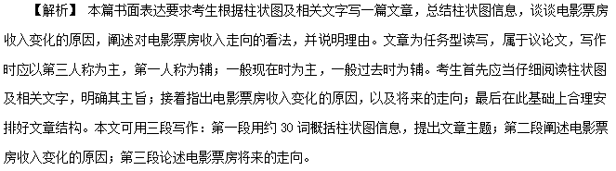在遣词造句上，应当注意合理使用连接成分，以提高文章的逻辑性，如在列举理由时可以用to begin with, what's more, last but not least等；还应尽量使用较复杂的句型，如在总结全文大意时可以用定语从句、分词结构；在其他地方可以用主语从句、倒装句等。
【参考范文】
The boxoffice income of Chinese movies witnessed a constant increase from about 17 billion yuan in 2012 to over 40 billion in 2015. However, that increase slowed down in 2016.
The reasons behind this are various. The fast economic development before 2016 was probably the most powerful engine driving the constant growth in the boxoffice income. The application of new technologies and the wide appeal of movie stars could also account for the increase. However, China saw a decline in its economic growth rate last year. And the Internet increased options for movie lovers. Consequently, some viewers began to turn away from cinemas, leading to a slower growth.
China's economy is expected to grow at a medium speed in the coming years, so an increase is possible in the investment in the movie industry and the number of quality movies. Therefore, its boxoffice income will probably enjoy a slight increase.
7.
你的英国朋友Jim所在的学校要组织学生来中国旅行，有两条线路可以选择：“长江之行”或者“泰山之旅”。Jim来信希望你能给些建议。请你给他回信，内容包括：
1. 你建议的线路；
2. 你的理由；
3. 你的祝愿。
注意：1. 词数不少于50；
2. 开头和结尾已给出，不计入总词数。
Dear Jim，
________________________________________________________________________
________________________________________________________________________
Yours，
Li Hua
1. I am delighted to learn that…
2. Of the two routes given by…， I strongly recommend that…
3. immersed in the grandeur and splendour of the landscape
4. I promise that the trip, both fruitful and rewarding, will turn out to be a memorable experience for you.
【参考范文】
Dear Jim，
I'm happy to receive your letter and know you're coming to China.
Of the two trips to the Yangtze River and Mount Tai, both are highly recommended. Personally, I prefer the tour along the Yangtze, the longest river and one of the mother rivers of Chinese civilization. You can learn a lot about the history of China and Chinese people. Moreover, the scenery along the river is amazing, with many wellknown sightseeing spots. That's why I think the trip along the Yangtze will be a better choice.
Hope you'll have a good time in China.
Yours，
Li Hua

情景作文

假设你是红星中学高三学生李华，请根据以下四幅图的先后顺序，写一篇英文周记，记录毕业前夕你们制作以“感恩母校”为主题的毕业纪念视频的全过程。
注意：词数不少于60。
提示词：视频video
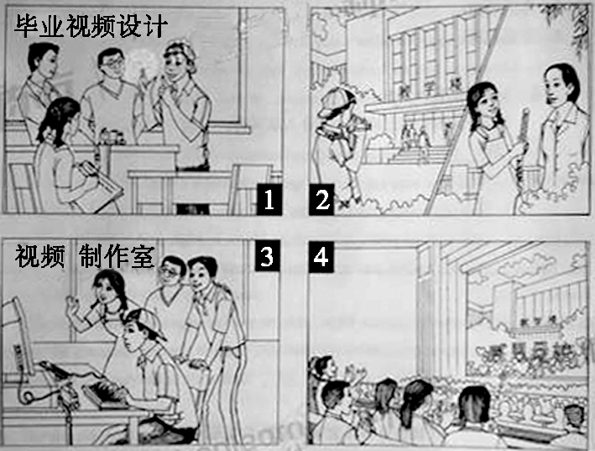
________________________________________________________________________
________________________________________________________________________
参考词汇和句型：
1. In order to leave some impressive memories for all of us before graduation, our class made a special video to express our appreciation to…
2. carried out a discussion/various ideas were put forward
3. shot some wonderful videos in the school/interviewed our teachers…
4. Those who are talented in computer contributed to the making of the video.
5. edited the video/added our love to…
6. The show received a warm welcome among our fellow schoolmates.
7. Memories of the past flooded into our minds/firm bond to our school…
内容要点：
1. 讨论分工 2. 收集素材 3. 编辑制作 4. 放映视频
One possible version：
Graduation finally came. My classmates and I decided to do something. After a heated discussion, we agreed on making a video to record our experiences at school. Material collecting took us a whole week, during which we interviewed our teachers and took pictures of every aspect of school life. The editing part after that was tough. We debated over what to put into the video. Some compromises were unavoidable, but the video turned out perfect. Several days later, when the video was played on the graduation ceremony, it was well received. The students and teachers shared a great time. That surely gave us a great sense of achievement.
8.【2017·四川广元市二模】
在某学校门口及附近，上学和放学时候交通常常拥挤甚至堵塞，给师生、家长及市民带来许多不便，很多人为些担忧。作为一名该校学生，请你以李华的名义给某英语报社写信反映该情况，内容包括：
1．交通拥挤的原因；
2．提出至少两条建议。
注意：
1．词数100左右；
2．可以适当增加细节，以使行文连贯；
3．开头和结尾已给出，不计入总词数。
Dear Editor,
I’m Li Hua, s student of Senior 3. I am writing to discuss the traffic problem near our school gate. ___________
__________________________________________________________________________________________________________________________________________________________________________________________________________________________________________________________________________________________
Yours,
Li Hua
【答案】没有答案
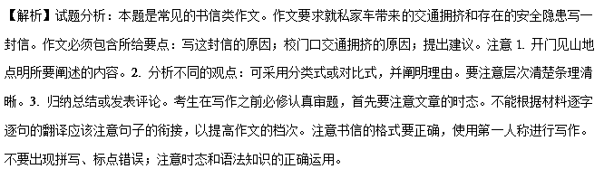9.【2017·山东菏泽市一模】
有没有想过给自己写信，尤其是给将来的自己写信。请用英语给五年后的自己写封信，信的内容包括以下三个方面：
1.写信的目的；
2.给五年后的你一些忠告；
3.如何看待五年后的你。
注意：
1.词数100左右；
2.可以适当增加细节，以使行文连贯；
3.开头和结尾已为你写好，不计入总词数。
Dear myself,

Yours,
Me
【答案】Dear myself,
I have been confused for a long time，neglecting to think about the future. Escaping from the future sounds abnormal.If one can not face the future how can he face the reality? Thus I decide to write this letter to you- myself, five years later.
First of all,I want to give some suggestions.Learning's light shall never dim in your life for no one can survive in this fast changing world without learning. And remember:health is wealth.One can not abandon any kind of sport. Also,parents should be your first concern and deserve to be loved forever.
BesidesJ would like to remind you of keeping your spirits up, which are the basis of your life.
5 years later,wow. Now you are reading this letter in front of Beijing Tian:anmen Square.You will be working in Beijing after graduation,being an excellent translator or an energetic teacher.
Yours,
Me
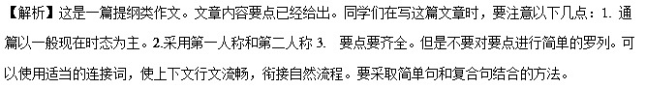【范文亮点】
1. 范文采取了非谓语动词作状语（I have been confused for a long time，neglecting to think about the future.）（You will be working in Beijing after graduation,being an excellent translator or an energetic teacher.）和非限定性定语从句（BesidesJ would like to remind you of keeping your spirits up, which are the basis of your life.）等句式。
2. 文章采用了dim；keep up；basis；fast-changing等高级单词或短语。采用了First of all，Besides等过渡衔接词。
10.【2017·山东潍坊市实验中学二模】
假如你是新华中学学生李华，在最近举行的市高中生英语口语大赛中获得了一等奖。某英语报社邀请你写一篇稿件，介绍你练习英语口语的经验。稿件内容如下：
(1) 树立自信，克服羞怯心理；
(2) 多参加英语角活动；
(3) 多看英语新闻（如CCTV-9）
注意：1.词数：100左右；2.可适当增加细节，以使行文连贯
I'm Li Hua from Xinghua Middle School. _________________________________
【答案】I'm Li Hua from Xinghua Middle School. Now I'd like to share my experience in practicing oral English. Firstly, I'm always confident and brave. I seize every opportunity to speak, not afraid of making mistakes which may embarrass me. I also find it of great benefit to take part in English corners, where I make many friends. By talking with them, my oral English has improved a lot. Finally, some English programs like CCTV-9 contribute to the progress in my speaking ability. Through this channel, not only am I kept informed of the current events going on both at home and abroad, I also learn the standard pronunciation and intonation by repeated imitation. Practice makes perfect, as the saying goes. Our hard work will finally be rewarded.
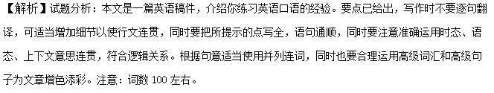【名师点睛】
本文内容齐全，布局合理，文中使用高级句子。I seize every opportunity to speak, not afraid of making mistakes which may embarrass me.形容词性短语作伴随状语，同时句中运用which引导的限制性定语从句；I also find it of great benefit to take part in English corners, where I make many friends.此句中it作形式宾语，动词不定式作真正的宾语，同时句中where引导非限制性定语从句；Through this channel, not only am I kept informed of the current events going on both at home and abroad, I also learn the standard pronunciation and intonation by repeated imitation.句中not only…but also的部分倒装堪称经典；Practice makes perfect, as the saying goes.as引导的非限制性定语从句和名句完美结合。
11.【2017·贵州省黔东南州高考模拟】
假如你是李华，今年春节去美国旅游度假一周。你的美国朋友Luke招待了你。 请给他写一封信，表示感谢。要点如下：
1．玩得很开心；
2．谢谢他的招待；
3．邀请其来中国旅游。
注意：1．词数100左右；
2．可以适当增加细节，以使行文流畅。
【答案】Dear Luke,
How are you doing these days? With the deepest gratitude, I am writing to you to express my thanks for your hospitality when I was traveling in America. You know how hard it is for a foreigner to travel in a foreign country alone. I couldn’t imagine what my vacation would be without your help. I enjoyed myself very much. I will be glad if you can come to China to visit me. I hope we can still keep in touch with each other! I will forever remember the valued time with you. Thank you again and wish everything goes well.
Your sincerely,
Lin Hua
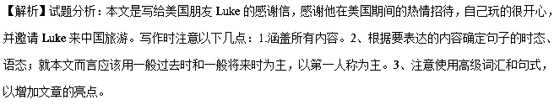【亮点说明】
文章使用了非常好的短语和句子给文章增色，如含有宾语从句和形式主语it的句子You know how hard it is for a foreigner to travel in a foreign country alone.；虚拟语气I couldn’t imagine what my vacation would be without your help.；enjoyed myself玩的开心；keep in touch with保持联系。
12.【2017·吉林省实验中学第五次模拟】
假如你是张萌，在刚结束的寒假里，你作为学校的交换生 (exchange student) 去美国Wilson Middle School学习，期间你结交了很多朋友，增进了对美国文化的了解。现请你代表你的学校，根据下列内容要点，给Wilson Middle School的校长写一封感谢信。
内容要点：
自我简介；
表示感谢（你的收获）；
希望多举办这样的活动；
欢迎该校师生来你校参观
注意： 1. 词数100左右；
2. 可以适当增加细节，以使行文连贯；
3. 信的开头和结尾已为你写好，不计入总词数。
Dear Headmaster,
My name is Zhang Meng____________________________________________________
______________________________________________________________________________________________________________________________________________________________________________________________________________________________________________________________________________________________________________________________________________________________________________________________________________________________________________________________________________
Best wishes.
Yours sincerely,
Zhang Meng
【答案】Dear headmaster,
My name is Zhang Meng and I’m a senior 3 student from China. Now I’m writing to express my thanks to you on behalf of my school and myself.
I have been studying as an exchange student in your school for a month. The past month has been a wonderful time, during which I have made many friends and learned a lot about American culture. Not only my spoken English, but also my ability to live independently has been improved a lot.
Thanks for your treatment and the service you offered us. And since this activity was completely a success, our school hopes to hold such activities more often in the future.
Finally, we warmly welcome you and your students to visit our school. I would be very glad to be your guide at that time.
Best wishes.
Yours sincerely,
Zhang Meng
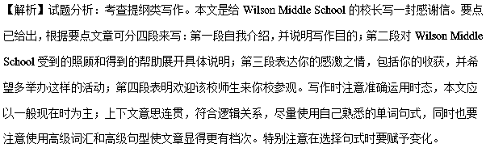【亮点说明】
本文格式正确，布局合理，运用高级句子。The past month has been a wonderful time, during which I have made many friends and learned a lot about American culture. during which引导非限制性定语从句；Not only my spoken English, but also my ability to live independently has been improved a lot. not only…but also…在句中连接两个主语，并与现在完成时态的被动语态巧妙结合；since this activity was completely a success, our school hopes to hold such activities more often in the future. since引导原因状语从句。
13.【2017·华中师大新高考联盟模拟】
假如你是李华，你的美国笔友David来信说，当他了解到人工智能（AI）Master战胜了60 位顶尖职业围棋（Go）高手后，迷上了下围棋，希望你给他一些关于提高棋艺的建议。
要点如下：
1．最好到中国参加培训班； 2．熟能生巧，尽量多在网上对弈；
3．多观看www. weiqitv.com上的国际大赛直播。
注意：1.词数100左右
2. 可适当增加细节，以使行文连贯。
Dear David,
_________________________________________________________________________________________________________________________________________________________________________________________________________________________________________________________________________________________
Yours,
Li Hua
【答案】Dear David,
I’m delighted to receive your letter, in which you have told me you have become a Go addict after knowing Master had defeated 60 world-top professional players and ask for my advice on how to learn Go well. Here are some tips for you.
First, it is a good idea for you to register for a training class in China, where Go was born. In addition, as the proverb says, practice makes perfect. So you are expected to play the game online as much as possible. Finally, I recommend that you watch more live broadcasts of international matches at www. weiqitv. Com, which is sure to help you acquire advanced Go-playing skills.
I hope you will find these ideas beneficial.
Yours,
Li Hua
【解析】试题分析：
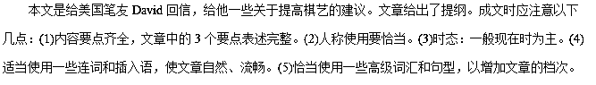【亮点说明】
1.使用高级句型：非限制性定语从句…, in which you have told me you have become a Go addict…；宾语从句…ask for my advice on how to learn Go well.；关系副词引导的非限制性定语从句…a training class in China, where Go was born.；虚拟语气以及非限制性定语从句I recommend that you watch more live broadcasts of international matches at www. weiqitv. Com, which is sure to help you acquire advanced Go-playing skills.. 2.使用了过渡词语：First，In addition，Finally等。3.使用了重要短语及谚语：ask for请求，要求；谚语practice makes perfect熟能生巧。
14.【2017·山西省高三名校联考】
假如你是李华，你的加拿大笔友Dave想了解中国的传统节日“春节”，请你回复他的电子邮件，介绍“春节”及这个节日里的主要活动。
1．它是中国的传统节日之一；
2．家人团聚；
3．吃饺子、放焰火、走亲访友等其他活动。
注意：1.词数100左右；
2. 可适当增加细节，以使行文连贯；
3. 开头结尾已为你写好，不计入总数。
参考词汇：
春节the Spring Festival 放焰火set off fireworks
Dear Dave,
In your last letter, you asked me about the Spring Festival.____________________________________________
_________________________________________________________________________________________________________________________________________________________________________________________________________________________________________________________________________________________
Yours sincerely,
Li Hua
【答案】Dear Dave,
In your last letter, you asked me about the Spring Festival. As is known to all, it has been enjoying great popularity in our country.
Usually, no matter how far away or how busy we are, we will try to come home for the celebration. On the eve of the Spring Festival, all the family members get together, making dumplings and having a feast. Children have great fun in setting off fireworks. Parents take their kids to pay a visit to relatives or friends. In addition to these traditional activities, people have a new tendency to celebrate it such as travelling and sending best wishes through Wechat.
Hopefully, you will come to China to experience it. Looking forward to your early reply.
Yours sincerely,
Li Hua
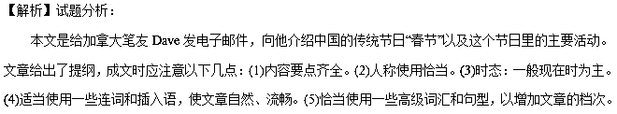【亮点说明】
1.使用高级句型： as引导的非限制性定语从句As is known to all, it has been enjoying great popularity in our country.；现在分词做伴随状语On the eve of the Spring Festival, all the family members get together, making dumplings and having a feast。2.使用了重要短语：have great fun玩的非常开心，in addition to除了，look forward to期待。
15.【河北省邯郸市2017届高三上学期期末教学质量检测】
假定你是李华,你班上最近转来一位身材肥胖的新生,很多同学都嘲笑他。这让你感到非常气愤,但又无计可施。就此请你用英语写封邮件给你的网友Tom求助,内容要点包括：
1．简略介绍该情况；
2．表达你对该事的看法；
3．征求Tom的建议。
注意：
1．词数100左右；
2．可以适当增加细节,以使行文连贯；
3．开头和结尾已为你写好,不计人总词数。
Dear Tom,
How are you going? I miss you very much._______________
______________________________________________________________________________________________________________
Yours,
Li Hua
【答案】One possible version:
Dear Tom,
How are you going? I miss you very much. I feel very depressed now because there is an annoying thing that discourages me.
There is a new classmate who is very fat coming to my class. Many classmates laugh at him just because of his weight, which makes me angry. In my opinion, looking down on the newcomer is a foolish behavior, and it makes themselves look like a fool. As a result, the relationship between classmates must be broken.
Unluckily, I have no idea to solve the problem. So I hope you can give me some suggestions. I will appreciate it if you can help me get out of the trouble.
Best wishes!
Yours,
Li Hua
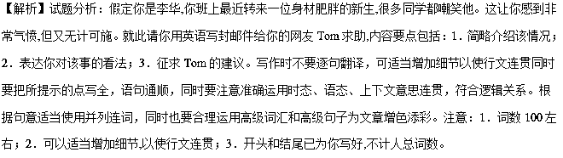【亮点说明】本文内容齐全，结构严谨，层次分明，布局合理，语言精练，同时运用高级句子。原因状语从句的使用：I feel very depressed now because there is an annoying thing that discourages me.定语从句的使用：There is a new classmate who is very fat coming to my class.非限制性定语从句的使用：Many classmates laugh at him just because of his weight, which makes me angry.固定句型的使用：I will appreciate it if you can help me get out of the trouble.

