2017年高考试题及模拟题分项解析之 专题7完形填空
1.【2017·新课标I】完形填空(共20小题；每小题1.5分，满分30分)
阅读下面的短文，从短文后各题所给的A、B、C和D四个选项中，选出可以填入空白处的最佳选项，并在答题卡上将该项涂黑。
While high school does not generally encourage students to explore new aspects of life, college sets the stage for that exploration. I myself went through this 41 process and found something that has changed my 42 at college for the better: I discovered ASL-American Sign Language(美式手语).
I never felt an urge to 43 any sign language before. My entire family is hearing, and so are all my friends. The 44 languages were enough in all my interactions(交往).Little did I know that I would discover my 45 for ASL.
The 46 began during my first week at college. I watched as the ASL Club 47 their translation of a song. Both the hand movements and the very 48 of communicating without speaking 49 me. What I saw was completely unlike anything I had experienced in the 50 .This newness just left me 51 more.
After that, feeling the need to 52 further, I decided to drop in on one of ASL club`s meetings. I only learned how to 53 the alphabet that day. Yet instead of being discouraged by my 54 progress,I was excited. I then made it a point to 55 those meetings and learn all I could.
The following term, I 56 an ASL class. The professor was deaf and any talking was 57 . I soon realized that the silence was not unpleasant. 58 , if there had been any talking, it would have 59 us to learn less. Now, I appreciate the silence and the 60 way of communication it opens.
41. A. searching B. planning C. natural D. formal
42. A. progress B. experience C. major D. opinion
43. A. choose B. read C. learn D. create
44. A. official B. foreign C. body D. spoken
45. A. love B. concern C. goal D. request
46. A. meeting B. trip C. story D. task
47. A. recorded B. performed C. recited D. discussed
48. A. idea B. amount C. dream D. reason
49. A. disturbed B. supported C. embarrassed D. attracted
50. A. end B. past C. course D. distance
51. A. showing B. acting C. saying D. wanting
52. A. exercise B. explore C. express D. explain
53. A. print B. write C. sign D. count
54. A. slow B. steady C. normal D. obvious
55. A. chair B. sponsor C. attend D. organize
56. A. missed B. passed C. gave up D. registered for
57. A. prohibited B. welcomed C. ignored D. repeated
58. A Lastly B. Thus C. Instead D. However
59.A.required B. caused C. allowed D. expected
60.A.easy B. popular C. quick D. new
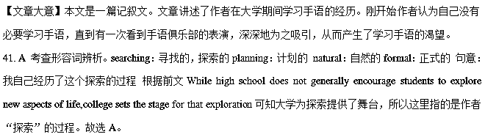42. B 考查名词辨析。progress：进步 experience：经历 major：主修课目 opinion：观点 句意：我发现有些东西改变了我的大学生活经历。分析可知故选B。
43. C 考查动词辨析。choose：选择 read：看，读 learn：学习 create：创造 句意：我以前从没有过学习手语的冲动 分析可知故选C。
44. D 考查形容词辨析。official：官方的foreign：外国的body：肢体的spoken：口语的 根据前文My entire family is hearing,and so are all my friends.可知作者的家人及朋友都可以听得到，作者认为在平时的交流中，再加上肢体语言就足够了。body language：肢体语言 故选D。
45. A考查名词辨析。love：热爱concern：关心，顾虑 goal：目标request：请求 句意：我没想过我会发现自己对美式手语的热爱。前文中I never felt an urge to learn any sign language before作者表明以前从未想过学习手语，而根据后文内容可知作者非常喜欢手语。故选A。
46. C 考查名词辨析。meeting：会议 trip：旅行story：故事task：任务 句意：故事发生在我上大学的第一周 分析可知在这里作者开始讲述在大学学习手语的事情，故选C。
47. B 考查动词辨析。record：记录 perform：表现，表演 recite：背诵discuss：讨论 句意：在ASL 俱乐部表演一首歌的翻译时，我正观看着。分析可知ASL 俱乐部是手语俱乐部，应该是在用手语表演一首歌。故选B。
48. A 考查名词辨析。idea：想法amount：数量dream：梦想reason：原因 句意：手部的动作和不用语言进行交流的想法吸引了我 分析可知作者当时在看手语表演，而手语就是为了想借助手势进行交流。故选A。
49. D 考查动词辨析。disturb：打扰 support：支持embarrass：使...难堪attract：吸引 分析语境可知ASL 俱乐部的表演吸引了作者，否则作者也不会去学习手语。故选D。
50. B 考查名词辨析。end：结束，末尾past：过去 course：课程 distance：距离 句意：我所看到的和我在过去经历的事情完全不同。 固定短语in the past：在过去 故选B。
51.D 考查动词辨析。show：展示act：行动say：说want：想要 句意：这种新奇的感觉使我想了解更多。分析语境可知作者被手语吸引，想要进一步了解，所以也有了后文中的参加手语俱乐部的会议，上手语课的经历。故选D。
52.B考查动词辨析。exercise：锻炼 explore：探索 express：表达explain：解释 句意：在那之后，我感觉到想要探索更多关于手语的东西，我参加了ASL 俱乐部的一次会议。故选B。
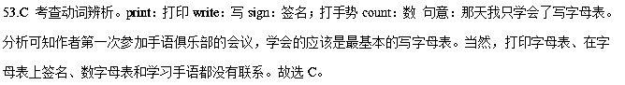54.A考查形容词辨析。slow：缓慢的steady：平稳的 normal：正常的obvious：明显的 句意：我并没有因为缓慢的进步而沮丧，相反我很兴奋。因为作者只学会了写字母表，所以进步是很慢的。故选A。
55.C 考查动词辨析。chair：主持；使…入座sponsor：赞助 attend：参加 organize：组织 句意：我下定决心参加俱乐部所有的会议去学习我能学习的一切。attend meeting：参加会议 故选C。
56.D 考查动词辨析。miss：错过，想念pass：通过give up：放弃register for：报名注册 句意：接下来的一个学期，我报名上了一个手语班。故选D。
57.A 考查动词辨析。prohibit：禁止welcome：欢迎ignore：忽视repeat：重复 句意：教授的耳朵听不见，任何口语交流都是禁止的。根据后文if there had been any talking可知在课堂上没有口语交流。故选A。
58.C 考查副词辨析。lastly：最后，终于thus：因此；如此instead：反而however：然而 句意：反而，如果当时有口语交流，那只会造成我们学的手语更少。根据前文I soon realized that the silence was not unpleasant.可知作者很快意识到安静并不是令人不愉快的。反而有口语交流会影响手语的学习。故选C。
59.B 考查动词辨析。require：要求cause：造成 allow：允许expect：期待 句意：如果当时有口语交流，那只会造成我们学的手语更少。故选B。
60.D 考查形容词辨析。easy：简单的popular：受欢迎的quick：快速的 new：新的 句意：现在我很感激当时的安静并且享受它带来的一种新的交流方式 分析可知手语对于作者来说是一种新的交流方式，故选D。
【名师点睛】
“记叙文”类完形填空主要包括幽默故事、名人传记、事件叙述等。文中以叙述为主，通过人物之间的对话来反映人们对事件的看法及其起因。叙述上多半用平述的形式，很少加入作者的评论。 因此如果对文章上下文情景把握不住，就会失分。为了减少失分率，考生可以参考以下几点：
1、首先读懂文章的首句，把握全篇，弄清文章要讲什么。
完形填空一般没有标题，读懂第一句很关键。第一句一般不留空，是个完整的句子，整篇文窜的信息从此句开始。因此读好第一句不仅能够把握文章要讲什么内容，而且也可能把握作者的写作态度。因此，考生最好在读完第一句话后，不要急于看下一句，而是应先根据首句内容，对下文所要出现的故事进行一下推测，这有利于靠近作者的思路，避免走弯路。根据文章第一段的第一句While high school does not generally encourage students to explore new aspects of life,college sets the stage for that exploration.可知作者在大学期间探索某些东西。所以第41题I myself went through this 41 process划线处应该填searching，和前文中的exploration呼应。
2、先通读全文，掌握大意，理清各种角色。
记叙文一般有两个或两个以上的角色，作者对这些角色的态度各不一样，即使同样—件事发生在不同人身上作者也可能采用不同的写作描述。
3、理顺事件的发生、发展、结局
记叙文的多项选择式完形填空题多半以事情发展的顺序进行叙述。正确把握文章的发展顺序对于把握文章的主旨有着重要的意义，因此在选择答案时可以先理情人物的关系及各自所做的事情。
例如第57题The professor was deaf and any talking was 57 . I soon realized that the silence was not unpleasant.可知作者参加报名上手语课，教授的耳朵是听不见的，这是符合情理的。按照事情的发展，考生可以推测课堂上讲话应该是不允许的。所以选择A选项prohibit，表示“禁止”。
2.【2017·新课标II】阅读下面短文，从短文后各题所给的A、B、C和D四个选项中，选出可以填入空白处的最佳选项。
In1973,I was teaching elementary school.Each day,27kids 41 “The Thinking Laboratory.”That was the 42 students voted for after deciding that “Room 104” was too 43 .
Freddy was an average 44 ,but not an average person .He had the rare balance of fun and compassion（同情）.He would 45 the loudest over fun and be the saddest over anyone’s 46 .
Before the school year 47 ,I gave the kids a special 48 , T-sherts with the words “Verbs Are Your 49 on them. I had advised the kids that while verbs（动词）may seem dull ,most of the 50 things they do throughout their lives will be verbs.
Through the years, I’d run into former students who would provide 51 on old classmates. Ilearned that Freddy did several jobs after his 52 from high school and remained the same 53 person I met forty years before .Once, while working overnight at a store, he let a homeless man 54 in his truck. Another time ,he 55 a friend money to buy a house .
Just last year, I was 56 a workshop when someone knocked at the classroom door. A woman 57 the interruption and handed me an envelope. I stopped teaching and 58 it up. Inside were the “Verbs” shirt and a 59 from Freddy’s mother. “Freddy passed away on Thanksgiving. He wanted you to have this.”
I told the story to the class. As sad as it was, I couldn’t help smiling . Although Freddy was taken from us, we all 60 something from Freddy.
41. A. built B. entered C. decorated D. ran
42. A. name B. rule C. brand D. plan
43. A. small B. dark C. strange D. dull
44. A. scholar B. student C. citizen D. worker
45. A. speak B. sing C. question D. laugh
46. A. misfortune B. disbelief C. dishonesty D. mistake
47. A. changed B. approached C. returned D. ended
48.A.lesson B. gift C. report D. message
49. A.friends B.Awards C.Masters D.Tasks
50. A.simple B.unique C. fun D.clever
51. A.assessments B. comments C.instructions D.updates
52. A.graduation B. retirement C.separation D.resignation
53. A.daring B.modest C.caring D.smart
54. A.wait B.sleep C.study D.live
55. A.paid B.charged C.lent D.owed
56. A.observing B.preparing C. designing D.conducting
57. A.regretted B.avoided C.excused D.ignored
58. A.opened B.packed C.gave D.held
59. A.picture B.bill C.note D.diary
60. A.chose B.took C.expected D.borrowed
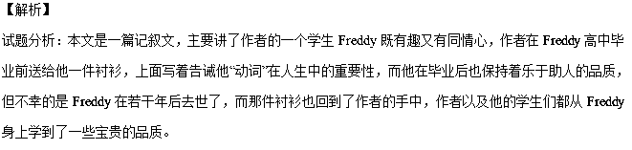41.B 考查动词词义辨析，A. built 建造， B. entered 进入， C. decorated 装饰， D. ran跑步，根据句意：每天，27个孩子都会“进入”“思想实验室”，故选B.
42.A 考查名词词义辨析，A. name名字， B. rule规则，C. brand品牌， D. plan计划，结合文意：应该是“思想实验室”这个“名字”是同学们投票得来的，故选A.
43.D 考查形容词词义辨析，A. small小的，B. dark 黑的， C. strange 奇怪的， D. dull无聊的，由后文可知，同学们是因为“104班级”这个名字太“无聊”才把名字改为“思想实验室”的，故选D.
44.B 考查名词词义辨析，A. scholar学者， B. student学生， C. citizen市民， D. worker工人，通读全文可知Freddy是作者的一名“学生”，故选B.
45.D 考查动词词义辨析，A. speak 说， B. sing 唱歌， C. question质问， D. laugh大笑，结合文意：对于好玩的事情，他会“笑”地最大声，故选D.
46.A 考查名词词义辨析，A. misfortune不幸， B. disbelief怀疑，C. dishonesty 不诚实， D. mistake错误，根据前句：Freddy在有趣和富有同情心之间可以做到罕见的平衡，所以对于任何人的“不幸”，他会很悲伤，故选A.
47.D 考查动词词义辨析，A. changed 改变， B. approached接近， C. returned返回，D. ended结束，结合句意：在学期“结束”之前，我……，故选D.
48.B 考查名词词义辨析，A.lesson课，教训， B.gift礼物， C.report 报告，D.message信息，根据后文可知作者送给Freddy一件衬衫，即一个特殊的礼物，故选B.
49.A 考查名词词义辨析，A.friends 朋友，B.Awards奖， C.Masters 主人，D.Tasks任务，结合文意：衬衫上写着“动词是你的朋友”，故选A.
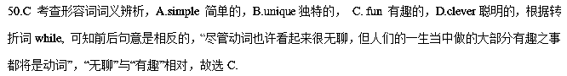51.D考查名词词义辨析，A.assessments评估，B. comments评论， C.instructions 指导， D.updates更新，根据句意：我遇到过以前的学生，他们常常会提供一些老同学的“最新情况”，故选D.
52.A考查名词词义辨析，A.graduation毕业， B. retirement退休，C.separation 分离，D.resignation辞职，结合文意：在Freddy高中毕业后，做了好几份工作，故选A.
53.C 考查形容词词义辨析，A.daring勇敢的， B.modest 谦虚的，C.caring贴心的， D.smart聪明的，根据后一句他让无家可归的人睡在了他的卡车上，可知他仍然是很爱关照人的，贴心的，故选C.
54.B 考查动词词义辨析，A.wait等待，B.sleep 睡觉， C.study 学习， D.live居住，结合文意：他让一位无家可归的人“睡在”他的卡车上，故选B.
55.C 考查动词词义辨析，A.paid ，支付，B.charged 索要， C.lent 借出， D.owed欠，结合文意：还有一次，他借钱给朋友，让朋友买到房，故选C.
56.D考查动词词义辨析，A.observing观察， B.preparing 准备，C. designing设计， D.conducting组织，实施，执行，结合上下文：我正在班级里组织一个专题研讨会的时候，突然有人敲门，故选D.
57.C 考查动词词义辨析，A.regretted 后悔，遗憾， B.avoided避免，C.excused原谅，宽恕， D.ignored忽视，结合上下文：因为当时正在上课，所以这名女子为自己的打断行为要求得到原谅，故选C.
58A 考查动词词义辨析，A.opened打开，B.packed打包， C.gave给予， D.held握住，结合文意：我停止教学，打开信，故选A.
59.C 考查名词词义辨析，A.picture 图片， B.bill 账单， C.note 纸条，便笺， D.diary日记，根据后文的描述，可知衬衫上是一个便笺，上面写着……，故选C.
60.B 考查动词词义辨析，A.chose 选择， B.took 拿走， C.expected 期待， D.borrowed借入，结合文意：尽管Freddy离开了我们，我们从他的身上也带走了一些东西，故选B.
【名师点睛】
本篇完形填空很好地体现出重在考查语篇理解能力，且不在情节上、词汇考查大做文章的趋势。其中对于语篇的上下文复现考查非常之多。 语篇复现的信息包括原词复现、同义词和反义词复现、上义词和下义词复现、概括词复现和代词复现等。语篇中有词汇和结构同现的现象，如与语篇话题相关、意义相关的词汇同时出现，结构同现，同义同现，修饰同现，因果同现等。因此，利用上下文寻找解题信息，确定正确答案。如：
I learned that Freddy did several jobs after his 52 from high school and remained the same 53 person I met forty years before .
A.daring B.modest C.caring D.smart
考点：考查记叙文阅读
3.【2017·新课标III】阅读下面短文，从短文后各题所给的A、B、C和D四个选项中，选出可以填入空白处的最佳选项。
A Toronto man is offering a free round-the-world air to the right woman. But __41_ apply. You must be named Elizabeth Gallahgher and have a Candian ___42___ .
Jordan Axani, 28, said he and his then girlfriend, Elizabeth Gallagher, booked heavily discounted round-the-world air tickets in May, but their 43 ended and he did not want her ticket to 44 . The ticket had a strict no-transfer（不可转让） 45 , but since passport information was not required when 46 , any Canadian Elizabeth Gallagher can
47 it.
“I just want to see the ticket go to good use and for someone to 48 a lot of joy,” said Axani. He posted his 49 on a social networking website, and received thousands of e-mails, including thirty from actual Elizabeth Gallagbers with the 50 passports, “More 51 , there are hundreds of Canadians who are interested in 52 their name to Elizabeth Gallagher,” Axani said. “It was absolutely out of 53 , thousands of e-mails, people around the world 54 their stories of travel.”
Axani wrote in his post that he is not 55 anything in return and that the woman who uses the 56 ticket can choose to either travel with him or 57 the ticket and travel on her own.
The 58 is scheduled to start on December 21 in New York City and continue on to Milan, Prague, Paris, Bangkok and New Delhi before 59 in Toronto on January 8. He said the 60 woman will be announced on the website and the trip will be shared online.
41.A.benefits B.deposits C.retrictions D.examinations
42.A.orgin B.passport C.accent D.firend
43.A.holiday B.marriage C.dream D.relationship
44.A.go to waste B.come to mind C. go no sale D.come into effect
45.A.policy B.order C.parment D.schedule
46.A.applying B.booking C.checking D.bargaining
47.A.use B.borrow C.choose D.buy
48.A.sacrifice B.express C.experience D.provide
49.A.answer B.advice C.offer D.comment
50.A.same B.right C.now D.real
51. A. interesting B. annoying C. satisfying D. convincing
52. A. writing B. giving C. lending D. changing
53. A. touch B. question C. date D. control
54. A. admiring B. advertising C. sharing D. doubting
55. A. leaving B. looking for C. losing D. dealing with
56. A. leaving B. looking for C. losing D. dealing with
57. A. return B. take C. reserve D. hide
58. A. interview B. program C. trip D. meeting
59. A. ending B. calling C. repeating D. staying
60.A.honored B. lovely C. intelligent D. lucky
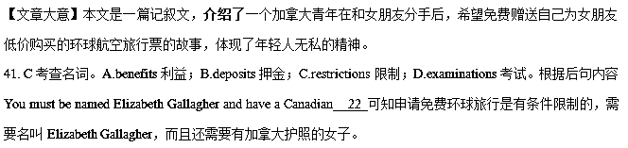42. B考查名词。A.orgin 来源； B. passport护照；C.accent 口音；D.firend朋友。据第三段中including thirty from actual Elizabeth Gallaghers with the 30 passports可知，申请人需要有加拿大的护照。故选B。
43. 考查名词。D A.holiday 假期； B.marriage 婚姻；C.dream 梦想；D.relationship关系。根据下文Jordan Axani转让机票可知他和女朋友关系结束了。
44. A考查动词短语。A.go to waste浪费；B.come to mind想到；C. go no sale 开始销售； D.come into effect 开始生效。根据下文“I just want to see the ticket go to good use and for someone to 28 a lot of joy,”可知他之所以把票想赠送给同名的人，目的是不想浪费掉机票。go to waste浪费； come to mind想到； go no sale开始销售；come into effect 开始生效。故选A。
45. A考查名词。A.policy政策；B.order 命令；C.payment 付款；D.schedule 计划，时间表。机票都是实名制，而且不可以转让，根据情理和语境可知这是一种政策。policy政策； order命令；payment付款；schedule 计划，时间表。故选A。
46. B考查动词。A.applying 申请；B.booking预定； C.checking核实； D.bargaining讨价还价。虽然机票不可转让，但是在预定的时候不需要护照的具体信息，因此在预定后这张机票可以给姓名相同的人使用。故选B。
47. A考查动词。A.use 使用；B.borrow借用； C.choose 选择； D.buy 购买。根据上文的介绍可知，因为护照信息没有登记，所以任何一个名叫Elizabeth Gallagher，而且拥有加拿大护照的人都可以用这张机票。
48. C考查动词。A.sacrifice牺牲；B.express 表达；C.experience经历； D.provide提供。人们如果能免费环球旅行，当然会享受到很多的乐趣，。
49. C考查名词。A.answer 答案；B.advice 建议；C.offer 提议；D.comment评论。根据上文可知Jordan Axani在社交网站上贴出的是自己的提议，即免费赠送机票。
50. B考查形容词。A.same同样的；B.right 正确的； C.now 现在；D.real真的。根据句中actual Elizabeth Gallagbers 以及文章首段对申请这张免费机票的要求可知，申请人要有同样的名字和加拿大的护照。
51. A考查形容词。A. interesting 有趣的； B. annoying 令人恼火的； C. satisfying 令人满意的； D. convincing令人信服的。根据空后内容可知有数百人想改名字，这当然是一件很有趣的事情。
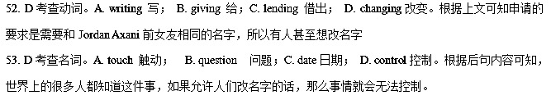54. C考查动词。A. admiring 羡慕；B. advertising 广告； C. sharing 分享；D. doubting怀疑。根据上文可知Jordan Axan收到了数千封邮件，所以很多人都知道他们旅行的故事。
55. B考查动词。A. leaving 离开； B. looking for 寻找； C. losing 失去；D. dealing with 对付。根据文章首段首句可知Jordan Axan是免费送给别人他多余的票，而不求回报。
56. D考查形容词。A. single 单一的；B. strange奇怪的；C. regular定期的；D. extra额外的。根据上文第二段可知Jordan Axan在和女朋友分手后，女朋友的机票就是多余出来的了。
57. B考查动词。A. return 回去；B. take 拿走；C. reserve 保留；D. hide隐藏。根据空后内容and travel on her own可知，申请到票的人可以和他一起旅行，也可以拿着票自己去旅行。
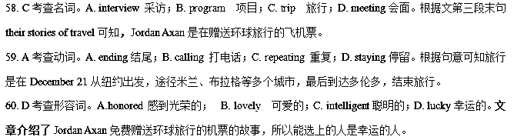4. 【2017·北京卷】完形填空（共 20 小题；每小题 1.5 分，共 30 分）
阅读下面短文，掌握其大意，从每题所给的 A、B、C、D 四个选项中，选出最佳选项，并在答题卡上将该项涂黑。
Hannah Taylor is a schoolgirl from Manitoba, Canada. One day, when she was five years old, she was walking with her mother in downtown Winnipeg. They saw a man 36 out of a garbage can. She asked her mother why he did that and her mother said that the man was homeless and hungry. Hannah was very 37 .She couldn't understand why some people had to live their lives without shelter or enough food. Hannah started to think about how she could 38 ,but,of course, there is not a lot one five-year-old can do to solve(解决)the problem of homelessness.
Later ,when Hannah attended school, she saw another homeless person. It was a woman, 39 an old shopping trolley（购物车）which was piled with 40 . It seemed that everything the woman owned was in them. This made Hannah very sad, and even more 41 to do something. She had been talking to her mother about the lives of homeless people 42 they first saw the homeless man. Her mother told her that if she did something to change the problem that made her sad, she wouldn’ t 43 as bad.
Hannah began to speak out about the homelessness in Manitoba and then in other provinces. She hoped to 44 her message of hope and awareness. She started the Ladybug Foudation ,an organization aiming at getting rid of homelessness. She began to 45 “Big Bosses” lunches, where she would try to persuade local business leaders to 46 to the cause. She also organized a fundraising(募捐)drive in “Ladybug Jars” to collect everyone`s spare change during “Make Change” month. More recently, the foundation began another 47 called National Red Scarf Day—a day when people donate $20 and wear red scarves in support of Canada`s 48 and homeless.
There is an emergency shelter in Winnipeg called “Hannah`s Place”, something that Hannah is very 49 of. Hannah`s Place is divided into several areas, providing shelter for people when it is so cold that 50 outdoors can mean death. In the more than five years since Hannah began her activities, she has received a lot of 51 .For example, she received the 2007 BRICK Award recognizing the 52 of young people to change the world. But 53 all this, Hannah still has the 54 life of a Winnipeg schoolgirl, except that she pays regular visits to homeless people.
Hannah is one of many examples of young people who are making a 55 in the world. You can,too!
36. A. jumping B. eating C. crying D. waving
37. A. annoyed B. nervous C. ashamed D. upset
38. A. behave B. manage C. help D. work
39. A. pushing B. carrying C. buying D. holding
40. A. goods B. bottles C. foods D. bags
41. A. excited B. determined C. energetic D. grateful
42. A. since B. unless C. although D. as
43. A. sound B. get C. feel D. look
44. A. exchange B. leave C. keep D. spread
45. A. sell B. deliver C. host D. pack
46. A. contribute B. lead C. apply D. agree
47. A. campaign B. trip C. procedure D. trial
48. A. elderly B. hungry C. lonely D. sick
49. A. aware B. afraid C. proud D. sure
50 A. going B. sleeping C. traveling D. playing
51. A. praises B. invitations C. replies D. appointments
52. A. needs B. interests C. dreams D. efforts
53. A. for B. through C. besides D. along
54. A. healthy B. public C. normal D. tough
55. A. choice B. profit C. judgement D. difference
【解析】
试题分析：本文讲述Hannah Taylor通过自己的努力来建立公益组织筹集资金帮助那些无家可归忍饥挨饿的人。
36.考查动词。A. jumping 跳B. eating 吃 C. crying 哭 D. waving挥手。他们看见一个人从垃圾桶里捡东西吃，根据后文的hungry可知答案为B。
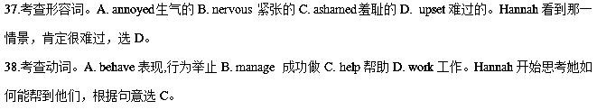39.考查动词。A. pushing 推B. carrying 拿C. buying买D. holding握。购物车肯定是推着的，根据逻辑常识可推出，故选A。
40.考查名词。A. goods 货物B. bottles瓶子C. foods 食物D. bags包。因为是流浪者，所以随身的东西肯定都是用包装好的，故车上堆满了包，里面装满了东西，选D。
41.考查形容词。A. excited 激动的B. determined下决心的，坚定的C. energetic精力充沛的D. grateful感激的。Hannah很难过，所以她更加下定决心一定要把这件事做好，故选B。
42.考查连词。A. since 自从B. unless 除非C. although尽管D. as因为。句意：自从他们第一次看到无家可归的人，Hannah就一直在跟她的妈妈说流浪者的生活，根据句意可知选A。
43.考查动词。A. sound 听B. get获得C. feel 感觉. Look看。她妈妈告诉她只要她付出努力去改变那些让她难过的事情，就不会和以前一样感觉那么糟糕了，此处指的是感觉上，故选C。
44.考查动词。A. exchange交换B. leave 离开C. keep 保持D. spread传播。她希望她那带着希望和意识的信息能够传播开来，根据句意可知选D。
45.考查动词。A. sell 卖B. deliver 传送; 投递C. host 主办宴会D. pack打包。 她开始主办大老板午餐会，说服那些商业领导们为她的慈善事业做出一些奉献，此处考查host的特殊用法，主办宴会的意思，符合语境，选C。
46.考查动词。A. contribute 贡献，捐献B. lead领导C. apply 申请，应用D. agree同意。她试图劝说那些商业领导们能为她的慈善事业做出些奉献，根据句意可知选A。
47.考查名词。A. campaign 运动B. trip 旅行C. procedure 过程D. trial实验。基金会又举办了一项运动，来筹集资金，根据句意和逻辑推理可知选A。
48.考查形容词。A. elderly 年纪大的B. hungry 饥饿的C. lonely 孤独的D. sick生病的。此处是指为那些饥饿的人和无家可归的人，前文中第一次出现的就是从垃圾桶里找东西吃的人让Hannah很难过，所以她的帮助对象肯定包含饥饿的人，选B。
49.考查形容词。A. aware 意识的B. afraid 害怕的C. proud 骄傲的 D. sure肯定的。前面提到为那些无家可归的人见建了一个名为Hannah`s Place的地方，以她的名字命名的，所以 Hannah肯定非常骄傲，自豪，故选C。
50.考查动词。A. going 去B. sleeping 睡 C. traveling 旅行D. playing玩。当天冷到在室外睡觉就意味着死的时候，这个避难所就会给那些无家可归的人，根据句意可知选B。
51.考查名词。A. praises赞美B. invitations邀请C. replies回复D. appointments约会。她收到了很多的赞美。因为下文有这方面的举例，给她颁奖，故答案为A。
52.考查名词。A. needs 需要 B. interests 兴趣C. dreams梦想D. efforts努力。此处是指这个奖项是为了认可年轻人改变这个世界所作出的努力，根据句意可知选D。
53.考查介词。A. for 为了B. through 通过C. besides 此外D. along沿着。但是经过所有这些之后，Hannah依然过着Winnipeg学校一名女生的普通的生活，根据句意可知选B。
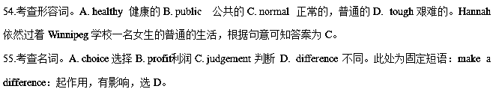考点：人物故事类短文阅读
【名师点睛】
完型填空题的命题特点及答题方法：
1.侧重基础知识，考查学生语言知识的能力
完型填空以文入手，结合文章的内容考查学生的基础知识，主要是词语搭配、固定句型、近义词辨析、辨析句子结构、掌握语法规则的能力，其中考查实词居多。比如最后一题who are making a 55 in the world. 根据选项提供的词马上就可以判断此处为固定短语：make a difference：起作用，有影响，选D。
2.上下文对照，考查学生捕捉关键词的能力
解完型填空题时，单独看一句话是找不到正确答案的，需要注意句子间的关系及句子与段落的关系。所谓上下对照，即在上文和下文中找到与正确答案相同的关键词。因此，在做题时要边读边在大脑中储存上下文信息的能力，捕捉关键词。
3.设置语境，考查学生的分析推理能力
旨在考查学生在选项都符合语法及句子结构的情况下能否利用前后语境去推断出正确答案。例如第51空，she has received a lot of 51 。她收到了很多的 。这是就要考虑到下文了，因为下文有这方面的举例，是给她颁奖，由此可判断是对她的赞美，故答案为A。
4.结合生活，考查学生利用常识题的能力
目的考查学生的生活常识，看看学生是否善于观察生活，积累生活常识，能否利用常识去做恰当的选择。
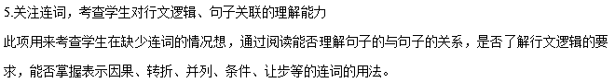5. 【2017·浙江卷】完形填空（共20小题；每小题1.5分，满分30分）
阅读下面短文，从短文后各题所给的A、B、C和D四个选项中，选出可以填入空白处的最佳选项，并在答题纸上将该项涂黑。
Alia Baker is a librarian in Iraq. Her library used to be a 36 place for all who loved books and liked to share knowledge. They 37 various matters all over the world. When the war was near, Alia was 38 that the fires of war would destroy the books, which are more 39 to her than mountain of gold. The books are in every language — new books, ancient books, 40 a book on the history of Iraq that is seven hundred years old.
She had asked the government for 41 to move the books to a 42 place, but they refused. So Alia took matters into her own hands. 43 , she brought books home every night, 44 her car late after work. Her friends came to 45 her when the war broke out. Anis who owned a restaurant 46 to hide some books. All through the 47 , Alia, Anis, his brothers and neighbours took the books from the library, 48 them over the seven-foot wall and 49 them in the restaurant. The books stayed hidden as the war 50 . Then nine days laters, a fire burned the 51 to the ground.
One day, the bombing stopped and the 52 left. But the war was not over yet. Alia knew that if the books were to be safe, they must be 53 again while the city was 54 . So she hired a truck to bring all the books to the houses of friends in the suburbs(郊区). Now Alia waited for the war to end and 55 peace and a new library.
36. A. meeting B. working C. personal D. religious
37. A. raised B. handled C. reported D. discussed
38. A. worried B. angry C. doubtful D. curious
39. A. practical B. precious C. reliable D. expensive
40. A. then B. still C. even D. rather
41. A. permission B. confirmation C. explanation D. information
42. A. large B. public C. distant D. safe
43. A. Fortunately B. Surprisingly C. Seriously D. Secretly
44. A. starting B. parking C. filling D. testing
45. A. stop B. help C. warn D. rescue
46. A. intended B. pretended C. happened D. agreed
47. A. war B. night C. building D. way
48. A. put B. opened C. passed D. threw
49. A. hid B. exchanged C.burnt D. distributed
50. A. approached B. erupted C. continued D. ended
51. A. restaurant B. library C. city D. wall
52. A. neighbours B. soldiers C. friends D. customers
53. A. sold B. read C. saved D. moved
54. A. occupied B. bombed C. quiet D. busy
55. A. dreamed of B. believed in C. cared about D. looked for
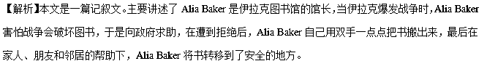36.考查形容词。A.meeting会议的；B.working工作的；C.personal个人的；D.religious虔诚的。根据后文“for all who loved books and liked to share knowledge”,可知图书馆是为那些喜爱书，喜欢分享知识的人而建立的，因此“her library used to be a ___place”她的图书馆是这些人集会、碰面的地方。故选A。
37.考查动词。A.raised举起、抬高；B.handled应付、处理；C.reported报道；D.discussed讨论。根据“They___various matters all over the world”,根据语境，应该是他们讨论世界大事。故选D。
38.考查形容词。A.worried担心；B.angry生气；C.doubtful怀疑的；D.curious好奇的。根据后文“So Alia took matters into her own hands”，Alia用双手搬书，可知“Alia was ___that the fires of war would destroy the books”,Alia担心战火会破坏书。故选A。
39.考查形容词。A.practical实践的；B.precious珍贵的；C.reliable可靠的；D.expensive昂贵的。根据后文“which are more__to her than mountains of gold”,由more可知，是将书与金山作比较，可见书的珍贵性。故选B。
40.考查副词。A.then然后；B.still仍然；C.even甚至；D.rather稍微。根据“a book on the history of Iraq that is seven hundred years old”,这本关于伊拉克历史的书已经有了七百年的历史，因此是比较宝贵的，与前面“new books,ancient books”是一种层次上的上升与递进关系。故选C。
41.考查名词。A.permission许可；B.confirmation确认；C.explanation解释；D.information信息。根据“She had asked the government for__to move the books to a__place”,可知她想获得政府的许可，将书转移到安全的地方。故选A。
42.考查形容词。A.large大的；B.public公共的；C.distant遥远的；D.safe安全的。根据“She had asked the government for permission to move the books to a__place”,她想获得政府的许可，将书转移到（ ）的地方。故选D。
43.考查副词。A.Fortunately幸运地；B.Surprisingly惊奇地；C.Seriously严重地；D.Secretly秘密地。根据“she brought books home every night”,可知她是在秘密地转移书籍。故选D。
44.考查动词。A. Starting开始；B.parking停车；C.filling装满；D.testing测试。根据“__her car late after work”,可知，在工作之后，她的车都被书装满的。故选C。
45.考查动词。A.stop停止；B.help帮助；C.warn警告；D.rescue营救。根据后文“Anis who owned a restaurant 46 to hide some books.”可知，她的朋友们都过来帮她转移书。故选B。
46.考查动词。A. intended 打算；B. pretended假装；C. happened 发生；D. agreed同意。根据“Anis who owned a restaurant 46 to hide some books”根据语境分析，Anis同意把书藏在她的饭店里面。故选D。
47.考查名词。 A. war 战争；B. night夜晚C. building 楼房；D. way 方法。根据前文“she brought books home every night,”所以与之相对应“All through the 47 ”，故选B。
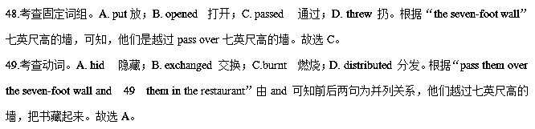50.考查动词。A. approached 接近；B. erupted 爆发；C. continued D. ended 结束。由后文
“Then nine days laters, a fire burned the 51 to the ground.”可知，战争仍在继续。故选C。
- 考查名词。A. restaurant 饭店；B. library 图书馆；C. city 城市；D. wall 墙壁。根据后文“Now Alia waited for the war to end and 55 peace and a new library”可知原来的图书馆已经损毁，所以“a fire burned the 51 to the ground.”战火蔓延到了图书馆。故选B。
- 考查名词。A. neighbours 邻居；B. soldiers 士兵；C. friends 朋友；D. customers 顾客。“the bombing stopped and the 52 lef”，and连接两个并列句，轰炸停止，与之相对应的是，士兵离开了。故选B。
- 考查动词。A. sold 卖；B. read 阅读；C. saved救；D. moved 移动。根据“So she hired a truck to bring all the books to the houses of friends in the suburbs(郊区)”，可知，她决定要再次移动书。故选D。
- 考查形容词。A. occupied 占据；B. bombed 轰炸；C. quiet 安静的；D. busy 忙的。“the bombing stopped and the soldiers left”根据语境，战争刚结束，城市应该很安静。
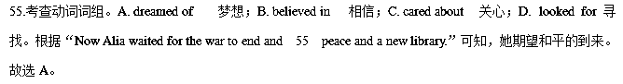【名师点睛】
本篇完形填空很好地体现出重在考查语篇理解能力，且不在情节上、词汇考查大做文章的趋势。逐渐侧重于对语篇复现的考查。
如47题，根据前文“she brought books home every night,”可知“All through the 47 , Alia, Anis, his brothers and neighbours took the books from the library”他们选择晚上转移书籍，故选B。
语篇复现的信息包括原词复现、同义词和反义词复现、上义词和下义词复现、概括词复现和代词复现等。语篇中有词汇和结构同现的现象，如与语篇话题相关、意义相关的词汇同时出现，结构同现，同义同现，修饰同现，因果同现等。因此，利用上下文寻找解题信息，确定正确答案。
考点：考查记叙文阅读。
6.【2017·天津卷】完形填空（共20小题；每小题1.5分，满分30分）
阅读下面短文，掌握其大意，然后从16-35各题所给的A、B、C、D四个选项中，选春最佳选项。
At my heaviest I weighed 370 pounds. I had a very poor relationship with food: I used it to
16 bad feelings, to make myself feel better, and to celebrate. Worried about my health, I tried many different kinds of 17 but nothing worked. I came to believe that I could do nothing about my 18 .
When I was 50, my weight problem began to affect me 19 . I didn’t want to live the rest of my life with this 20 weight any more.
That year, I 21 a seminar where we were asked to create a project that would touch the world. A seminar leader shared her 22 story —she had not only 125 pounds, but also raised $25,000 for homeless children.
23 by her story, I created the As We Heal(痊愈), the World Heals 24 . My goal was to lose 150 pounds in one year and raise $50,000 25 a movement founded 30 years ago to end hunger. This combination of healing myself and healing the world 26 me as the perfect solution.
27 I began my own personal weight program, I was filled with the fear that I would
28 the same difficulties that beat me before. While the 29 hung over my head, there were also signs that I was headed down the right 30 . I sent letters to everyone I knew, telling them about my project. It worked perfectly. Donations began 31 in from hundreds of people.
Of course, I also took some practical steps to lose weight. I consulted with a physician（内科医生）, I hired a fitness coach, and I began to eat small and 32 z&xxk meals. My fund-raising focus also gave me new motivation to exercise 33 .
A year later, I 34 my goal: I lost 150 pounds and raised $50,000! I feel that I’ve been given a second life to devote to something that is 35 and enormous.
16.A.add B. mix C. kill D. share
17.A. diets B. drinks C. fruits D. dishes
18.A. height B. ability C. wisdom D. weight
19.A. temporarily B. recently C. seriously D. secretly
20.A.ideal B. extra C. normal D. low
21.A. attended B. organized C. recommended D. mentioned
22.A. folk B. success C. adventure D. science
23.A. Surprised B. Amused C. Influenced D. Disturbed
24.A. project B. business C. system D. custom
25.A. in search of B.in need of C. in place of D. in support of
26.A.scared B. considered C. confused D. struck
27.A. As B. Until C. If D. Unless
28.A. get over B. run into C. look for D. put aside
29.A.excitment B. joy C. anger D. fear
30.A.row B. hall C. path D. street
31.A. breaking B. flooding C. jumping D. stepping
32.A. heavy B. full C. expense D. healthy
33.A. regularly B. limitlessly C. suddenly D. randomly
34.A. set B. reached C. missed D. dropped
35.A. stressful B. painful C. meaningful D. peaceful
【语篇解读】这是一篇记叙文。作者讲述自己减肥成功的经历，作者通过给自己制定目标然后坚持不懈的努力去战胜困难而不仅减肥成功并且募集了50,000美元的资金，实现了自己既定目标，通过这次经历作者也认识到自己投入到了意义巨大的事情。
16.【答案】C
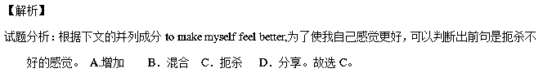考点：考查动词辨析。
- 【答案】A
【解析】
试题分析：根据段首句at my heaviest I weighed 370 pounds. 和上文Worried about my health, ，可知本句：我尝试了不同种类的饮食但都没有起作用。A. 饮食 B. 饮料 C. 水果 D. 菜。根据句意，故选A。
考点：考查名词辨析。
18.【答案】D
【解析】
试题分析：根据上文I tried many different kinds of diets but nothing worked.，可知下文是：我开始觉得我对于我的体重无能为力。A. 身高 B. 能力 C. 聪明 D. 体重。根据句意，故选D。
考点：考查名词辨析。
19.【答案】C
【解析】
试题分析：根据上文可知作者减肥没有成功，可知本句：当我五十岁时，我的体重严重影响了我。A. 临时地 B. 近期 C. 严重地 D. 秘密地。故选C。
考点：考查副词辨析。
20.【答案】B
【解析】
试题分析：根据下文affect me seriously，可知下文：我不想我的余生带着这些额外的体重。A.理想的 B. 额外的 C.正常的 D. 低的。故选B。
考点：考查形容词辨析。
21.【答案】A
【解析】
试题分析：根据宾语a seminar一个研讨班，可知，她参加了一个研讨班。A. 参加 B. 组织 C. 推荐 D. 提到。故选A。
考点：考查动词辨析。
22.【答案】B
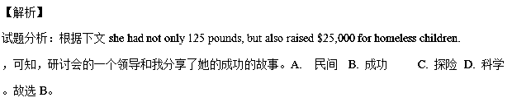考点：考查名词辨析。
23.【答案】C
【解析】
试题分析：根据上文成功的故事和下文I created the As We Heal(痊愈), the World Heals 24 .，可知，我被她的故事所影响。A. 感到惊讶 B. 感到高兴 C. 被影响 D. 被打扰。故选C。
考点：考查形容词辨析。
24.【答案】A
【解析】
试题分析：根据上文下文My goal was ...可知，我创建了这个As We Heal(痊愈), the World Heals 工程。A. 工程 B. 生意 C. 系统 D. 风俗习惯。故选A。
考点：考查名词辨析。
25.【答案】D
【解析】
试题分析：根据上文raise $50,000可知，为了支持三十年前为了结束饥饿而创办的一项活动。A. 为了寻找 B.需要 C.代替 D. 为了支持 。故选D。
考点：考查介词短语辨析。
26.【答案】D
【解析】
试题分析：根据主语：This combination of healing myself and healing the world ，可知，这种既治愈自己又治愈世界的结合在我看来似乎是一个完美的解决方案。根据句意和关键词as判断出这是考查固定短语：strike sb as ...， 在某人看来似乎是...。故选D。
考点：考查动词辨析。
27.【答案】A
【解析】
试题分析：根据主句：I was filled with the fear... 我充满了恐惧，可知上文，当我开始我的个人体重项目时。A. 当...的时候 B.直到 C.如果 D. 除非。故选A。
考点：考查连词辨析。
- 【答案】B
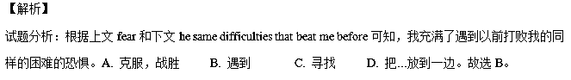考点：考查动词短语辨析。
29.【答案】D
【解析】
试题分析：根据上文I was filled with the fear that ...，可知，尽管恐惧围绕在我的脑海。A.兴奋B. 高兴 C. 生气 D. 恐惧。故选D。
考点：考查名词辨析。
30.【答案】C
【解析】
试题分析：根据上文While the fear hung over my head,可知，有迹象表明我正走向正确的道路。A.排 B. 大厅 C. 路 D. 街道。故选C。
考点：考查名词辨析。
31.【答案】B
【解析】
试题分析：根据上文It worked perfectly，可知，捐款从几百人那里涌入。根据固定短语：break in 闯入；flood in 大量涌入；jump in 跳进； step in 步入。故选B。
考点：考查动词辨析。
- 【答案】D
【解析】
试题分析：根据上文hired a fitness coach可知，我开始吃少量的且健康的食物。A. 重的 B. 满的 C. 贵的 D. 健康的。故选D。
考点：考查形容词辨析。
33.【答案】A
【解析】
试题分析：根据exercise可知，我的募集资金的关注也给了我定期锻炼的激励。A. 定期地 B.无限度地 C. 突然地 D. 随意地 。故选A。
考点：考查副词辨析。
34.【答案】B
【解析】
试题分析：根据下文I lost 150 pounds and raised $50,000! 可知，我实现了我的目标。A. 制定 B. 实现，达到 C.错过 D. 使降低 。故选B。
考点：考查动词辨析。
35.【答案】C
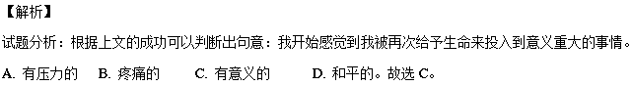考点：考查形容词辨析。
【名师点睛】这篇文章是记叙文，难度适中，这类文章首先要通读抓住故事发生的情节和作者想传达的中心思想。围绕主旨解答更有把握。故事内容体现了作者的坚持不懈的毅力和不被困难压倒的精神。学生要抓住这个主题，而且这个主题贯穿整个文章。这个文章一个明显的特点是上下文之间的联系非常紧密。做题时把握选项词义且要牢记上下文的关联对解题会很有帮助。
做题时要结合完形填空的特点，完形填空题有的考查词语同现、词语复现，有的则是要运用逻辑推理能力，领会和掌握解题策略对提高完形填空的解题速度和准确率大有裨益。
1. 上下文串联和语境暗示。
这篇完型填空里面出现词语同现的很少，但是词语复现不少，就是指某一个词以原词、同根词、同义词、反义词等方式重复出现在语篇中，语篇中的句子通过这种复现关系达到相互衔接。像这篇完型的18题和首句的动词weighed 相对应；24题，下文明显出现了program，还有29题，上文出现了the fear；34题是和下文的I lost 150 pounds and raised $50,000!信息词对应的，都是属于这种类型。
2. 逻辑推理。
逻辑推理是通过对句子间和上下文之间逻辑关系的理解从而推断出正确答案。其中逻辑关系主要包括因果关系、转折关系、对比关系、并列关系等。逻辑推理题需要考生对上下文的理解全面把握，难度较大，考生不能将句子独立开，要注意一个句群，一个段落的整体理解。这篇文章逻辑推理的题较多。19题主要是上下文的逻辑关系，推断出是程度副词seriously；如27题，根据主句和宾语内容推断出是as；还有35题，抓住通读全文和位于末端尾句推断出来这是一个总结全文的主题句。
7.【2017·江苏卷】完形填空(共20小题；每小题1分，满分20分)
请阅读下面短文，从短文后各题所给的A、B、C、D四个选项中，选出最佳选项，并在答题卡上将该项涂黑。
For a long time Gabriel didn’t want to be involved in music at all. In his first years of high school, Gabriel would look pityingly at music students, __36__across the campus with their heavy instrument cases, __37__at school for practice hours __38__ anyone else had to be there. He swore to himself to__39__music, as he hated getting to school extra early.
__40___, one day, in the music class that was __41__of his school’s standard curriculum, he was playing idly (随意地)on the piano and found it ____42___to pick out tunes. With a sinking feeling, he realized that he actually __43__doing it. He tried to hide his __44__pleasure from the music teacher, who had __45__over to listen. He might not have done this particularly well, __46__the teacher told Gabriel that he had a good___47__and suggested that Gabriel go into the music store-room to see if any of the instruments there __48__him. There he decided to give the cello(大提琴) a __49__. When he began practicing, he took it very __50__. But he quickly found that he loved playing this instrument, and was __51__to practicing it so that within a couple of months he was playing reasonably well.
This __52__, of course, that he arrived at school early in the morning, __53__his heavy instrument case across the campus to the __54__looks of the non-musicians he had left__55__.
36.A.travelling B.marching C.pacing D.struggling
37. A.rising up B.coming up C.driving up D.turning up
38. A.before B.after C.until D.since
39. A.betray B.accept C.avoid D.appreciate
40. A.Therefore B.However C.Thus D.Moreover
41. A.part B.nature C.basis D.spirit
42. A.complicate B.safe C.confusing D.easy
43. A.missed B.disliked C.enjoyed D.denied
44. A.transparent B.obvious C.false D.similar
45. A.run B.jogged C.jumped D.wandered
46. A.because B.but C.though D.so
47. A.ear B.taste C.heart D.voice
48. A.occurred to B.took to C.appealed D.held to
49. A.change B.chance C.mission D.function
50. A.seriously B.proudly C.casually D.admitted
51. A.committed B.used C.limited D.admitted
52. A.proved B.showed C.stressed D.meant
53. A.pushing B.dragging C.lifting D.rushing
54. A.admiring B.pitying C.annoying D.teasing
55. A.over B.aside C.behind D.out
【答案】36-40. DDACB 41-45. ADCBD 46-50. AACBC 51-55. ADBBC
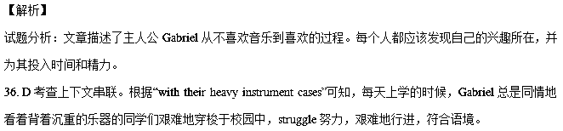37. D考查上下文串联。根据“ __37__at school for practice hours __38__ anyone else”可知，学习音乐的同学需要比不学音乐的早到学校几个小时，为了练习弹奏乐器，turn up原意“调高(音量)”，在此意为“出现”，符合语境。
38. A 考查上下文串联。“anyone else”指不学音乐的学生，学习音乐的要比规定的到校时间早到几个小时，before anyone else had to be there比规定的到校时间早几个小时。这也是Gabriel不想学习音乐的原因之一。
39. C考查上下文串联。本题需要结合语境进行选择。根据“as he hated getting to school extra early”可知，Gabriel讨厌过早到校，因此他对自己发誓“不学”音乐，A背叛；B接受；C避免，避开；D欣赏。注意单词在文章中的灵活翻译，只有C项符合语境。
40. B考查上下文串联。本段讲Gabriel在一次音乐课上意外发现自己很喜欢音乐，与上一段是转折关系，
故选B。
41. A考查名词辨析和句意理解。that was __41__of his school’s standard curriculum是定语从句，音乐课是学
校的标准课程的一部分，言外之意就是说，每个学生都得上这门音乐课。
42. D考查上下文串联。根据下句“actually... tried to hide... pleasure”等词或词组可以看出，Gabriel在音乐中找到了乐趣，并试图隐藏这份愉悦，由此可知，第38空的意思是“演奏音乐很容易”。只有D项符合语境。
43. C考查上下文串联。根据actually可知，Gabriel对音乐的看法有了变化，他实际上是喜欢音乐的，A/B/D都是有否定倾向的词，不符合语境。
44. B考查近义词辨析和上下文串联。Gabriel不想让音乐老师看到自己表露出来的很明显的喜悦之情，transparent指(谎言、借口)易看穿的；obvious明显的，显然的，故选B。
45. D考查动词辨析。A.run 跑，经营；B.jogged慢跑；C.jumped跳；D.wandered漫游，闲逛，徘徊。音乐老师在教室里来回走动，听到Gabriel弹奏钢琴的声音，就走过来聆听。wander符合语境。
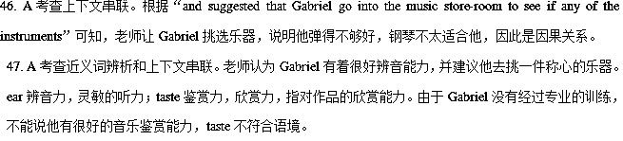48. C考查词组辨析。A.occur to sb某人突然想起；B.take to开始喜欢；C.appeal to有吸引力，引起兴趣；D.hold to抓住。老师让Gabriel找一件自己喜欢的乐器。
49. B考查名词辨析和上下文串联。A.change改变，零钱；B.chance机会，可能性；C.mission任务；D.function功能。Gabriel准备试一下大提琴。给大提琴一次机会，即尝试拉一下大提琴，其余不符合语境。
50. C考查上下文串联。根据But可知，前后是转折关系，下句说Gabriel发现自己很喜欢大提琴，说明前一句是说他只是随便拉一下。
51. A考查固定搭配和上下文串联。be committed to sth/ doing sth致力于；be used to doing sth某人习惯于做
某事；be limited to被限制在；be admitted to被录取，允许进入某地。根据“so that within a couple of months
he was playing reasonably well”可知，花了几个月的时间练习之后，Gabriel的大提琴已经拉得非常好了。
52. D考查上下文串联。本段与第一段呼应。学习音乐意味着早到学校，要把沉重的乐器背来背去，meant在此意为“意味着”，构成句型It/This means that...这就意味着......。
53. B考查上下文串联。开始学习音乐之后，Gabriel不得不拖着沉重的乐器早早地到学校练习拉琴。drag指吃力地拖、拉某物，符合语境。
54. B考查上下文串联。根据“non-musicians”可知，这里指不学音乐的学生的表情，根据第一段可知，不学音乐的学生对学音乐的投去同情的目光，故选pitying。
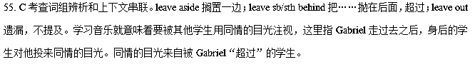【名师点睛】
完形填空的首句往往开宗明义，是文章的主题。细读首句可启示全文。而尾句往往是对文章主题的总结。所以，它们是了解文章大意的一个窗口，对我们理解全文有着重要的启示作用。因此，要充分利用段首句提供的信息，去挖掘文章的思路，寻找文章的脉络与线索。一般来讲，高考完形填空的首、尾句通常是不挖空的。先跳读这两句，便可判断体裁，猜想它要讲的内容。若首句交代了when, where, who, what，即四个W，那么就是记叙文，很可能就是一个故事，为了测试语篇的理解能力，出题者特别注意选材的趣味性，其结尾往往出人意料，耐人寻味。
本题而言，文章开头部分“For a long time Gabriel didn’t want to be involved in music at all. In his first years of high school, Gabriel would look pityingly at music students...”告诉了我们一些很有价值的信息，比如：“For a long time”的暗示作用。Gabriel一点也不想接触音乐，这种想法已经存在很久了，暗示他可能会开始学习音乐。“look pityingly at music students”同情地看着学习音乐的学生，也为下文的转折做了铺垫。
另外，完形填空题中对词汇知识的考查，主要体现在习惯用法和同义词、近义词的辨析两方面。习惯用法是英语中某种固定的结构形态，即所谓的“习语”，不能随意改动。所以，考生平时应掌握好习惯用法。对词义辨析题的考查有加大力度的趋势。要做好这类题，需要有较大的词汇量和词语搭配能力、词语辨析能力，特别是在特定的语境中能灵活运用的能力。本题的44、47就是考查了近义词的辨析，第47题的taste误导性很大。
同时，信息的复现也是完形填空的一个特点。语篇复现的信息包括原词复现、同义词和反义词复现、上义词和下义词复现、概括词复现和代词复现等。语篇中有词汇和结构同现的现象，如与语篇话题相关、意义相关的词汇同时出现，结构同现，同义同现，修饰同现，因果同现等。因此，可以利用上下文寻找解题信息，从而确定正确答案。
考点：考查记叙文阅读
8.
Two years ago, Dubuque, Iowa, started its first annual “Back to School Bash” programme. It offered needy families an opportunity to learn about free __1__ in the community. Holmes decided to __2__ by providing help to kids. He was __3__ two jobs at the time, one of which was working as a barber. Saturday was his __4__ day, but he chose to __5__ his time and gave free haircuts to lowerclass kids on condition that the kids should __6__ their free haircut by having to read a book to him.
The idea was so __7__ that he continued it for the next two years. Many kids would __8__ a favourite book, settle into the barber chair, and read aloud __9__ Holmes was doing their hair. After the haircut, they'd review the book, from the __10__ and vocabulary to the themes—just like in school, only more fun.
Holmes, who is married __11__ two sons, recognizes that not every parent has the time to __12__ with their kids. So he hopes to offer some __13__ in this way. And he admits he, __14__， benefits from doing that.
There was a sevenyearold kid who __15__ stuttered(结巴) over words while reading. He had the boy take the book home and __16__. When the child came back a few days later, he read it with no problems. That __17__ Holmes to do more.
Holmes and his family have recently moved to a Chicago suburb. When they get __18__， he plans to restart his __19__ as the Storybook Barber. “Today's world is full of guns and violence，” he says, “The barbershop is a __20__ place for the kids to come and read books.”
1．A.materials B．resources C．methods D．connections
2．A.participate B．perform C．develop D．withdraw
3．A.faced with B．caught in C．presented with D．engaged in
4．A.happiest B．worst C．busiest D．best
5．A.spend B．waste C．save D．donate
6．A.receive B．earn C．demand D．request
7．A.popular B．ordinary C．complex D．strict
8．A.put away B．take over C．pick up D．give out
9．A.before B．after C．while D．until
10．A.kids B．heroines C．barbers D．characters
11．A.with B．to C．for D．about
12．A.stay B．read C．talk D．learn
13．A.guidance B．judgement C．assistance D．insurance
14．A.again B．still C．then D．too
15．A.usually B．hardly C．merely D．necessarily
16．A.write B．practise C．remark D．reflect
17．A.surprised B．excited C．inspired D．impressed
18．A.settled B．relaxed C．pleased D．refreshed
19．A.ownership B．hobby C．promise D．role
20．A.secret B．safe C．rough D．crowded
【文章大意】 本文是一篇记叙文，主要分享了主人公做公益的励志故事。
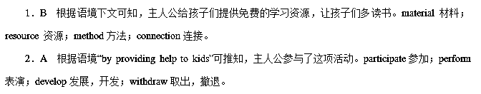3．D 根据语境可知，主人公同时从事了两份工作。 be faced with面临；be caught in陷入；be presented with提供；be engaged in从事。
4．C 根据上文“as a barber”和语境中“Saturday”可推知，主人公周六很忙，与上文从事两份工作和下文的转折中“his time”呼应。happiest最开心，最幸福；worst最糟糕；busiest最繁忙；best最好。
5．D 与文中关键词“free”呼应可知，主人公把自己繁忙的时间贡献出来，做有意义的事。spend花费；waste浪费；save节约；donate捐献。
6．B 根据语境“their free haircut”提示可推知，孩子们要通过读书才能获得免费理发的权利，故用earn“挣得”。receive收到；earn挣得；demand要求；request要求。
7．A 根据语境“…he continued it for the next two years.”可推知，这项活动开展得很好，很受欢迎，因此主人公坚持了两年。 popular流行，受欢迎；ordinary普通的；complex复杂的；strict严格的。
8．C 根据语境可知，孩子拿起书，坐在理发店的椅子上，开始读书。put away存储；take over接管；pick up捡起；give out分发，发出。
9．C 与下文“while reading”呼应可推知，孩子们读书是在主人公理发期间。before 在……之前；after在……之后；while在……期间；until直到。
10．D 根据语境“…they'd review the book, from the…and vocabulary to the themes…”可推知，孩子们回顾书中的角色、词汇以及主题。kid小孩；heroine女英雄；barber理发师；character角色。
11．A 根据语境可知，此处表示主人公有两个孩子。with有，带着；to到；for为了；about关于。
12．B 与上文“Saturday was his 4 day, but he chose to 5 his time and gave free haircuts to lowerclass kids on condition that the kids should 6 their free haircut by having to read a book to him.”呼应可知，并不是每个父母都有时间陪孩子一起读书的。stay待，留；read读书；talk谈话；learn学习。
13．C 根据上文“Holmes decided to 2 by providing help to kids.”可推知，主人公施以援助。guidance指导；judgement判断；assistance 帮助；insurance保险。
14．D 由语境“and”提示可知，主人公在帮助他人的过程中自己也受益匪浅。again再次；still仍旧；then接下来，那时；too也。
15．A 根据语境可知，孩子口吃是一种习惯，因此后来就把书拿回家读。usually通常；hardly几乎不；merely仅仅；necessarily必要地。
16．B 根据下文“When the child came back a few days later, he read it with no problems.”可推知，口吃的孩子回家进行了练习，因此再读起来就没有问题了。write写；practise练习；remark评论；reflect反射，反思。
17．C 根据语境“do more”可推知，主人公受到了激励，从而做得更多。surprise吃惊；excite使激动；inspire激励；impress使人印象深刻。inspire sb to do sth激励某人做某事。
18．A 根据上文“Holmes and his family have recently moved to a Chicago suburb.”可推知，主人公搬了家，然后安顿下来，与下文重新开始的自己原有的项目计划呼应。settle安顿，定居；relax放松；please开心；refresh振奋，精神焕发。
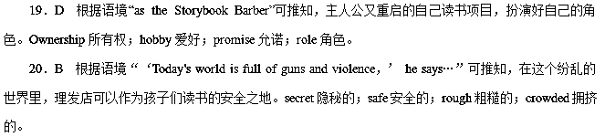9.
My husband Jeff and I moved into our new home in Scottsbluff last year just before Christmas.I did not have the __1__ or energy to carry out my traditional Christmas decorating and baking activities.What was the point, anyway? It was going to be a __2__ Christmas after all.
__3__， the neighbourly nature of west Nebraska residents started to trickle (陆续来临) in.
There was a __4__ on the door one evening.It was Jeff's new colleague, John Smith, and his wife, Phyllis.The Smiths had stopped by to __5__ us with a loaf of homemade bread.They pointed out a __6__ on the porch (门廊)．Apparently the doorbell wasn't working in the cold snowy weather and we had __7__ a visit from the Browns, our acrossthestreet neighbours, who brought us a Christmas card and more Christmas cookies.
The __8__ feelings brought by these thoughtful gestures lasted longer than the food.
As Jeff and I were __9__ preChristmas snow from our driveway, Ernie Guzman came over from next door to __10__ us to dig out.
Then, we received an invitation to __11__ a Christmas Eve meal with our neighbours, Ernie and Nancy Sommer, and their __12__—a 90yearold lady, who also had no family in the immediate area with whom to spend the holiday.
Our Christmas Eve was quite merry, thanks to our __13__. Our Christmas morning __14__ was special, thanks to the Smiths' gift of bread.I was so __15__ for these gestures of welcome, especially during the holidays.
This year, we were again unable to be with our families for Christmas.The __16__ and work schedules just made things too difficult.__17__ that sense of Christmas isolation (孤立) all too well, we decided to try to round up some other folks who were __18__ in the holidays.
Lonely people are all around us, but most of us __19__ notice them.Just take a look around you.Sometimes, the smallest __20__ gesture can make a world of difference.
1. A．chance B．anxiety C．time D．ability
2. A．lonely B．free C．merry D．usual
3. A．Therefore B．However C．Somehow D．Meanwhile
4. A．sign B．knock C．card D．note
5. A．invite B．welcome C．drive D．send
6. A．tree B．flower C．mail D．package
7. A．forgot B．missed C．arranged D．received
8. A．warm B．deep C．true D．mixed
9. A．buying B．clearing C．preparing D．giving
10. A．teach B．urge C．help D．forbid
11．A.prepare B．share C．taste D．exchange
12．A.guest B．aunt C．maid D．partner
13．A.folks B．relatives C．neighbours D．colleagues
14．A.call B．greeting C．meeting D．breakfast
15．A.sorry B．eager C．grateful D．ready
16．A.season B．expense C．distance D．situation
17．A.Knowing B．Showing C．Studying D．Discovering
18．A.happy B．busy C．alone D．active
19．A.always B．usually C．finally D．seldom
20．A.careful B．kind C．pretty D．patient
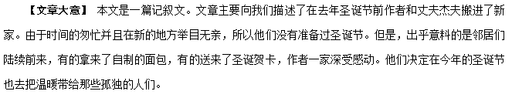1．C 根据上文“My husband Jeff and I moved into our new home in Scottsbluff last year just before Christmas.”可知他们在圣诞节前刚搬进新家，因而没时间和精力去筹备圣诞节，故选C。chance机会；anxiety渴望；time时间；ability能力。
2．A 根据文章倒数第二段“This year，we were again unable to be with our families for Christmas.…that sense of Christmas isolation(孤立)all too well…”可以判断作者刚搬到新地方的时候是打算孤独地去过圣诞节的，故选A。lonely孤独的；free自由的；merry快乐的；usual通常的。
3．B 根据上下文“…the neighbourly nature of west Nebraska residents started to trickle(陆续来临) in.”原本认为它将是一个孤独的圣诞节，然而却收到邻居的邀请，前后内容有转折关系，故选B。therefore 因此；however然而；somehow不管怎样；meanwhile同时。
4．B 根据下文可知邻居来了，而且由“Apparently the doorbell wasn't working in the cold snowy weather…”知道门铃坏了，所以别人只能敲门，故选B。sign标志；knock敲击；card卡片；note笔记。
5．B 从语境可知杰夫的同事送来了自家做的面包作为对我们来这里的欢迎，故选B。invite邀请；welcome欢迎；drive驾驶；send寄送。
6．D 从下文“…who brought us a Christmas card and more Christmas cookies.”可知邻居布朗一家给我们送来了甜饼，贺卡等，由此推测应该是用包裹包好的，故选D。tree树；flower花；mail邮件；package包裹。
7．B 因为包裹放在了门廊里，而且从上文可知门铃坏了，由此推断他们没能见到送礼物的布朗一家，所以此处指我们错过了一次邻居的来访，故选B。forget忘记；miss错过；arrange安排；receive收到。
8．A 在上文中邻居和同事带来了贺卡、甜饼和面包，从情理可知作者对此非常感动，感到了他们所带来的温暖，而且这种温暖的感觉比实物持续的时间更长，故选A。warm温暖的；deep深的；true真实的；mixed混合的。
9．B 从上文“Apparently the doorbell wasn't working in the cold snowy weather…”可知当时是下雪天，由此判断作者和丈夫正清扫车道上的积雪，故选B。buy买；clear清洁；prepare准备；give给。
10．C 根据语境可知隔壁的邻居看到他们在扫雪，也过来帮忙，故选C。teach教；urge敦促；help帮助；forbid禁止。
11．B 从句意可知我们收到一个去和邻居们共进圣诞晚餐的邀请，应该用share“分享”，故选B。prepare准备；share分享，分担；taste品尝；exchange交换。
12．A 根据下文“…who also had no family in the immediate area with whom to spend the holiday.”可知这位老人也是没有家人在这个地方的，所以也是客人，故选A。guest客人；aunt阿姨；maid少女；partner伙伴。
13．C 从上文“a Christmas Eve meal with our neighbours”可知他们是和邻居一起共进晚餐，所以他们对邻居心怀感激，故选C。folk人们；relative亲戚；neighbour邻居；colleague同事。
14．D 根据上文内容可知邻居和杰夫的同事在清晨送来了吃的东西，再由下文“thanks to the Smiths'gift of bread”可以判断此处指早餐，故选D。call电话；greeting问候；meeting会见；breakfast早餐。
15．C 从故事内容可知作者对邻居的善意是心存感激的，故选C。sorry遗憾的；eager渴望的；grateful感激的；ready准备好的。
16．C 根据文章内容可知他们远离亲朋好友来到了一个新地方，所以此处指距离和工作日程使作者不能和家人共度圣诞，故选C。season季节；expense花费；distance距离；situation情景。
17．A 从上文内容可知作者刚来到这个新地方的时候曾经体味过孤独的感觉，故选A。know知道；show展示；study学习；discover发现。
18．C 根据上文“that sense of Christmas isolation(孤立)all too well”和下文“Lonely people are all around us…”可以推测作者曾经体会过孤独的感觉，所以他们决定设法在假期里把孤独的人们聚在一起，故选C。happy快乐的；busy繁忙的；alone单独的；active积极的。
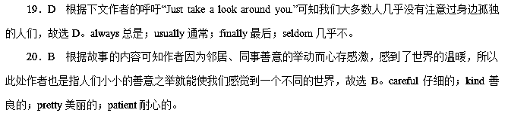10.
Determined to keep my private life private from the census taker (户口调查员) ，I locked the front door.After several more days of __1__ to answer the door，one afternoon I walked __2__to my car.The census taker，who had been __3__ all week to catch me，spotted me and ran up to __4__．I told the man firmly I would not answer his questions.He glared at me and__5__ walked away.
A week went by，all my neighbours had __6__ their census questions，and the census taker __7__．Then one afternoon there came a knock at the door.I answered to find a middleaged lady.Suddenly, I realized my__8__，“I'm Carla with the US Census Bureau，”she said, __9__ herself the way the former one had.Only there was something different：she was __10__．
So I let her in，offered her a bottle of water，and waited for the __11__．But first, she asked about my family.__12__ she told me about her own family and something else.I __13__a lot about Carla，as she was in no hurry to get to the __14__．She was pleasant and relaxed.And so was I．After about an hour，she put away her __15__ and thanked me for the water，__16__ as she climbed into her car.I didn't __17__ her visit at all，I realized.
Carla would call every few months，asking if our __18__ had changed.We always talked about our families and lives __19__ we were friends.
I was __20__ to have met Carla.She taught me that a smile can unlock any door.
1. A．refusing B．planning C．happening D．hesitating
2. A．forward B．out C．away D．on
3. A．standing B．thinking C．trying D．repeating
4. A．drive away B．shout out C．help out D．catch up
5. A．possibly B．naturally C．politely D．eventually
6. A．made B．answered C．collected D．forgot
7. A．surrendered B．stayed C．disappeared D．continued
8. A．mistake B．feeling C．behaviour D．responsibility
9. A．showing B．proving C．directing D．introducing
10. A．talking B．moving C．smiling D．worrying
11．A.instructions B．greetings C．questions D．results
12．A.Then B．So C．Only D．Even
13．A.missed B．learnt C．understood D．remembered
14．A.agreement B．meeting C．discussion D．interview
15．A.clothes B．papers C．bottles D．bags
16．A.crying B．whispering C．shaking D．waving
17．A.regret B．remember C．mind D．appreciate
18．A.information B．address C．arrangement D．phone
19．A.when B．until C．as if D．now that
20．A.eager B．fortunate C．modest D．willing
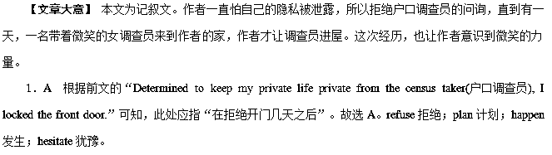2．B 句意：一天下午，我出门去开车。故选B。forward向前；out向外；away离开；on(动作的方向、对象)向。
3．C 句意：那个一周以来一直想试着逮着我的户口调查员发现了我。故选C。stand站着；think想；try尝试；repeat重复。
4．D 句意：(户口调查员)跑过来抓住了我。故选D。drive away赶走；shout out大叫；help out帮忙；catch up追赶。
5．D 句意：他盯着我，最终走开了。故选D。possibly可能地；naturally自然地；politely礼貌地；eventually最终。
6．B 句意：一周过去了，我所有的邻居都回答了他们的户口问题。故选B。make做；answer回答；collect收集；forget忘记。
7．C 句意：一周过去了，我所有的邻居都回答了他们的户口问题，那个户口调查员消失了。故选C。surrender屈服，放弃；stay待在；disappear消失；continue继续。
8．A 根据前文的“户口调查员不见了”可知，当打开门的时候，我突然意识到了自己的错误(判断)。故选A。mistake错误；feeling感觉；behaviour行为；responsibility责任。
9．D 此处指“用前一个调查员的方式介绍自己”。故选D。show展示；prove证明；direct指导；introduce介绍。
10．C 句意：唯一不同的是她一直在微笑着。故选C。talk说；move移动；smile微笑；worry担心。
11．C 句意：所以我让她进来了，给了她一瓶水，等着被提问问题。故选C。instruction说明；greeting问候；question问题；result结果。
12．A 句意：然后，她告诉我关于她自己的家人和其他的事情。故选A。then然后；so所以；only只有；even甚至。
13．B 句意：我了解了一些Carla的事情。故选B。miss错过；learn了解；understand理解；remember记得。
14．D 句意：因为她没有着急进行口头的调查。故选D。agreement协议；meeting会议；discussion讨论；interview口头审查。
15．B 句意：大约一个小时后，她把她的文件收起来了，感谢我给她提供了水。故选B。cloth衣服；paper文件；bottle瓶子；bag袋子。
16．D 句意：当她上自己的汽车的时候，她挥手告别。故选D。cry哭；whisper耳语；shake摇动；wave挥动。
17．C 句意：我意识到，我一点也不介意她的造访。故选C。regret后悔；remember记得；mind介意；appreciate欣赏。
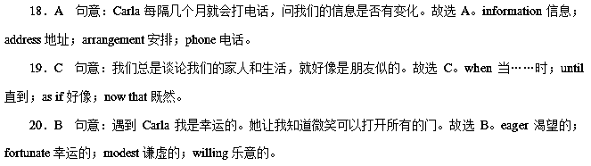11.
After 21 years of marriage, my wife wanted me to take another woman out to dinner and a movie.The other woman my wife wanted me to was my mother. That Friday after work, I drove over to pick her up.
We went to a restaurant that, although not __1__ , was very nice and cosy(舒适的)．My mother took my arm __2__ she were the First Lady.During the dinner, we had an agreeable conversation—nothing __3__ but catching up on recent __4__ of each other's life.We talked so much that we missed the __5__. As we arrived at her house later, she said, “I'll go out with you again, but only if you let me __6__ you.”I agreed.
“How was your __7__？” asked my wife when I got home.“Very nice.Far __8__ my wildest imagination，” I answered.
A few days later, my mother died of a heart attack.It happened so __9__ that I didn't have a chance to do anything for her.Some time __10__，I received an envelope with a copy of a restaurant __11__ from the same place where Mother and I had dined.An __12__ note said: “I paid this bill __13__．I wasn't sure that I __14__ be there; but I still paid for two plates—one for you and the other for your __15__．You will never know what that night __16__ for me.I love you, son.”
At that moment, I __17__ the importance of saying in time“I LOVE YOU” and giving time to our family.__18__ in life is more important than your family.Give them the time they __19__， because these things cannot be __20__ till “some other time”．
1. A．grand B．comfortable C．shabby D．delicate
2. A．even if B．as though C．so that D．in case
3. A．unbelievable B．attractive C．interesting D．extraordinary
4. A．accidents B．events C．coincidences D．conditions
5. A．bus B．appointment C．movie D．time
6. A．accompany B．order C．satisfy D．invite
7. A．date B．party C．film D．talk
8. A．than B．beyond C．beneath D．out of
9. A．immediately B．abruptly C．absolutely D．awfully
10. A．before B．ago C．later D．after
11．A.receipt B．bill C．reception D．notice
12．A.extra B．additional C．attached D．approved
13．A.by chance B．on purpose C．for myself D．in advance
14．A.might B．should C．could D．would
15．A.son B．wife C．friend D．colleague
16．A.meant B．paid C．provided D．made
17．A.advocated B．appreciated C．admired D．applauded
18．A.Something B．Anything C．Everything D．Nothing
19．A.demand B．need C．deserve D．desire
20．A.put off B．called off C．taken off D．turned off
【文章大意】 本文是一篇记叙文。文章通过讲述作者和母亲去吃饭的一次经历，和母亲的突然离世来告诉人们：要多花些时间和亲人在一起，这比什么都重要。不要等到子欲养而亲不待之时，让人抱憾终身。
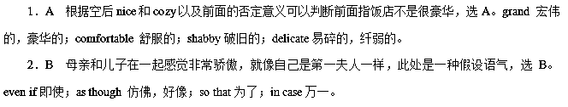3．D 儿子和母亲的聊天没有特别的事，根据but的转折可知选D。unbelievable 让人难以置信的；attractive 迷人的；interesting 有趣的；extraordinary非凡的。
4．B 母子的谈话只是涉及彼此生活中发生的事情，选B。accident事故；event事件；coincidence巧合；condition条件，状况。
5．C 从第一段“After 21 years of marriage, my wife wanted me to take another woman out to dinner and a movie.”可知他们错过了电影，故选C。bus 公共汽车；appointment 约会；movie电影；time时间。
6．A 只要你让我陪着你。故选A。accompany陪伴；order命令；satisfy使满意；invite邀请。
7．A 句意：当我回到家的时候，我的妻子问“你们的约会怎么样？”故选A。date约会；party聚会；film电影；talk谈话。
8．B 句意：非常好，远远超出我的想象。far beyond远远超过。故选B。
9．B 根据空后内容可知事情发生的非常突然，作者都没来得及做些什么，选B。immediately立即，马上；abruptly突然；absolutely绝对地；awfully可怕地，十分。
10．C 从事情的发展可知此处指过了一段时间以后，选C。before 在……之前；ago在某段时间前；later后来；after在……之后。
11．A 根据后句内容可知母亲已经提前支付了费用，由此判断信封里面装的是收据，选A。receipt 收据；bill账单；reception 接待；notice通知。
12．C 在收据上附带着一张便条来说明情况，选C。extra额外的；additional附加的，额外的；attached 附加的；approved被认可的；经过检验的。
13．D 根据后句内容可知母亲没等到和作者一起去吃饭，而是提前支付了费用，选D。by chance 偶然；on purpose故意；for myself 为自己；in advance提前。
14．C 母亲不确定自己是否能够再次和儿子一起吃饭，选C。might可能；should 应该；could 能够，可能；would将。
15．B 从上句内容可知母亲不确定自己是否能够到场，但还是付了两份食物的钱，由此判断她计划给作者和他的妻子预定，选B。son儿子；wife妻子；friend朋友；colleague同事。
16．A 从上文第二段内容可知母亲对上次和儿子在一起吃饭感到特别开心，感觉那顿饭对她意味着很多，选A。mean意味着，意思是；pay 付款；provide 提供；make制作。
17．B 母亲的话和母亲的去世使作者意识到了和家人在一起的重要性，选B。advocate 提倡；appreciate 意识到，领会；admire 羡慕；applaud鼓掌。
18．D 此处表达了作者清楚地认识到：没有什么会比你的家人更重要，选D。something某事；anything 任何事；everything 一切；nothing没什么。
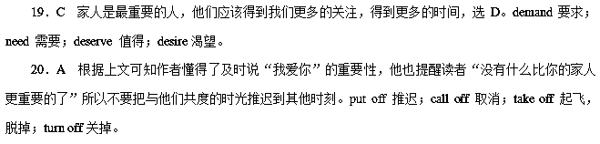12.
The hardest arithmetic to master is that which enables us to count our blessings.
—Eric Hoffer
According to legend, a young man while walking in the desert came across a spring of delicious crystalclear water.The water was so sweet, he __1__ his leather canteen so that he __2__ bring some back to an elder who had been his teacher.After a fourday journey he __3__ the water to the old man who took a __4__ drink, smiled warmly and thanked his student for the sweet water.The young man returned to his village__5__ a happy heart.
Later, the teacher let another student __6__ the water.He spat it out, saying it was __7__．It apparently had become sour __8__ the old leather container.The student __9__ his teacher，“Master, the water was foul.Why did you __10__ to like it？”The teacher replied, “You only tasted the water.I tasted the __11__．The water was simply the container for an act of lovingkindness and __12__ could be sweeter.”
I think we understand this lesson best __13__ we receive innocent gifts of love from young children.__14__ it's a jewel or a stone the natural and proper response is __15__ and expressed thankfulness because we love the idea __16__ the gift.
Gratitude doesn't always come naturally.__17__，most children and many adults value only the thing given _18__ the feeling in it.We should remind ourselves and teach our children about the beauty and __19__ of feelings and expressions of gratitude.__20__，gifts from the heart are really gifts of the heart.
1. A．cleared B．emptied C．filled D．freed
2. A．should B．could C．needed D．dared
3. A．contributed B．delivered C．posted D．presented
4. A．deep B．long C．hard D．broad
5. A．beyond B．with C．without D．under
6. A．breathe B．suck C．taste D．lick
7. A．sweet B．dirty C．salty D．awful
8. A．because of B．despite of C．instead of D．regardless of
9. A．offended B．challenged C．answered D．demanded
10. A．try B．intend C．pretend D．want
11．A.feeling B．gift C．dish D．mood
12．A.something B．nothing C．everything D．anything
13．A.before B．after C．when D．until
14．A.Either B．Neither C．However D．Whether
15．A.appreciation B．excitement C．disappointment D．satisfaction
16．A.for B．within C．about D．over
17．A.Luckily B．Honestly C．Unfortunately D．Actually
18．A.rather than B．other than C．more than D．less than
19．A.height B．depth C．accuracy D．purity
20．A.Above all B．In all C．After all D．At all
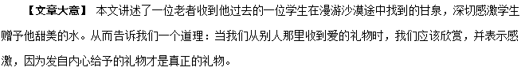1．C 因为水的味道非常甜美，于是他灌满了他的皮水壶。故选C。clear清洁；empty成为空的，把……弄空；fill装满，填满，灌满；free释放，使自由。
2．B 这样的话他就能带回一些给曾经是他老师的一位老者。根据句意可知这里用情态动词could，故选B。
3．D 他把水呈献给老人，故这里用D合适。contribute 捐献，投稿；deliver递送；post张贴，邮寄；present提出，介绍，赠送。
4．A 根据后面“…smiled warmly and thanked his student for the sweet water.”老人开心地笑着并感谢他的学生带来的水，可知这里老人喝了一大口(deep drink)，故选A。deep深的，重大的；long长的；hard坚硬的，困难的；broad宽的。
5．B 根据语境，年轻人得到老人的感激，怀着愉快的心情回到了村庄。with a happy heart怀着幸福的心，故选B。
6．C 根据常识，“水”是用来“品尝”的，句意：老师让他的另一个学生品尝水。故选C。breathe呼吸；suck吮吸，吸入；taste品尝；lick舔，轻轻拍打。
7．D 他把水吐出来，说味道很糟糕。根据语境可知这里选D。sweet甜的；dirty脏的；salty咸的；awful糟糕的。
8．A 句意：很明显，由于破旧的皮革容器，水已经变酸了。根据语意可知选A。because of由于；despite of 尽管；instead of代替；regardless of不管，不顾。
9．B 句意：学生质疑他的老师：“师父，水是臭的，你为什么要假装喜欢它？”故这里选B。offend冒犯；challenge质疑，挑战；answer回答；demand要求。
10．C 根据上下文可知，这里的意思是问老师为什么要假装喜欢。故选C。try尝试；intend打算；pretend假装；want想要。
11．B 联系下文gifts of love from young children，可知正确答案是gift。句意：你只品尝了水的味道，我却是在品尝礼物的味道。故选B。feeling情感；gift礼物；dish菜肴；mood情绪。
12．B 水仅仅是装载善与爱之行为的容器，而没有什么东西比善与爱更甜美了。故选B。
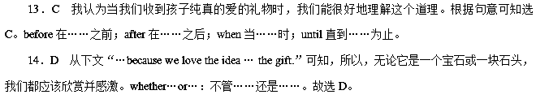15．A 无论它是一个宝石或一块石头，我们都应该欣赏并感激。根据句意可知选A。appreciation感激，欣赏；excitement激动；disappointment失望；satisfaction满意。
16．B 根据上下文可知这里意为，因为我们爱的是礼物的内涵。故这里介词用within，故选B。
17．C 根据语境，此处表达：不幸的是，大多数儿童和成人只看重被赠予的东西本身。故这里选C。luckily幸运的是；honestly诚实地；unfortunately不幸地；actually事实上。
18．A 根据句意，大多数儿童和成人只看重被赠予的东西本身，而不是它体现的情谊。故选A。rather than(要)……而不……，与其……倒不如……；而不是；other than不同于；除了(＝but，except)；more than不只是；很；超过；在……次以上；less than少于。
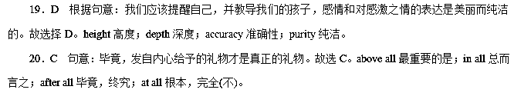13.
As the saying goes, “Rose given, fragrance in hand.” I am always in the __1__ of giving money to every beggar or homeless person I pass by.My friends say it is not good to __2__．We may come across beggars or homeless people begging every day and all beggars have their ability to survive.It __3__ them that I never listen.
On a __4__ day, my friend and I were walking to the __5__ when I passed a beggar lady.I had seen her several times before and had always given her a few __6__．That day, I gave her 2 Euros.I was waiting for the bus and reading a book when I __7__ to see that lady standing in front of me.She __8__ me a piece of paper covered in a plastic bag to prevent it from getting __9__．She stood there, looking at me __10__．Putting away my book, I took the paper, which __11__ she and her family had to __12__ their country because of floods, and she was __13__ to support them.She had got a bit of money, but she needed 5 __14__ Euros to get home.I __15__ in my pockets and found 20 cents.My friend __16__ a 5 Euro note.I asked her to give it to the lady, and said that I would __17__ the next day.When she got the money, the lady hugged us and said thanks again and again, and went on her way.Later on the bus, I wondered where her home was and __18__ she had gotten to this country.In her story, I felt that my friend and I would always remain part of it as the __19__， who helped her get home on a rainy day.But for me, helping a stranger did bring me happiness, giving me a pleasant __20__．
1. A．time B．way C．trend D．habit
2. A．encourage B．expose C．evaluate D．envy
3. A．delights B．annoys C．interests D．attracts
4. A．rainy B．dry C．sunny D．cloudy
5. A．airport B．bus stop C．railway station D．downtown
6. A．books B．suggestions C．cents D．roses
7. A．turned around B．looked down C．looked up D．stood up
8. A．asked B．begged C．bargained D．handed
9. A．wet B．burnt C．lost D．dirty
10. A．cheerfully B．clumsily C．eagerly D．silly
11．A.wrote B．spoke C．said D．told
12．A.miss B．leave C．support D．blame
13．A.struggling B．exploring C．hesitating D．searching
14．A.many B．more C．another D．much
15．A.touched B．looked C．watched D．fished
16．A.gave out B．took out C．handed in D．made out
17．A.pay back B．take back C．come back D．get back
18．A.why B．where C．how D．whether
19．A.lookerson B．strangers C．foreigners D．passersby
20．A.situation B．mood C．spirit D．position
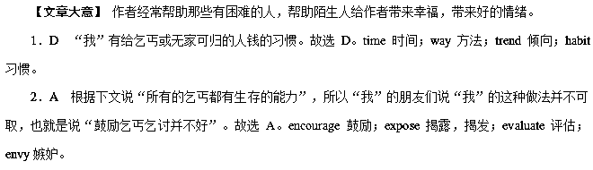3．B “我”从不听朋友的这些劝告，这使他们很烦恼。故选B。delight 使高兴；annoy使烦恼；interest使感兴趣；attract吸引。
4．A 根据文章倒数第二句“…who helped her get home on a rainy day.”可知是“在一个下雨天”，故选A。rainy下雨的；dry 干旱的；sunny 晴朗的；cloudy多云的。
5．B 根据下文的“I was waiting for the bus…”可知选B。airport 飞机场；bus stop公共汽车站；railway station火车站；downtown市中心区。
6．C “我”以前看见过她几次，总是给她几欧分。故选C。book书；suggestion建议；cent分；rose玫瑰。
7．C “我”等公共汽车时在看书，这时候“我”抬头看到那位女士站在“我”面前。故选C。turn around转身；look down 轻视； look up 抬头；stand up起立。
8．D 她递给“我”一张用塑料袋盖着的纸。故选D。ask 问；beg祈求；bargain 交易；hand递送。
9．A 用塑料袋盖着是为了防止它被淋湿。故选A。wet 湿的；burnt 烧焦的；lost 失去的；dirty脏的。
10．C 她站在那里渴望地看着我。故选C。cheerfully高高兴兴地；clumsily 笨拙地；eagerly渴望地；silly愚蠢地。
11．C “我”看到纸上写着因为洪水她和她的家人不得不离开他们的国家。故选C。write 写；speak 讲话；say说；tell告诉。
12．B “我”看到纸上写着因为洪水她和她的家人不得不离开他们的国家。故选B。miss 错过；leave离开；support支持；blame责备。
13．A 她努力地养育他们。故选A。struggle挣扎；explore 探索；hesitate 犹豫；search寻找。
14．B 她已经有了一点钱，但她需要更多的钱回家。故选B。many 很多；more 更多；another 另一个；much很多。
15．D “我”从口袋里摸出了20美分。可知D项最符合语境。touch感动，触摸；look看；watch观看；fish摸找。
16．B “我”朋友取出一张5欧元的纸币。故选B。give out发出，放出；take out 取出；hand in 上交；make out明白，理解。
17．A “我”让她把5欧元给了那位女士，第二天“我”还给她。故选A。pay back偿还；take back取回；come back回来；get back回来，找回。
18．C “我”想知道她的家在哪里，是怎样到达这里的。故选C。why 为什么；where 在哪；how 怎样；whether是否。
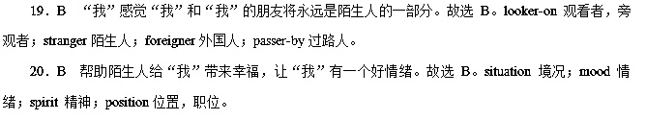14.
If life were a book and you were the author, how would you like the story to go? That is the question that __1__ my life forever.
One day I went home from the training of snowboarding with what I thought was the flu, and less than 24 hours later，I was in a __2__ on life support with less than two per cent__3__ of living.It wasn't until days later that the doctors diagnosed me with a__4__ blood infection.Over the__5__of 2.5 months, I lost the hearing in my left ear and both my legs below the knee.When my parents __6__ me out of the hospital, I__7__ that I had been put together like a patchwork (拼缝物) doll and I had to live with __8__ legs.I was absolutely physically and emotionally broken, __9__ streaming down.
But I knew in order to move forward, I had to let go of the Old Amy and__10__ the New Amy.It was at this moment that I asked myself that significant __11__．And that is when it __12__me that I didn't have to be fivefootfive anymore，__13__ I could be as tall as I wanted.And __14__ of all，I can make my feet the size of all the shoes.So there were__15__here.
Four months later，I was back upon a __16__．And this February, I won two Board World Cup gold medals，__17__ me the highest ranked snowboarder in the world.So, instead of looking at our __18__ and our limitations as something __19__ or bad, we can begin looking at them as a wonderful __20__ that can be used to help us go further than we ever know we could go.
1. A．saved B．risked C．ruined D．changed
2. A．hospital B．club C．field D．stadium
3. A．thought B．degree C．chance D．decision
4. A．mild B．severe C．potential D．slight
5. A．journey B．break C．course D．schedule
6. A．wheeled B．dragged C．pulled D．delivered
7. A．made sure B．felt like C．worked out D．put forward
8. A．muscled B．heavy C．shapely D．false
9. A．blood B．sweat C．tears D．water
10. A．hug B．recognize C．fix D．introduce
11．A.plan B．question C．information D．favour
12．A.struck B．broke C．beat D．broadened
13．A.although B．so C．while D．but
14．A.first B．strangest C．best D．luckiest
15．A.struggles B．benefits C．rewards D．conflicts
16．A.stage B．snowboard C．track D．playground
17．A.allowing B．giving C．calling D．making
18．A.challenges B．achievements C．devotions D．hesitations
19．A.active B．amazing C．negative D．terminal
20．A.ability B．skill C．tool D．gift
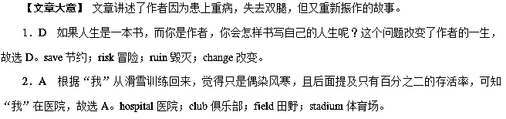3．C “我”只有百分之二的存活率，故选C。thought想法；degree程度；chance概率；decision决定。
4．B 医生诊断“我”患了严重的血液感染，故选B。mild温和的；severe严重的；potential潜在的；slight轻微的。
5．C 经过两个多月的治疗过程，故选C。journey旅途；break休息；course历程；schedule安排表。
6．A 前面说治疗让“我”丧失了左耳听力与小腿，所以父母用轮椅推“我”出院，故选A。wheel用轮子推；drag拖；pull拉；deliver传递。
7．B 被推出医院的时候，“我”感觉自己像一个被重新组装的玩具，故选B。make sure确保；feel like感觉像；work out 算出；put forward 提出。
8．D “我”必须用假肢行走，故选D。muscled 肌肉强健的；heavy沉重的；shapely线条好看的；false假的。
9．C “我”的精神和身体都崩溃了，眼泪不由自主流下，故选C。blood血液；sweat汗水；tear眼泪；water水。
10．A 作者要放下过去，拥抱一个新的自己，故选A。hug拥抱；recognize认出；fix固定；introduce介绍。
11．B “我”问了自己那个重要的问题，故选B。plan计划；question问题；information信息；favour帮助。
12．A “我”突然想到“我”可以不再是固定的五英尺五英寸高了，故选A。strike突然想到；break打破；beat击败；broaden变宽。
13．D 而是可以想变多高就变多高，表示转折，故选D。although尽管；so因此；while然而；but而，相反。
14．C 作者乐观地想这最好的事情是她可以穿任何尺码的鞋子，故选C。first首先；strangest最奇怪的；best 最好的；luckiest最幸运的。
15．B 根据前面可知作者乐观地认为还是有好处的，故选B。struggle斗争；benefit好处，利益；reward奖励；conflict冲突。
16．B 四个月后作者重新踏上了滑雪板，故选B。stage阶段；snowboard滑雪板；track轨道；playground操场。
17．D “我”赢得了两次世界冠军，使得“我”在世界上排名第一，故选D。allow允许；give给；call召唤；make使得。
18．A 不要把生活中的挑战和局限看作不好的或消极的东西，故选A。challenge挑战；achievement成就；devotion奉献；hesitation犹豫。
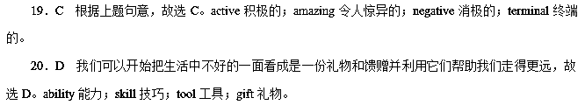15.
I was parked in front of the mall wiping off my car.__1__ my way from across the parking lot was what society would consider a bum (无业游民)．From the __2__ of him, he had no car, no home, no clean clothes, and no money.He sat down in front of the bus stop but didn't look like he could have enough money to even ride the bus.Sometimes you feel generous, but there are times when you just don't want to be __3__．“I hope he doesn't ask me for any money，” I thought.He didn't.“That's a very pretty car，” he said.He was __4__ but he had a(n) __5__ of dignity around him.I said, “Thanks，” and continued __6__ my car.He sat there __7__ as I worked.The expected __8__ for money never came.As the silence between us widened, something inside said, “Ask him if he needs any help.” I was __9__ that he would say “yes”．“Do you need any help？” I asked.He answered in three __10__ but profound (深远的) words that I shall never __11__．“Don't we all？” he said.
I had been feeling high, successful and important __12__ those three words __13__ me like a shotgun.Don't we all? I needed help.Maybe not for bus fare or a place to sleep, but I needed help.I __14__ my wallet and gave him not only enough for bus fare, but enough to get a warm meal and __15__ for the day.Those three little words still sound __16__．No matter how much you have, no matter how much you have __17__，you need help too.No matter how __18__ you have, no matter how loaded you are with problems, even without money or a place to sleep, you can __19__ help.Maybe he was an angel __20__ like a bum and was ordered, “Go to that man cleaning the car; that man needs help.”
Don't we all?
1. A．Taking B．Leaving C．Coming D．Having
2. A．expressions B．manners C．appearance D．attitudes
3. A．respected B．bothered C．admired D．influenced
4. A．generous B．disappointed C．modern D．ragged
5. A．air B．atmosphere C．look D．figure
6. A．cleaning B．fixing C．repairing D．painting
7. A．quietly B．casually C．aimlessly D．eagerly
8. A．request B．application C．order D．command
9. A．afraid B．glad C．doubtful D．sure
10. A．simple B．complex C．strange D．rigid
11．A.accept B．forget C．respond D．choose
12．A.unless B．after C．until D．when
13．A.frightened B．moved C．harmed D．hit
14．A.reached in B．searched for C．looked up D．exposed to
15．A.shelter B．clothes C．reward D．blanket
16．A.nice B．ridiculous C．true D．proper
17．A.submitted B．accomplished C．applied D．devoted
18．A.few B．many C．little D．enough
19．A.receive B．give C．need D．seek
20．A.acted B．wore C．devoted D．dressed
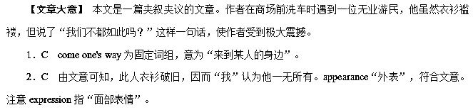3．B 由文意可知，你只是不想被打扰，故选bothered。
4．D 由文意可知，既然对方为无业游民，他应该是衣衫褴褛。
5．A 从下文dignity可知，对方虽然贫穷，但有尊严。注意此处air表示“神态、感觉”。其他选项不符合文意。
6．A 文章开头提到“我”在洗车，而下文提到“…as I worked.”，说明仍在洗车，故选A项。
7．A 由下文silence可知，他在旁边静静地看着“我”干活，故选A。
8．A 由上下文可推知，他一无所有，所以“我”觉得他会开口向“我”要钱。
9．D 由上句“…something inside said, ‘Ask him if he needs any help.’”可知，“我”相信像他这样的人，一定需要帮助，故选D项sure。
10．A 由but profound和下文他说的话可知，他说的话是简单的三个词。
11．B 通过上文和下文的still可知，他的话直到现在“我”还记得，故选B。
12．C 由“I had been feeling high, successful and important…”可知，“我”在此之前一直认为自己地位高、很成功，是个重要人物，所以C项最佳，其他选项不符合文意。
13．D 通过下文like a shotgun，可知他的话带给“我”极大的影响。
14．A reach in my wallet意为“伸手到钱包里拿(钱)”；search for搜寻……；look up在……里查找；expose……to把……暴露于……。根据文意可知A项正确。
15．A shelter在此意为“居所、住处”。从下文的for the day和sleep可以推知，“我”给他的钱足够他买车票、吃饭和寻找住处。
16．C 根据上下文理解可知，他的话是对的，“我”至今没忘。sound true意为“听起来是对的、真实的”，故选C。
17．B 根据上下文理解可知，无论你拥有多少，无论你取得了多大成功，都需要别人的帮助，故选B项 accomplished。
