2017年高考试题及模拟题分项解析之 专题6七选五
1.【2017·新课标I】第二节 (共5小题；每小题2分，满分10分)
根据短文内容，从短文后的选项中选出能填入空白处的最佳选项。选项中有两项为多余选项。
If anyone had told me three years ago that I would be spending most of my weekends camping. I would have laughed heartily. Campers, in my eyes, were people who enjoyed insects bites, ill-cooked meals, and uncomfortable sleeping bags. They had nothing in common with me. 36
The friends who introduced me to camping thought that it meant to be a pioneer.
37 We sleep in a tent, cooked over an open fire, and walked a long distance to take the shower and use the bathroom. This brief visit with Mother Nature cost me two days off from work, recovering from a bad case of sunburn and the doctor`s bill for my son`s food poisoning.
I was, nevertheless, talked into going on another fun-filled holiday in the wilderness.
38 Instead, we had a pop-up camper with comfortable beds and an air conditioner. My nature-loving friends had remembered to bring all the necessities of life.
39 We have done a lot of it since. Recently, we bought a twenty-eight-foot travel trailer complete with a bathroom and a built-in TV set. There is a separate bedroom, a modern kitchen with a refrigerator. The trailer even has matching carpet and curtains.
40 It must be true that sooner or later, everyone finds his or her way back to nature. I recommend that you find your way in style.
A．This time there was no tent.
B．Things are going to be improved.
C．The trip they took me on was a rough one.
D． I was to learn a lot about camping since then, however.
E．I must say that I have certainly come to enjoy camping.
F. After the trip, my family became quite interested in camping.
G. There was no shade as the trees were no more than 3 feet tall.
【答案】
【文章大意】三年前，作者对露营一无所知，也不认为自己会喜欢露营。然而后来有过几次露营的经历，作者和他的家人开始爱上了露营，甚至为露营购买了设备齐全的房车。作者认为露营是回归大自然的一个方式，也建议读者找到适合自己的回归自然的方式。
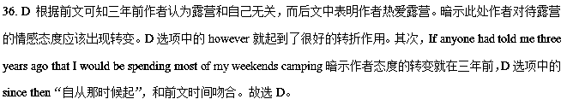37.C 根据后文We sleep in a tent, cooked over an open fire, and walked a long distance to take the shower and use the bathroom可知作者第一次露营条件很艰苦，C选项The trip they took me on was a rough one.中的rough暗示了这一点，符合语境。故选C。
38.A根据前文We sleep in a tent, cooked over an open fire, and walked a long distance to take the shower and use the bathroom可知作者第一次露营时住帐篷，露天生火做饭，走很远的距离去洗澡上厕所，条件很艰苦。而后文中Instead, we had a pop-up camper with comfortable beds and an air conditioner. 说明作者第二次露营有床有空调 A选项This time there was no tent“这次没有帐篷了”暗示作者进行了第二次露营，而且条件比较好，符合语境。故选A。
39.F 根据后文we bought a twenty-eight-foot travel trailer complete with a bathroom and a built-in TV set. There is a separate bedroom, a modern kitchen with a refrigerator. The trailer even has matching carpet and curtains.可知作者一家为了露营买了房车，里面设备齐全。既然花了这么大精力，说明作者一家人是喜欢露营的。F选项After the trip, my family became quite interested in camping“那次露营之后，我的家人开始对它感兴趣”符合语境，故选F。
40.E 根据后文It must be true that sooner or later, everyone finds his or her way back to nature. I recommend that you find your way in style.可知作者希望每个人能找到适合自己的回归自然的方法，而根据前文可知作者回归自然的方式就是露营。E选项I must say that I have certainly come to enjoy camping.“我必须得承认我真的开始享受露营”既是对文章第一段中作者态度转变的一个总结，也很好的衔接了后文。故选E。
【名师点睛】
七选五的考查形式是给考生呈现一篇缺了五句话的英语文章，并要求考生根据文章的结构、逻辑、上下文的内容选出相应的五句话填入空白处将文章补充完整。具体的解题步骤有以下几点：
步骤一：快速浏览一遍七个备选答案，先确定哪个选项适合放在文章的什么位置。通常有三个四个位置：标题，句首，句中，句尾。不同位置的句子有不同的特征。有时有的答案表述上就是错误的，可以直接从备选项中清除，以降低难度。
步骤二：快速浏览文章，确定文章体裁，抓住文章结构。一般说来，记叙文的语言是按时间发展顺序或因果关系排列的，常用的连接词有：then, later, after that, soon, after a while, in the end, so, as a result, because of that等。说明文常采用总-分-总的结构形式，第一段说明要说明的主题，下面几段多是从不同的角度来说明问题，最后总结，所以各段之间多是平行关系，经常出现举例说明的现象。议论文先抛出议题，然后从正反两个方面进行讨论，最后得出结论。新闻体裁的应用文首句为主题句，下面展开细节性的报道。
步骤三：分析篇章结构，找出各段的主题句或主旨大意。分析文章的层次包含两种形式：一种是分析整篇文章的层次，也就是段落，说明文和议论文这样体裁的文章，每段的第一句多是主题句。找到主题句有助于帮助确定选择的范围，即所选句子必须和该段主题一致。另一种是分析每一个段落内部的层次，也就是语篇层次。要真正体会句际间的意义关系，把握作者的思路，从语序上去发现断续点，理清层次。
步骤四：注意各选项中出现的句子衔接手段，寻找句中衔接标志词。文章的衔接手段有：重复式用某一词语或子范畴的词语，使用同义语表达，用总称指代具体事物或用具体事物指代整体，使用代词避免重复等。上述方法有助于段落的思路平稳在句子之间过渡。连贯使文章的每个段落、每个句子甚至每个短语融为一体。段落一致与句子衔接是文章连贯的两个必要因素。
步骤五：区分相似项七选五备选答案中有两个多余的选项，会对文章中两个空的选择构成干扰，这时要特别细致地比对相似选项，方法和答阅读理解时区分相似项一样。
步骤六：用代入法，检查答案是否合理。将所有选择答案放回空白处，通读全文，检查文章内容是否语义连贯合理、紧扣主题，语篇结构是否通顺连贯、具有一致性、合乎逻辑，写作思路是否清晰明了，格式以及用语是否恰当贴切，从而判断选择的答案是否正确。
2.【2017·全国新课标II】 第二节 （共5小题；每小题2分，满分10分）
根据短文内容，从短文后的选项中选出能填入空白处的最佳选项。选项中有两项为多余选项。
Interruptions are one of the worst things to deal with while you’re trying to get work done. 36 ,there are several ways to handle things. Let’s take a look at them now.
37 .Tell the person you’re sorry and explain that you have a million things to do and then ask if the of you can talk at a different time.
When people try to interrupt you, have set hours planned and let them know to come back during that time or that you’ll find them then. 38 .It can help to eliminate(消除) future interruptions.
When you need to someone, don’t do it in your own office. 39 .it’s much easier to excuse yourself to get back to your work than if you try to get someone out of your space even after explaining how busy you are
If you have a door to your office, make good use of it. 40 .If someone knocks and it’s not an important matter. Excuse yourself and let the person know you’re busy so they can get the hint(暗示) than when the door is closed, you’re not to be disturbed.
A. If you’re busy, don’t feel bad about saying no
B. When you want to avoid interruptions at work zxx.k
C. Set boundaries for yourself as your time goes
D. If you’re in the other person’s office or in a public area
E. It’s important that you let them know when you’ll be available
F. It might seem unkind to cut people shirt when they interrupt you
G. Leave it open when you’re available to talk and close it when you’re not
36-40 BAEDG
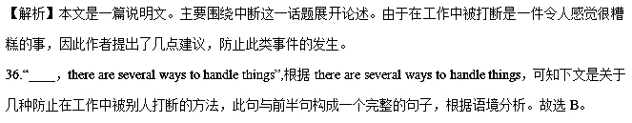37.根据后文“Tell the person you’re sorry and explain that you have a million things to do and then ask if the of you can talk at a different time”，这一段主要是讲述，学会在自己很忙的时候去拒绝别人。故选A。
38.根据横线前“have set hours planned and let them know to come back during that time or that you’ll find them then”安排好时间，让他们知道你在什么时候回来，或者告诉他们，你会去找他们，再结合后文“It can help to eliminate(消除) future interruptions”这样做可以帮助你消除未来被打断的可能，根据句意的衔接，
故选E。
39.根据后文“it’s much easier to excuse yourself to get back to your work than if you try to get someone out of your space even after explaining how busy you are”，此句中it指代前文“don’t do it in your own office.”，也就是说此段中作者认为比起在自己的办公室解释，不在自己的办公室更容易点。故选D
40.根据“If you have a door to your office,make good use of it.”可知，此段主要是讲述关于如何利用自己办公室的门来防止被打扰。故选G。
【名师点睛】
本文37题属于七选五阅读中最常见的设空在段首的方法，通常是段落主题句。认真阅读后文内容，根据段落一致性原则，查找同义词或其他相关的词，推断出主题句。本题我们根据后文“Tell the person you’re sorry and explain that you have a million things to do and then ask if the of you can talk at a different time”可知我们应该学会在自己很忙的时候去拒绝别人。故选A。当七选五阅读设空在句首时，还可能存在以下两种情况：
1. 属于段落间的过渡句。这时要前瞻后望找启示，即阅读上一段结尾部分，通常正确答案与上一段结尾有机地衔接起来，并结合下一段内容，看所选的答案是否将两段内容连贯起来。
2. 与后文是并列、转折、因果关系等。着重阅读后文第一两句，锁定线索信号词，然后在选项中查找相关特征词。通常正确答案的最后一句与空白后的第一句在意思上是紧密衔接的，因此这两句间会有 某种的衔接手段，尤其当选项是几句话时。比如，如果选项中出现时间年代时，往往要注意与原文中年代的前后对应关系。
考点：考查说明文阅读
3.【2017·新课标III】第二节 (共5小题；每小题2分，满分10分)
根据短文内容，从短文后的选项中选出能填入空白处的最佳选项。选项中有两项为多余选项。
Lots of people find it hard to get up in the morning and put the blame on the alarm clock. In fact, the key to easy morning wake-up lies in resting your body clock 36 Here is how to make one.
● 37 In order to make a change, you need to decide why it's important. Do you want to get up in time to have breakfast with your family, get in some exercise, or just be better prepared for your day? Once you are clear about your reason, tell your family or roommates about the change you want to make.
- Rethink mornings. Now that you know why you want to wake up, consider re-arranging your morning activities. If you want time to have breakfast with your family, save some time the night before by setting out clothes, shoes, and bags. 38 That’s a quarter-hour more you could be sleeping if you bought a coffee maker with a timer.
- Keep your sleep/wake schedule on weekends. If you’re tired out by Friday night, sleeping in on Saturday could sound wonderful. But compensating on the weekends actually feeds into your sleepiness the following week, a recent study found. 39
- Keep a record and evaluate it weekly. Keep track of your efforts and write down how you feel. After you’ve tried a new method for a week, take a look at your record. 40 If not, take another look at other methods you could try.
A. Get a sleep specialist.
B. Find the right motivation.
C. A better plan for sleep can help.
D. And consider setting a second alarm.
E. If the steps you take are working, keep it up.
F. Stick to your set bedtime and wake-up time, no matter the day.
G. Reconsider the 15 minutes you spend in line at the café to get coffee.
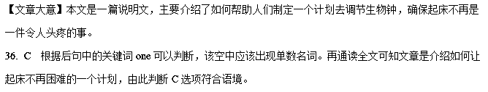37. B 本段内容是建议人们要先确定为什么要早起，早起的目的是什么，也就是早起的动机是什么。由此推断B可以概括本段中心。
38. G 根据下句内容可知，作者建议人们买一个可以定时的咖啡机，这样可以节约15分钟的喝咖啡时间，能够多睡15分钟，文中的a quarter-hour 和选项中的15 minutes呼应，是信息提示词。故选G。
39.F 根据段落小标题可知，本段是建议人们在周末也要坚持自己的作息时间，由此推断Stick to your set bedtime and wake-up time, no matter the day.和本段标题意思相同。故选F。
40.E 后句建议人们如果这样做没作用就尝试新办法，由此推断该空与If not对应，提出如果有效果的话如何去做。故选E。
4.【2017·北京卷】第二节 （共 5 小题；每小题 2 分，共 10 分）
根据短文内容，从短文后的七个选项中选出能填入空白处的最佳选项。选项中有两项为多余选项。
Every animal sleeps, but the reason for this has remained foggy. When lab rats are not allowed to sleep, they die within a month. 71
One idea is that sleep helps us strengthen new memories. 72 We know that, while awake, fresh memories are recorded by reinforcing (加强) connections between brain cells, but the memory processes that take place while we sleep have been unclear.
Support is growing for a theory that sleep evolved so that connections between neurons(神经元) in the brain can be weakened overnight, making room for fresh memories to form the next day. 73
Now we have the most direct evidence yet that he is right. 74 The synapses in the mice taken at the end of a period of sleep were 18 per cent smaller than those taken before sleep, showing that the connections between neurons weaken while sleeping.
If Tononi’s theory is right, it would explain why, when we miss a night`s, we find it harder the next day to concentrate and learn new information — our brains may have smaller room for new experiences.
Their research also suggests how we may build lasting memories over time even though the synapses become thinner. The team discovered that some synapses seem to be protected and stayed the same size. 75 “You keep what matters,” Tononi says.
A. We should also try to sleep well the night before.
B. It’s as if the brain is preserving its most important memories.
C. Similarly, when people go for a few days without sleeping, they get sick.
D. The processes take place to stop our brains becoming loaded with memories.
E. That’s why students do better in tests if they get a chance to sleep after learning.
F. “Sleep is the price we pay for learning,” says Giulio Tononi, who developed the idea.
G. Tononi’s team measured the size of these connections, or synapses, in the brains of 12 mice.
【答案】71C 72E 73F 74G 75B
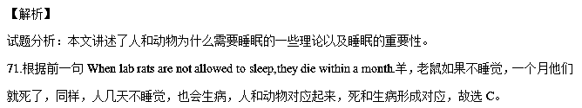72.根据前一句提到的睡觉有助于帮助我们加强新的记忆，所以学生在学习新知识后如果有机会睡一觉，他们在考试中就会表现得更好，前后逻辑关系很顺畅，因果联系，故选E。
73.根据下文中的he，可知此处要提到一个人，以及他的理论，正好F项中有，故选F。
74.根据下文中提到的关键词synapses in the mice以及整个句子可知，他肯定做了关于老鼠的实验，G项有关键词synapses，mice，都与他的实验有关，故答案为G。
75.根据后一句提到的You keep what matters,你记住重要的东西，可知大脑会把最重要的记忆保存下来，前后逻辑关系顺畅，故选B。
【名师点睛】
1、先看选项。跟完形填空不一样，七选五的答案选项较少，并且给出的都是句子，因此，我们可以通过句子的完整性或者句子后面的标点符号来判断该句在文章中的位置。另外，通过阅读选项，有可能找出跟其他选项表达完全不同意思的句子，这样的话我们就可以直接将该选项排除。
2、再看空前空后。由于七选五空出的是整个句子，而这些句子与句子之间，必然有一种联系，因此我们可以通过选项中某个名词或动词跟空前或空后的一致性或者相关性来确定这两个句子之间有一种关联性，从而选择正确的答案。
3、注意代词或定冠词。在做这类题目的时候，一定要注意句子中出现的人称代词或者指示代词，因为我们知道，代词是指代一个名词或者一个句子的，然后通过代词在句子中所做的成分我们可以推断出它指代的句子的类型，我们要做的就是从选项中找这类句型就可以了。比如第73题，代词的作用就体现的非常明显，如果看不到下文中的he，很难做出判断，但是只要看到了就会马上去设想前面必然会提到某个男性的人物，然后根据语境很快就可以锁定选项F，答案自然很快就可以确定。
4、注意一些特殊疑问词。如果选项中或空前出现特殊疑问词，一定要把这句话仔细读几遍，因为对于不同特殊疑问词的回答方式是不一样的，比如对why的回答，后面要有because等表原因的词，对when的回答，后面要有表时间的状语，对where的回答，后面要有表地点的名词，对how的回答，后面要有方式状语等。
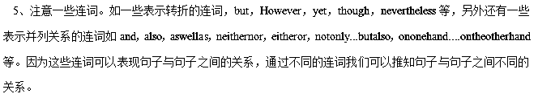5.【2017·浙江卷】根据短文内容，从短文后的选项中选出能填入空白处的最佳选项。选项中有两项为多余选项。
How to Do Man-on-the-Street Interviews
The man-on-the-street interview is an interview in which a reporter hits the streets with a cameraman to interview people on the sport. _____31_____ But with these tips, your first man-on-the-street interview experience can be easy.
- When your boss or professor sends you out to do man-on-the-street interviews for a story, think about the topic and develop a list of about ten general questions relating to it. For example, if your topic is about environmental problems in America, you might ask, “Why do you think environmental protection is important in America?” _____32_____
- Hit the streets with confidence. _____33_____ Say, “Excuse me, I work for XYZ News, and I was wondering if you could share your opinion about this topic.” This is a quick way to get people to warm up to you.
Move on to the next person if someone tells you she is not intereste
Don’t get discouraged.
● 34 Each interview that you get on the street shouldn’t be longer than ten minutes. As soon as you get the answer you need, move on to the next person. Make sure that as you go from interview to interview, you are getting a variety of answers. If everyone is giving you the same answer, you won’t be able to use it. A safe number of interviews to conduct is about six to ten. 35
● If your news station or school requires interviewees to sign release forms to appear on the air, don’t leave work without them.
A. Limit your time.
B. As you approach people, be polite.
C. If you don’t own a camera, you can buy one.
D. For new reporters, this can seem like a challenging task.
E. To get good and useful results, ask them the same question.
F. That number of interviews should give you all the answers you need.
G. With a question like this, you will get more than a “Yes” or “No” reply.
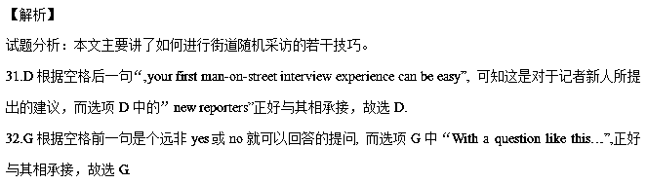33.B根据空格后一句所说的很有礼貌的提问，可知这里的建议应该是提问时要注意礼貌，而选项B中的polite正好与其相呼应，故选B.
34.A根据空格后一句“Each interview that you get on the street shouldn’t be longer than ten minutes.”可知这一段的建议是要限制采访的时间，故选A.
35.F根据空格前一句“A safe number of interviews to conduct is about six to ten”, 而选项F中“That number of interviews…”正好与其相呼应，故选F.
【名师点睛】
本文属于七选五阅读中最常见的设空在段首的方法，通常是段落主题句。认真阅读后文内容，根据段落一致性原则，查找同义词或其他相关的词，推断出主题句。本题我们根据空格后一句“Each interview that you get on the street shouldn’t be longer than ten minutes.”可知这段要求我们采访时要限制时间。故A项为本段主题句。
当七选五阅读设空在句首时，还可能存在以下两种情况：
1. 属于段落间的过渡句。这时要前瞻后望找启示，即阅读上一段结尾部分，通常正确答案与上一段结尾有机地衔接起来，并结合下一段内容，看所选的答案是否将两段内容连贯起来。
2. 与后文是并列、转折、因果关系等。着重阅读后文第一两句，锁定线索信号词，然后在选项中查找相关特征词。通常正确答案的最后一句与空白后的第一句在意思上是紧密衔接的，因此这两句间会有 某种的衔接手段，尤其当选项是几句话时。比如，如果选项中出现时间年代时，往往要注意与原文中年代的前后对应关系。
考点：考查说明文阅读
6.
The UK has a wellrespected higher education system and some of the top universities and research institutions in the world. But to those who are new to it all, sometimes it can be confusing.
October is usually the busiest month in the college calendar. Universities have something called Freshers' Week for their newcomers.__1__
However，having just left the comfort of home and all your friends behind，the prospect of meeting lots of strangers in big halls can be nervewracking (令人头痛的)．Where do you start? Who should you make friends with? Which clubs should you join?
__2__ So just take it all in slowly. Don't rush into anything that you'll regret for the next three years.
__3__
●Learn rules.__4__ Have a few wine glasses and snacks handy for your housemates and friends.
●Be kind. Sometimes cups of tea or even slices of toast can give you a head start in making friends.
●__5__The more active you are，the more likely you'll be to meet new people than those who never leave their room.
●Bring a doorstop. Keep your door open when you're in and that sends positive messages to your neighbours that you're friendly.
So with a bit of clever planning and effort, Freshers' Week can give you a great start to your university life and soon you'll be passing on your experience to next year's new recruits.
A．Make sure you know British social etiquette (礼节)．
B．Luckily, there will be thousands of others in the same boat as you worrying about starting their university social life on the right foot.
C．It's a great opportunity to make new friends, join lots of clubs and settle into university life.
D．Be honest.
E．Here is some top advice from past students on how to survive Freshers' Week.
F．Be sociable.
G．Keep yourself friendly to others sometimes.
【文章大意】 本文主要是针对刚步入大学的新生写的指导，告诉新生在刚进入大学的时候该怎么做，怎样才能轻松地展开新的生活。
1．C 空前的意思是：大学有为它们的新生设立的新生周。所以这里选C (这是交新朋友、加入许多俱乐部、展开新的大学生活的好机会)。
2．B 空后的意思是：所以一切都要慢慢来。所以这里选B (幸运的是，这儿会有数千人和你的处境相同，也在担心着大学生活的开始), 与上下文一致。
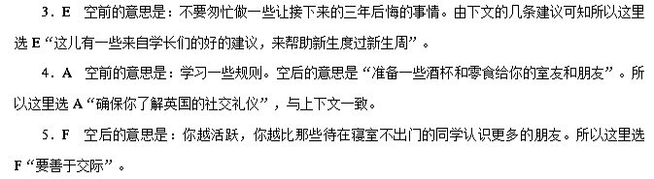
7.
The rules about how to talk, eat and sit, which are highly limited, are observed in most Western restaurants and homes.__1__Many Westerners have no idea how to act at the Chinese dinner table. No forks or knives for them to use! The Chinese host makes great, sweeping arm movements that go over large sections of the table, passing over both food and friends alike.__2__However, it leaves many foreigners at a loss for what to do.
In my childhood home, dinner was enjoyed with low voices, and the topics that we could discuss were very limited.__3__If I had to leave the table to use the toilet, I had to excuse myself without mentioning what it was that I was going to do.“May I be excused, please? I need to wash my hands.” I would say. My mother would say, “Sure.” My father would often play a joke on me by saying, “__4__”
As for eating, we did it quietly. No eating noises were allowed. Everything must be done as quietly as possible. If any sound was created by eating food or drinking, it would be considered as bad manners!
__5__He is to sit up straight with the recessive hand (usually the left) in one's lap holding a napkin while the dominant hand (usually the right) holds the fork or spoon. The only time one is allowed to have both hands on the table is when he is using a knife to cut something.
A．How one sits at the table is also prescribed(规定)．
B．We were not allowed to talk about anything that made listeners uncomfortable.
C．Can't you think up a better excuse than that?
D．They're completely different from what we find here in China.
E．Your hands don't look dirty!
F．The scene is fantastic.
G．In general they were all strictly forbidden topics.
【文章大意】 本文属于说明文，介绍了东西方在餐桌礼仪上的区别及差异。
1．D 根据横线后句“Many Westerners have no idea how to act at the Chinese dinner table.”可知西方人对于中国的餐桌礼仪一点也不清楚，这说明中西方餐桌礼仪差别很大。故D项“They're completely different from what we find here in China.”正确。
2．F 横线前句“The Chinese host makes great, sweeping arm movements that go over large sections of the table, passing over both food and friends alike.”描述中国人吃饭的情景。在西方人看来，这样的场景是怪异的。故F项“The scene is fantastic.”符合上下文语境。
3．B 横线前句“In my childhood home, dinner was enjoyed with low voices, and the topics that we could discuss were very limited.”中作者介绍了自己小时候吃饭的时候，很少说话，讨论的话题也受限制。故B项“We were not allowed to talk about anything that made listeners uncomfortable.”符合上下文语境。
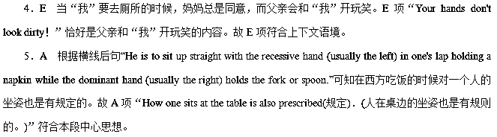8.
Imagine that you're an actor or actress performing in a play for the first time. You've learned all your lines and you know where to walk on stage. Waiting behind the closed curtain, you can hear the audience whispering. Then your big moment arrives! The curtain goes up, and the crowd falls silent. All you can see is the spotlight shining down on you.__ 1__The inside of your mouth is dry, and your hands are wet.
If you've experienced a moment like this, you know all too well what it means to have stage fright. It's one of the most common types of fear.__2__You can experience this kind of fear when playing sports, giving a talk, or even speaking in class.
__3__The experience differs from person to person, but the same chemical process occurs on each of us. In reaction to anxiety, our bodies produce a chemical that prepares us to either fight or run away quickly. Scientists refer to this as our bodies' “fight or flight” reaction. As a result, we feel the great energy that makes our hands sweat, our hearts race and knees shake.
__4__Practising your performance and following some simple tips can help you calm down and manage the feelings caused by anxiety. Firstly, dress comfortably and appropriately. Secondly, before the performance, take deep breaths and stretch to help relax your body. Thirdly, stay away from drinks that contain caffeine (咖啡因)．__5__Instead, try a banana! Some doctors believe that eating a banana can help calm your heart and the rest of your body. Finally, when you look into a crowd, try to focus on particular people rather than the whole group. These tips have helped many people learn to deal with their fears.
A．These might make your heart race even faster.
B．Maybe you don't have to be onstage to get stage fright.
C．Stage fright is really part of the body's reaction to stress.
D．With practice, we can learn how to relax while playing sports.
E．Then you try to speak your lines, but nothing seems to come out.
F．There's a time when stage fright prevents you from stepping onstage.
G．However, the good news about stage fright is that there are lots of ways to deal with it.
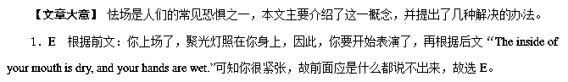2．B 根据后文“You can experience this kind of fear when playing sports, giving a talk, or even speaking in class.”可知不一定是在舞台上才会体会到怯场，在打比赛时、演讲时甚至是在班级讲话时，都会感受到这一恐惧，故选B。

3．C 本空是属于主题句。本段频繁出现关键词reaction，怯场只是身体对压力做出的反应，故选C。
4．G 本空属于主题句。根据后一句“Practising your performance and following some simple tips can help you calm down and manage the feelings caused by anxiety.”可知作者提出了办法来让你镇静下来，解决你的怯场问题，故选G。
5．A 根据前一句“Thirdly, stay away from drinks that contain caffeine (咖啡因)．”可知咖啡因会让你更加兴奋、心跳更快，并不会让你镇静下来，故答案为A。
9.
When we were children, we were taught the simplest lessons to be able to build good relationships with others.__1__However, the question is: What makes a good relationship?
Be willing to share
Once you are in a good relationship, you are not just thinking about yourself. You learn to share what you have. __2__ You should also share your thoughts, your ideas, your dreams and even your frustrations.
Learn to care
People in a good relationship are kind to each other. They make efforts to show how they value each others' space. They both take the time to know what matters to the other and also give time to try out each others' interests. __3__
Learn to play fair
__4__ Each one is allowed to move freely as an individual. However, each action is done with consideration of the other one's feelings. No one is above the other.
__5__
A healthy union is bound by cooperation. The people involved work as a team to achieve one goal. Each one helps and supports the other to succeed in their individual endeavours. They appreciate each other and they grow together and as individuals as well.
A．Learn to cooperate
B．Learn to work hard towards your goal
C．A good relationship is a twoway traffic.
D．This does not just include material things.
E．Everyone knows that the relationship they have won't stay strong.
F．Having good relationships will make you never have to live your life alone.
G．Most of all, they care enough to listen to each other and do nice things for each other.
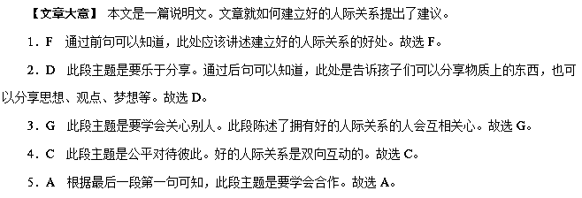10.
Whether you're a child, teenager, young adult or are middleaged, respect for your parents is an important value. Your parents are the people who raised you, devoting time, energy and money to your development. __1__No matter what your age is, there are 4 ways to show respect.
●Respect their belongings.
One important way to show respect is to show regard for the things important to your parents. For younger children, this may mean not touching jewellery or other valuable things. For grown children, respect may mean returning a borrowed tool in good condition and on time. Lack of respect for a parent's belongings is a violation of personal boundaries. __2__And never borrow things without asking first.
●Punctuality.
__3__Therefore, always be on time. For teenagers, showing up on time means coming home by curfew (宵禁时间)．Adult children should show up on time for family dinners or events, or to pick a parent up for a medical appointment. Call if you're going to be late because parents worry about children, no matter their age.
●__4__
Remembering birthdays, anniversaries and other special days is a sign that you honour your parents. Make plans to take them to lunch or dinner or bake a cake or cookies. Most parents don't expect expensive gifts, but a handmade gift is always appreciated. A phone call from a grown child who lives too far for a visit is a welcome sign of respect.
●Be kind.
Kind words and affection are simple ways to show respect. Tell your parents you love them. Listen and allow your parents to speak without interruption. Show a sincere interest in what your parents have to say. Be patient with your parents and don't rush them. Never talk back or be rude or disrespectful. Acknowledge your parents' achievements.__5__
A．Be a good listener.
B．Celebrate with them.
C．Lateness indicates a lack of respect.
D．Treat your parents the way you would like to be treated.
E．And they love you unconditionally throughout your life.
F．Being respectful helps build positive relationships with others.
G．Don't take advantage of your parents' kindness and generosity.
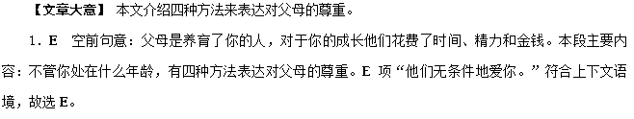2．G 空前句意：对父母的东西缺乏尊重是侵犯了个人界限的。空后句意：绝对不要不打招呼拿父母的东西。G项“不要利用父母的仁慈和慷慨。”符合上下文，故选G。
3．C 本段的主题是：准时。C项“迟到意味着不尊重。”符合语境，故选C。
4．B 此空是此段的主题句，根据本段主要内容：记得生日、周年日以及其他特殊的日子是尊重父母的标识。安排时间带他们一起吃饭或者做蛋糕或饼干给他们吃……。故本段主题句用B“和他们一起庆祝。”合适。
5．D 本段的主题是对父母友好。空前句意：决不要顶嘴，对父母粗鲁或不尊重。认可父母的成就。故这里用D项“以你希望别人对待你的方式来对待父母。”合适。
11. 根据短文内容，从短文后选项中选出能填入空白处的最佳选项。选项中有两项为多余选项。
Little Habits Make a Big Difference
Everything around us is changing at amazing speed, it seems---but some things will always remain the same. ___16___ Some of our daily habits have the power to always give us happiness and lead toward success. Here are some little habits that can make a big difference:
1. ___17___ Many studies have linked early rising with success. An early morning wake-up carries benefits including better planning and anticipation(预料)of problems, and more time to the things that make you happy.
2. Happiness comes to those who are curious. ___18___ As long as you live, there will always be something to learn, and as long as you follow your heart and your passions, you won’t miss out on learning.
3. Believe in yourself and all that you are. ____19____ Confidence is the key to success—the thing that lets you look at the past without regret, stay grounded in the present, and prepare for the future without fear.
4. A day well spent gets you a good night sleep. Enough sleep makes you feel healthier and happier, and it’s more than lifting up your or removing exhaustion(疲惫). Adequate sleep is a key part of your health and inner happiness. ___20___
It doesn’t take a huge effort to make a significant change in your life---using one or two tiny habits may be all you need. Get started today and you’ll soon be experiencing the rewards.
A. That’s why habits are so powerful.
B. The ground work of all happiness is good health.
C. Early to rise makes you healthy, wealthy, and wise.
D. The habit of respect means treating everyone with kindness.
E. Nothing will ever make you happier than having faith in yourself.
F. When you rest better, you can live better and achieve more happiness
G. There is no stage in life when we can’t be learning something valuable.
【答案】16. A
17. C 18. G
19. E 20. F
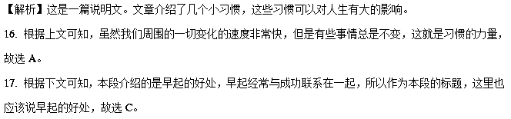18. 根据上下文可知，这一段讲述的是人只要活着，总有要学习的东西。时常保持着好奇心，好学习的人总会感到幸福。因此G选项人生中的任何一个阶段都能够学到珍贵的东西符合题意，故选G。
19. 根据上下文可知，这一段讲述的是要相信自己，自信是成功的关键，E选项中的have faith in yourself正是此意，故选E。

20. 根据上文可知，本段讲述了休息的重要性，休息的越好，才会感到更加幸福，故选F。
12. 根据短文内容，从短文后选项中选出能填入空白处的最佳选项。选项中有两项为多余选项。
Most cars have seat belts as part of their equipment. Seat belts protect drivers and passengers in case of accidents. They also reduce the effect of a crash on the body.
____16____Worldwide, the devices have protected up to a million people.
America first recognized the invention of an automobile seat belt in 1849. The government gave a patent to an engineer named Edward Claghorn of New York City so that others would not copy his invention of a safety device. ___17___This early version of safety belt was said to include hooks and other attachments for securing the person to a fixed object.
Other inventors followed with different versions of the seat belt. ___18___ It resulted from the work of a Swedish engineer, Nils Bohlin. His three-point, lap and shoulder seat belt first appeared on cars in Europe 50 years ago.
Nils Bohlin recognized that both the upper and lower body needed to be held securely in place. His invention contained a cloth strap（带子）that was placed across the chest and another strap across his hips(臀部) .___19___
Volvo was the first company to offer the modern seat belt to its cars. This company also provided use of Nils Bohlin's design to other car-makers.
___20___He received a gold medal from the Royal Swedish Academy of Engineering Sciences in 1995. He died in Sweden in 2002.
A. Claghorn called his invention a safety belt
B. The design joined the straps next to the hip.
C. The Swedish engineer won many honors for his seat belt.
D. Safety experts say that seat belts save thousands of lives a year in America alone.
E. There are many companies adopting Nils Bohlin's invention of the belt.
F. Claghorn was a promising young engineer with many honors all his life.
G. But more than 100 years passed before the current seat belt was developed.
【答案】16. D 17. A
18. G 19. B
20. C
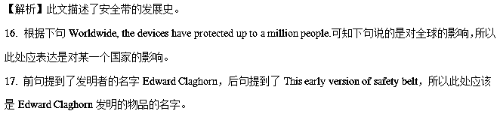18. 此处表达人们进行了不同的尝试，直到50 多年前才出现在车里，所以表明经过一百多年的发展。
19. 前句提到了a cloth strap（带子）和hips(臀部)，而且此段是在讲安全带的工作原理，所以B选项正确。
20. 根据前段中提到的Nils Bohlin's design，可知此处表达Nils Bohlin因为此法名获奖。
13. 根据短文内容，从短文后的选项中选出能填入空白处的最佳选项。选项中有两项为多余选项。
Ways to Help Your Teen Adjust to a New School
In an ideal world,a teen could start and finish their schooling at the same school.___16___.And while a move to a new city can be stressful for the entire family,it may be especially difficult for your teenager.Use these strategies to help your teen adjust to a new school.
___17___
The adjustment period begins before your teen ever steps foot into the new school.Point out the new opportunities that’ll be available.If you have confidence that you can make it a new city or a new job,your teen will feel more confident about his ability to succeed in a new school.
Listen to your teen’s concerns
If you don’t have an open relationship with your teen currently,now it is the time to build one.It’s easiest to get him to open up when he’s feeling unsure.___18___.Is he worried about new teachers?Does he doubt his ability to make the basketball team?
Talk about your reasons for moving
___19___.If you’re preparing for a better career opportunity,or you need to find a new house because you can’t afford to stay where you are,talk about it.
Learn about the new school ahead of time
Conduct as much research as possible about the new school before your teen starts attending.Get your teen to find out about the size of the school and the types of classes offered.___20___.Talking to a network guidance counselor ahead of time can also be helpful.
A.Keep a positive attitude
B.Develop your teen’s different abilities
C.Keep asking questions about his biggest concerns
D.Be honest with your teen about why you’re moving
E.Most schools have websites that offer a wealth of information
F.Joining a club or playing a sport can be a great way for your teen
G.However,when a family must move,a teenager must switch schools
【答案】16. G 17. A 18. C 19. D 20. E
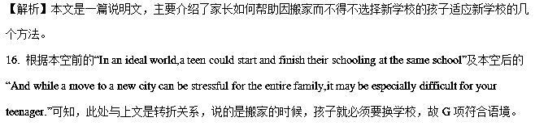17. 根据本段内容，特别是“Point out the new opportunities that’ll be available.If you have confidence that you can make it a new city or a new job,your teen will feel more confident about his ability to succeed in a new school.”可知，本段讲的是态度问题，故A项符合语境。
18. 根据本空后的“Is he worried about new teachers?Does he doubt his ability to make the basketball team? ” 可知，此处是说要持续关注孩子最大的担忧，C项中的questions与这两个问题相对应，故C项符合语境。
19. 根据本段小标题及本空后的内容可知，此处是说要如实地告诉孩子搬家的原因，故D项符合语境。
20. 根据本空后的“Talking to a network guidance counselor ahead of time can also be helpful. ” 可知，此处说的是一种让孩子了解学校和课程的途径，即通过网络信息，故E项符合语境。
【名师点睛】在七选五的解题过程中，过渡衔接词是关键点，需要将表示不同逻辑的关联词有效结合起来，如表示并列或递进关系的词表示前后句子的名词或句意具有同指性，如and, or, also, too, besides, as well as, what’s more等，例如本篇文章的第5题，由后面的also判断空格处应该提到一种了解学校及课程的途径，从而很容易确定答案。
14. 根据短文内容,从短文后的选项中选出能填入空白处的最佳选项。选项中有两项为多余选项。
Easy Ways to Keep Your Brain Sharp
Everyone is forgetful, but as we age, we start to feel like our brains are slowing down a bit—and that can be a very annoying thing. ___16___ Read on for some techniques worth trying.
___17___
People who regularly made plans and looked forward to upcoming events had a 50 percent reduced chance of Alzheimer's disease (早老性痴呆症), according to a recent study.____18____ Something as simple as setting a goal to havea weekly coffee date with a friend will do. There's evidence that people who have a purpose in life or who are working on long or short-term goals appear to do better. In other words, keep your brain looking forward.
Go for a walk.
Mildly raised glucose (葡萄糖) levels can harm the area of the brain that helps you form memories and physical activity can help get blood glucose down to normal levels. In fact, exercise produces chemicals that are good for your brain.____19____
Learn something new.
Take a Spanish class online, join a drawing club, or learn to play cards. A study found that mental stimulation (刺激) limits the weakening effects of aging on memory and the mind. But the best thing for your brain is when you learn something new and are physically active at the same time. ___20___.
A. Focus on the future.
B. This can be especially harmful to the aged.
C. It should be something like learning gardening or go dancing with your friends.
D. So take a few minutes each day to do some reading.
E. But don't worry if your schedule isn't filled with life-changing events.
F. Luckily, research shows there is a lot you can do to avoid those moments.
G. In other words, when you take care of your body, you take care of your brain.
【答案】16. F 17. A 18. E 19. G 20. C
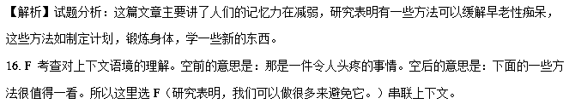17. A 考查对上下文语境的理解。空后的意思是：那些经常做计划并期待即将到来的事情的人们患早老性痴呆的机率会减少百分之五十。所以这里选A（关注未来。）串联上下文。
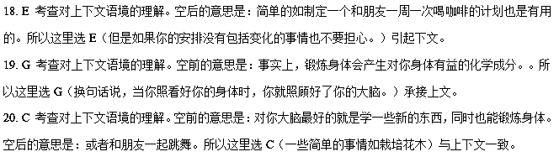考点：考查对文章的整体理解和上下文逻辑关系的把握。
15. 根据短文内容，从短文后的选项中选出能填入空白处的最佳选项，选项中有两项为多余选项。
We face problems in our everyday life.___16___Don’t worry. As long as you are breathing, you can solve problems.
Be aware of problem.
First of all, it is important to know and understand the problem clearly.___17___Following questions like why, what, how, when, where and who will take you to the root cause of the problem.
Analyze the problem.
Analyzing the problem will give you time to think of a proper solution.____18____They can be diagrams, flowcharts or a lists, etc.
Plan a strategy.
Planning a strategy will help you waste less energy and time in attempting all the solutions. This step includes knowing the pros and cons of applying a solution. In this way, you can abandon the strategy that you don’t find worthy to apply.
_____19_____
Leave out the information that is not required for the solving of the problem. You need to be accurate with the details. Keeping the unrelated information can sometimes complicate the simple problem as we tend to overlook the important information.
Carry out the solution
Putting the solution into effect in a correct way to get the result expected is important while solving a problem. You need to be creative while actualizing a solution just in case some other problem arises while applying the solution. ___20___
A. Delete irrelevant information
B. You can use various tools to study the problem
C. Use yes or no questions to get better information
D. Knowing the problem means solving half the problem itself
E. They can be social problems, relationship problems, or problems at work.
F. Spend 10% of the time analyzing the problem and 90% on the solution, not the opposite.
G. Being ready with alternatives is also important in case a solution works only half way.
【答案】16. E 17. D 18. B 19. A 20. G
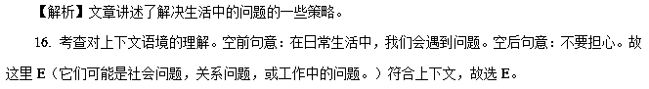17. 考查对上下文语境的理解。空前句意：首先，了解清楚问题很重要。空后句意：接下来的问题，比如：为什么，什么问题，怎么产生的，什么时候，在哪里以及谁会让你找到问题的根源。故这里D（了解问题就意味着解决了一半的问题。）符合上下文，故选D。
18. 考查对上下文语境的理解。空前句意：分析问题会给你时间考虑一种恰当的解决方法。空后句意：它们可能是图表，流程图或列表。故这里B（你可以使用不同的工具来研究问题。）符合上下文，故选B。
19. 考查对上下文语境的理解。此空是本段的主题句。根据下文所描述的内容：忽略那些解决问题时不需要的信息。无关的信息有时会让简单的问题复杂化。故这里A（删去无关的信息。）符合上下文，故选A。
20. 考查对上下文语境的理解。本段的主题是：实施解决方法。空前句意：你需要创造性地实现一个解决方案，以防其他问题出现。故这里G（为了预防解决方法半途而废，准备可选择的方法也很重要。）符合上下文，故选G。

