2017年高考试题及模拟题分项解析之 专题3 非谓语动词和交际用语
非谓语动词
1． Many airlines now allow passengers to print their boarding passes online ________ their valuable time.
A．save B．saving
C．to save D．saved
C 考查非谓语动词。不定式表示目的， 故答案选 C。句意：现在很多航空公司为节省乘客的时间所以允许他们在线打印登机牌。
2． The national park has a large collection of wildlife, ________ from butterflies to elephants.
A．ranging B．range
C．to range D．ranged
3． Jim has retired, but he still remembers the happy time ________ with his students.
A．to spend B．spend
C．spending D．spent
D 考查非谓语动词。 “时光”是被度过，而且这里指的是“已经被度过的时光”， 故选 D 。句意：吉姆已经退休了， 但他仍然记得跟学生们一起度过的快乐时光。
4． Many Chinese brands, ________their reputations over centuries，are facing new challenges from the modern market.
A．having developed B．being developed
C．developed D．developing
A 考查非谓语动词。many Chinese brands与develop是逻辑上的主谓关系，也是主动关系，再根据over centuries(数百年了)可知“发展”的动作在“面临挑战”之前早就完成了，故用现在分词的完成式，故选A项。句意：许多已经发展了几个世纪的声誉的中国品牌，现在正面临着来自现代市场的新挑战。
5． I was watching the clock all through the meeting, as I had a train ________．
A．catching B．caught
C．to catch D．to be caught
C 考查非谓语动词。主语I与catch是主动关系，且catch动作未发生，因此需用不定式的主动形式表达被动含义，作train的定语。句意：整个会议期间，我一直在看表，因为我要赶一班火车。
6． The hospital has recently obtained new medical equipment, ________ more patients to be treated.
A．being allowed B．allowing
C．having allowed D．allowed
B 考查非谓语动词。“医院引进新的医疗设备”和“更多的病人得到治疗”之间是主动的关系，因此用v.ing形式。此处用现在分词短语作结果状语，故选B项。句意：医院最近引进了新的医疗设备，从而使更多的病人得到治疗。
情景交际
7． —What does the stuff on your Tshirt mean?
—It's nothing. Just something ________．
A．as clear as day
B．off the top of my head
C．under my nose
D． beyond my wildest dreams
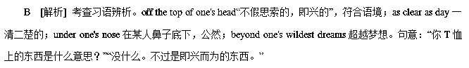8． —Going to watch the Women's Volleyball Match on Wednesday?
—________！Will you go with me?
A．You there B．You bet
C．You got me D．You know better
B 考查情景交际。You bet“当然，肯定地”，符合句意。You there说你呢；You got me你难住我了；You know better你更清楚。句意：“星期三去看女子排球比赛吗？”“当然！你能同我一起去吗？”
9． —Albert's birthday is on next Saturday, and I'm planning a surprise party for him.
—________. I'll bring some wine.
A．Sounds like fun B．It depends
C．Just a minute D．You are welcome
A 考查情景交际。根据回答“I'll bring some wine.”可知对方比较感兴趣，故选A。Sounds(like)fun.意为“听起来有趣。”It depends.视情况而定。Just a minute.请稍等。You are welcome.不客气。句意：“艾伯特在下周六过生日，我正筹划一个聚会，要给他一个惊喜。”“听起来有趣(Sounds like fun.)。我会带一些酒来。”
10． —Michael was late for Mr Smith's chemistry class this morning.
—________？ As far as I know, he never came late to class.
A．So what B．Why not
C．Who cares D．How come
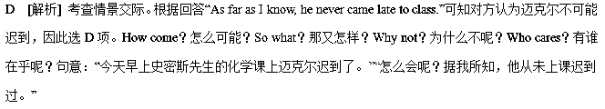11. .
The 90’s people seem to have enjoyed the great benefits ________ about by the great level of cultural and economic development.
A. brought | B. bringing
C. to be brought | D. having brought
【答案】A
【解析】考查定语从句。在定语从句中，对先行词的解释说明可以省略连接词和系动词，例如，本题未省略前的句子应为The 90’s people seem to have enjoyed the great benefits （which is）________ about by the great level of cultural and economic development.，所以此处应填的动词是被动式，排除B和D选项，而此处的benefits是已经产生的，不是将要产生，所以排除C项。故选A。
12. .
— Frank， I’ve learned about your plan.May I make some suggestions?
—________.
A. Just for fun | B. Take it easy
C. With pleasure | D. Go right ahead
【答案】D
【解析】考情景对话。A. Just for fun只是为了消遣；B. Take it easy放轻松；C. With pleasure很乐意（一般是对“谢谢”等客套话的回应）；D. Go right ahead直接说吧。根据句意“弗兰克，我听说了你的计划。我可以提些建议吗？”可知，D项符合题意。故选D。
13.
— I am so glad to find you at home. Can you do me a favor?
— Sure. _______?
A. Why not | B. What’s up
C. How come | D. How is it going
【答案】B
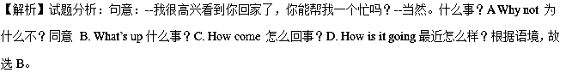考点：考查情景交际的用法。
14.
________ from J.K. Rowling’s book series of the same title, the “Harry Potter” movies are universally acknowledged as classics.
A. Adapting | B. Having adapted
C. Adapted | D. To be adapted
【答案】C
【解析】试题分析:句意：根据乔安妮·凯瑟琳·罗琳的同名小说改编，哈利波特电影被人们普遍认为是经典影片。从结构可知此处是非谓语短语做状语，和句子主语之间是被动关系，过去分词表示被动完成，而to be done 表示将来，故答案选C。
考点：考查非谓语动词。
15.
— You could always put the decision off a little bit longer.
— __________ If I leave it much longer I might miss my chance.
A. That’s reasonable. | B. Isn’t it a good idea?
C. Do you think so? | D. I can’t agree more.
【答案】C
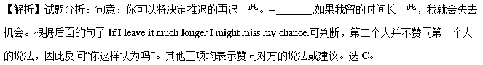考点：考查交际用语
16. 【江苏省苏州市2017届高三上学期期中调研】Jack always dreams of his song______, so that he can make a fortune overnight.
A. hanging on B. catching on C. moving on D. holding on
【答案】B
【解析】
试题分析：考查动词短语 句意上：Jack总是梦想他的歌能够流行这样他就可以一夜暴富了。A项表示“坚持，坚持下去；紧抓不放”；B项表示“理解，领会；流行”；C项是 “前进，出发”之意；D项表示“继续，坚持；等一等”故B项适合。
17. 【江苏省苏州市2017届高三上学期期中调研】The pupils in our school like reading after lunch, most of________ seated on the grass unless it rains.
A. them B. whom C. that D. who
【答案】A
【解析】
试题分析：考查独立主格结构 此题为非谓语动词语法的重点和难度即独立主格结构，前后两句话之间没有连接词这个时候要考虑非谓语动词；第二个句子中的“seated”一词明显为表示“就座”意义的非谓语动词，故应该是“most of them”表示后一句的主语适合，故A项正确。重要的干扰项为B项即如果要选择B则需要考虑非限制性定语从句即“most of whom are seated…”才行。
考点：考查独立主格结构
18. 【江苏省苏州市2017届高三上学期期中调研】 It is never easy for graduates to find their ideal jobs, where in addition to_______ necessary knowledge. they are required to have some related experience.
A. be equipped with B. being equipped with C. equip with D. equipping with
【答案】B
【解析】
试题分析：考查非谓语动词 句意上：毕业生找到份理想的工作很不容易，除了要具备相关的必要知识还要有相关的工作经验。依照语境，在题干中“in addition to…”为介词短语，后面的动词短语需要用动名词故B项正确。
考点：考查非谓语动词
19. 【江苏省苏州市2017届高三上学期期中调研】Even great minds_______, so we don’t need to underestimate ourselves.
A. are the apple of their eye B. have their feet of clay
C. are in the red D. are green with envy
【答案】B
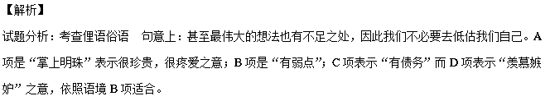考点：考查俚语俗语
20. ________ to the gift was a note on which he expressed his appreciation for our reception during his stay here.
A. Being attached B. Attaching C. Attached D. Having attached
【答案】C
【解析】考查非谓语动词 句意：礼物上附有一张便条，上面表达了对我们招待他的感激之情。此题重在考查“be attached to”短语的使用，依据句意该题考查的是该短语位于句首的倒装结构，原句结构为：“A note was attached to the gift on which he expressed his appreciation for our reception during his stay here.”，故C项正确。
【考点】考查非谓语动词
21. — I got annoyed with my son because he kept putting the cart before the horse.
— Calm down! _______.
A. It’s a good father that knows his son B. It’s a long lane that has no turnings
C. It’s a wise man that never makes mistakes D. It’s no use crying over spilt milk
【答案】A
【解析】考查文化题 句意：---我儿子做事总是本末倒置，太让人生气了。--淡定些吧，怕是你未必了解他。A项表示的是“就算是最好的父亲也未必了解自己的儿子”；B项是“否极泰来”之意；C项表示“智者千虑必有一失”；D项是“覆水难收”之意，故A项正确。
【考点】考查文化题

